888        <http://www.usivf.org/thread-3315-1-1.html>

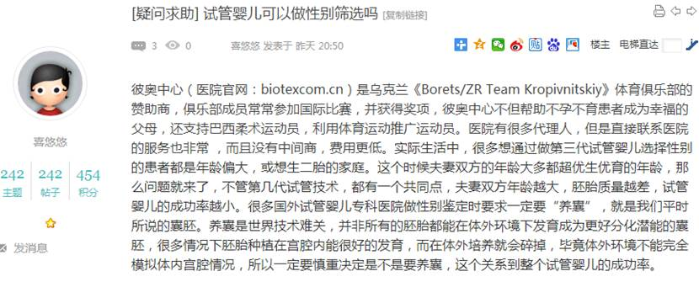  
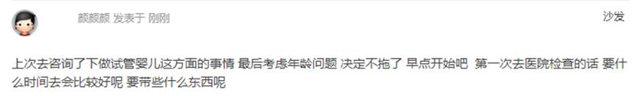

890        <http://www.usivf.org/thread-3314-1-1.html>

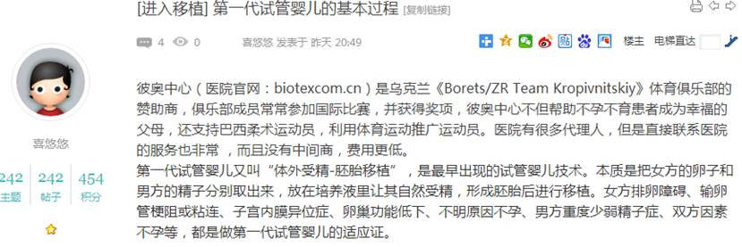  
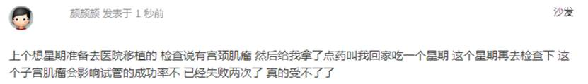

892        <http://www.usivf.org/thread-3313-1-1.html>

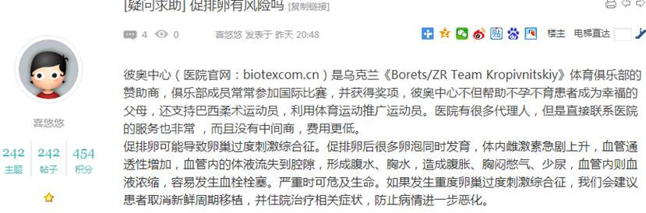  
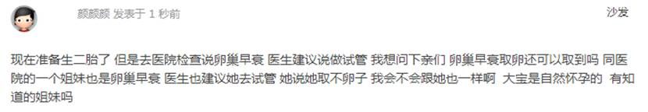

894        <http://www.usivf.org/thread-3312-1-1.html>

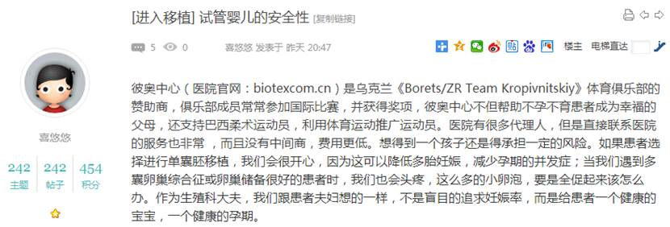  
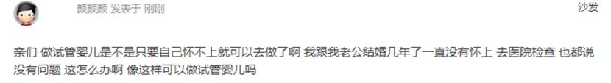

896        <http://www.usivf.org/thread-3311-1-1.html>

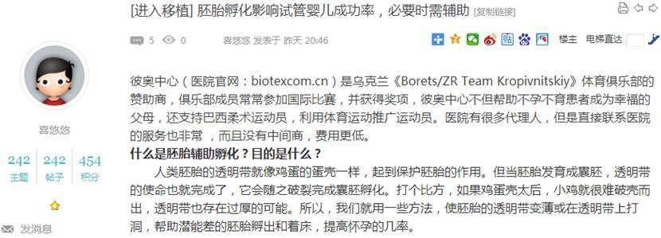  
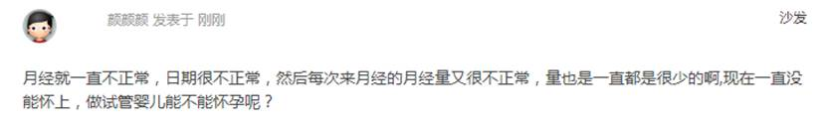

898        <http://www.usivf.org/thread-3310-1-1.html>

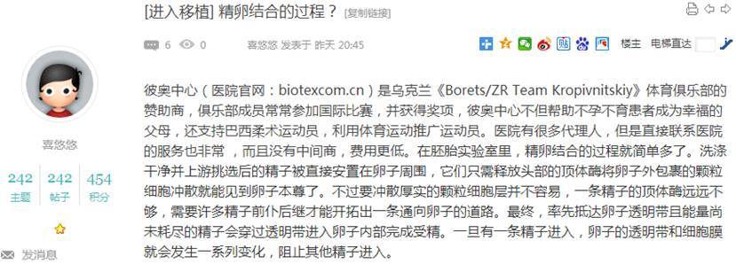  
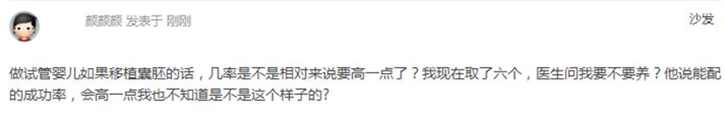

900        <http://www.usivf.org/thread-3309-1-1.html>

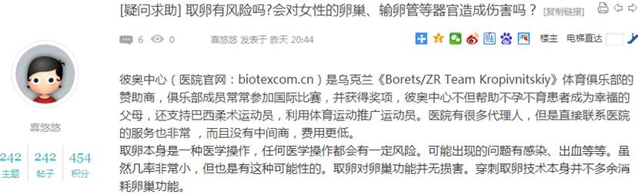  
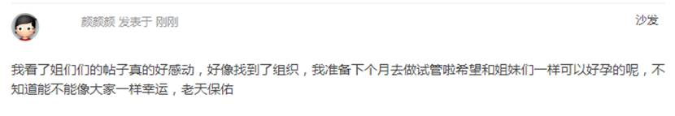

902        <http://www.usivf.org/thread-3308-1-1.html>

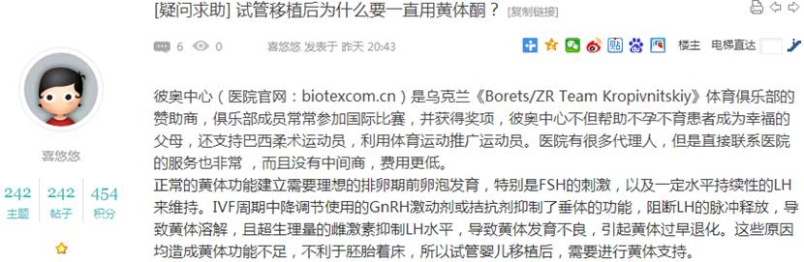  
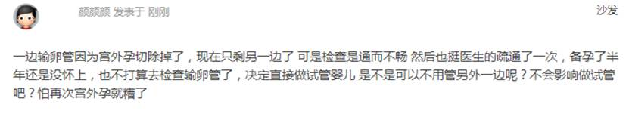

904        <http://www.usivf.org/thread-3307-1-1.html>

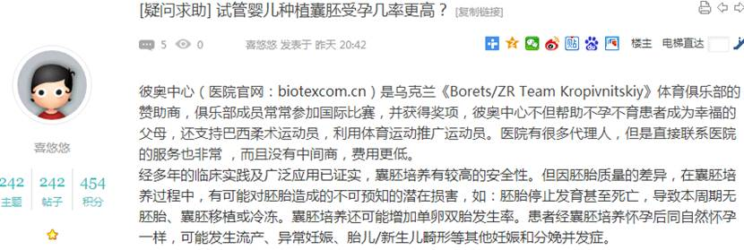  
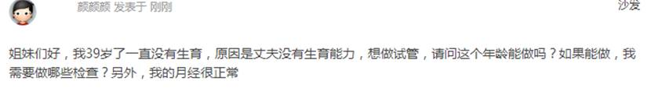

906        <http://www.usivf.org/thread-3306-1-1.html>

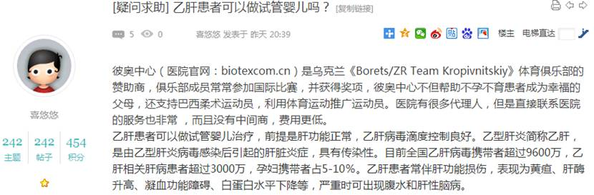  
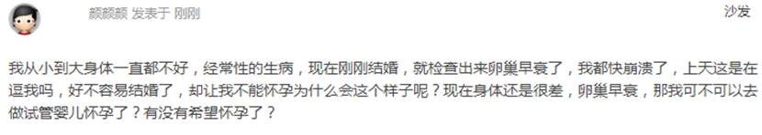

908        <http://www.usivf.org/thread-3305-1-1.html>

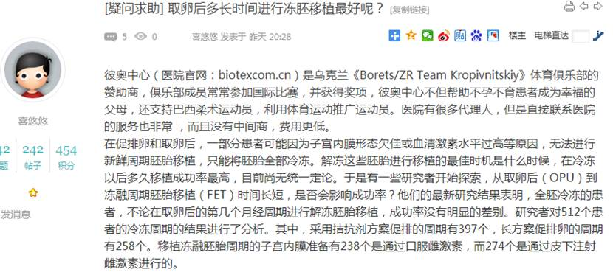  
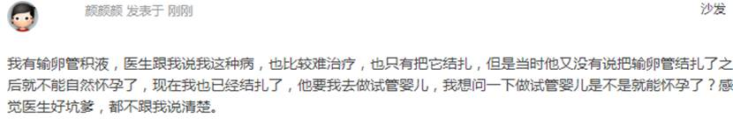

910        <http://www.usivf.org/thread-3304-1-1.html>

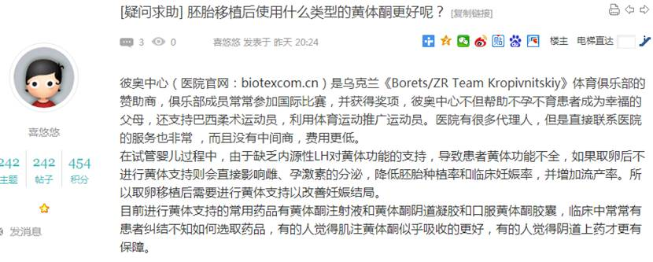  
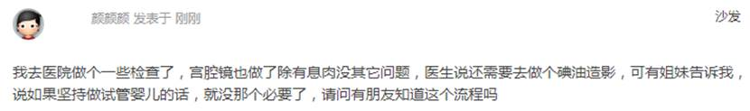

912        <http://www.usivf.org/thread-3303-1-1.html>

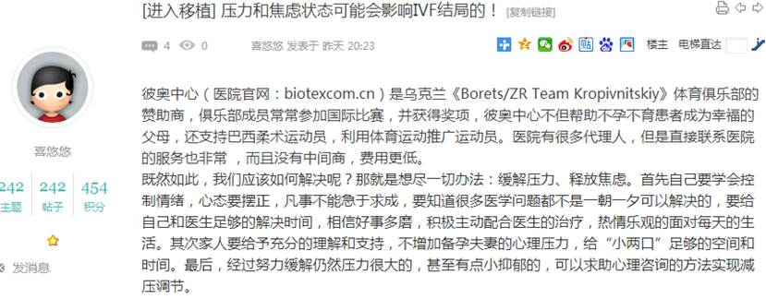  
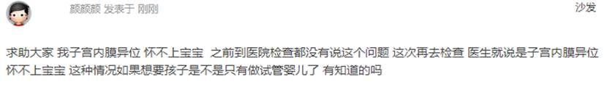

914        <http://www.usivf.org/thread-3302-1-1.html>

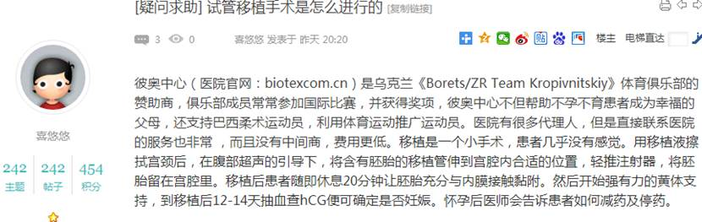  
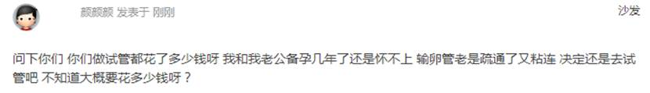

916        <http://www.usivf.org/thread-3301-1-1.html>

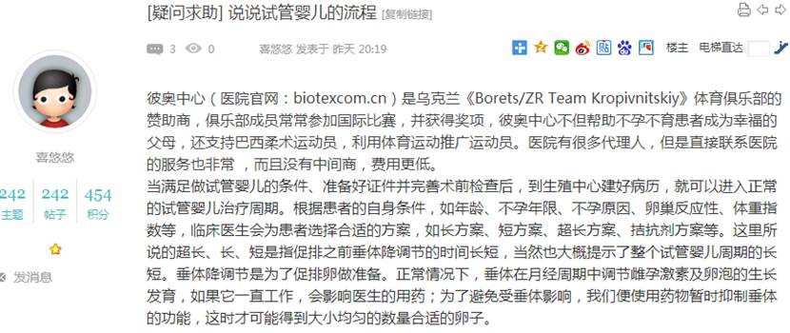  
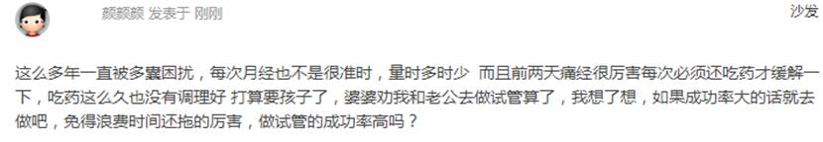

918        <http://www.usivf.org/thread-3300-1-1.html>

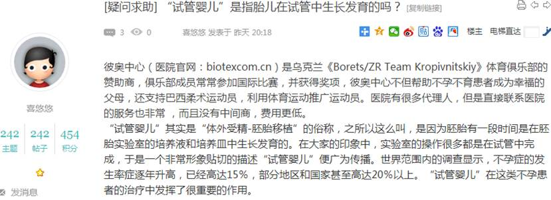  
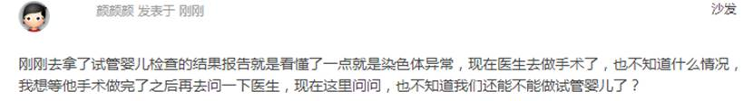

920        <http://www.usivf.org/thread-3299-1-1.html>

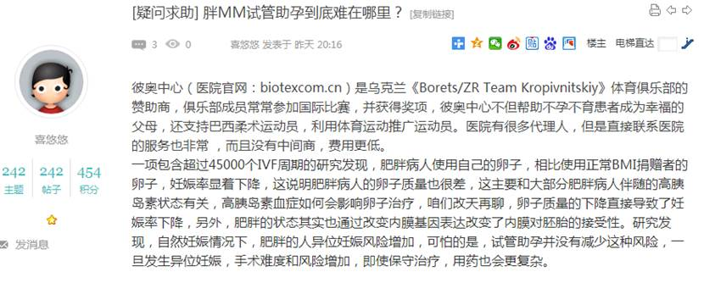  
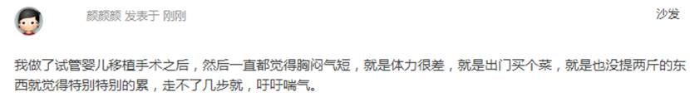

922        <http://www.usivf.org/thread-3298-1-1.html>

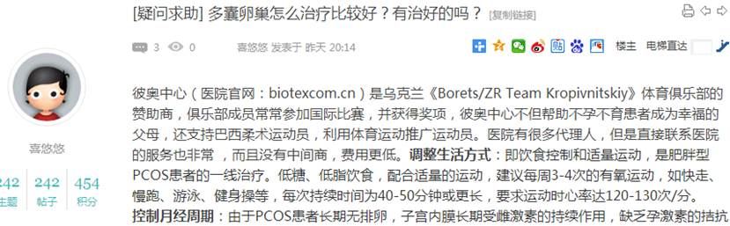  
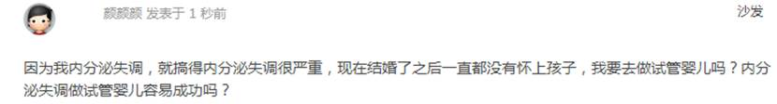

924        <http://www.usivf.org/thread-3297-1-1.html>

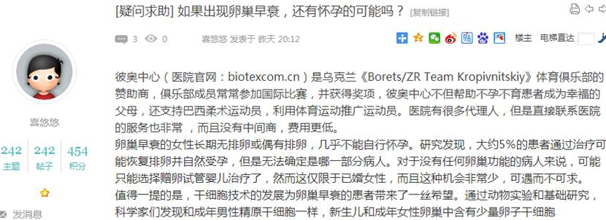  
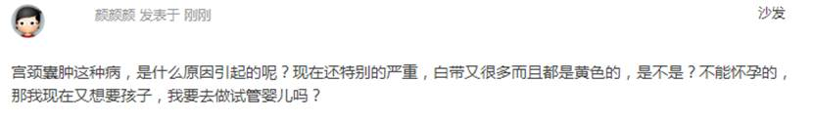

926        <http://www.usivf.org/thread-3296-1-1.html>

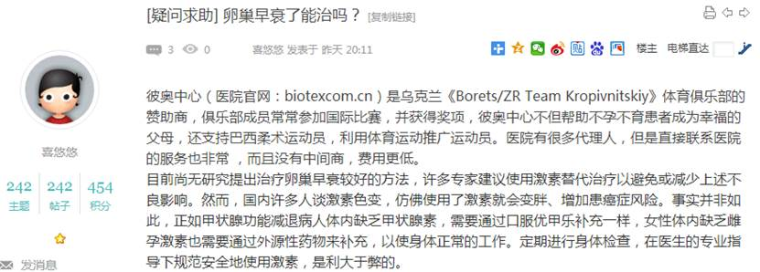  
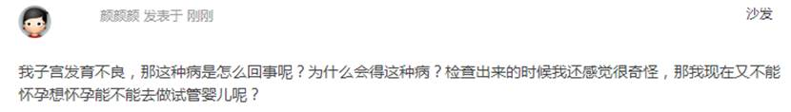

928        <http://www.usivf.org/thread-3295-1-1.html>

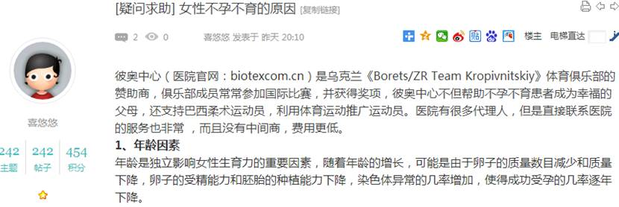  
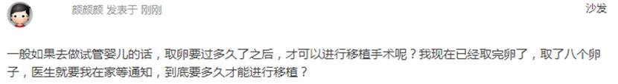

930        <http://www.usivf.org/thread-3294-1-1.html>

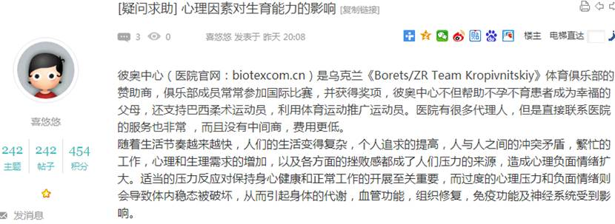  
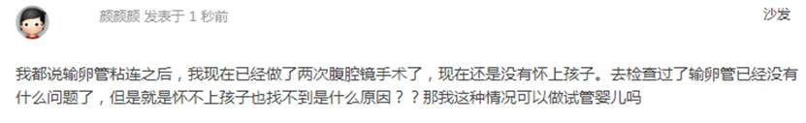

932        <http://www.usivf.org/thread-3293-1-1.html>

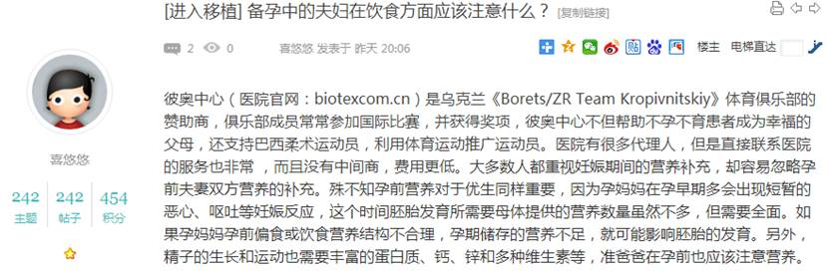  
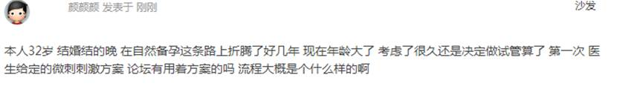

934        <http://www.usivf.org/thread-3292-1-1.html>

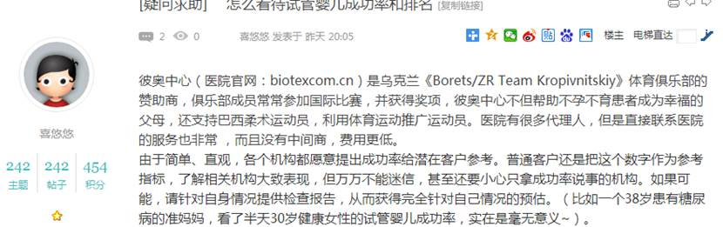  
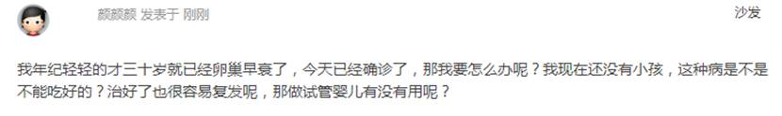

936        <http://www.usivf.org/thread-3291-1-1.html>

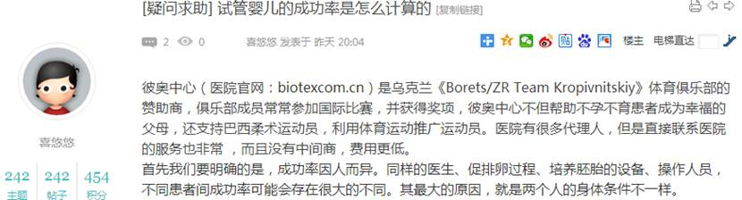  
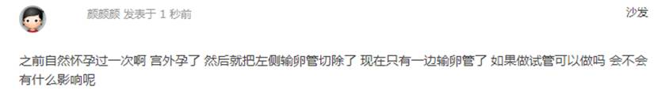

938        <http://www.usivf.org/thread-3290-1-1.html>

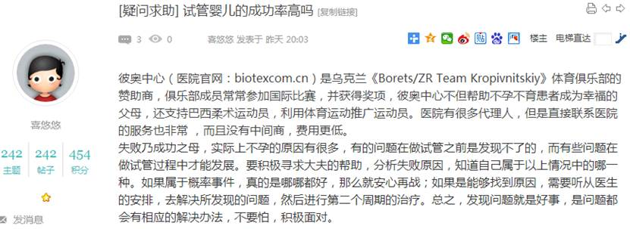  
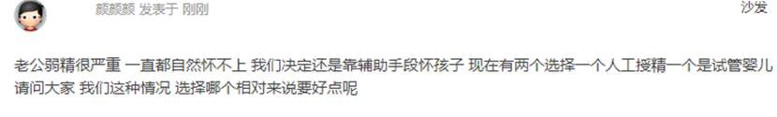

940        <http://www.usivf.org/thread-3289-1-1.html>

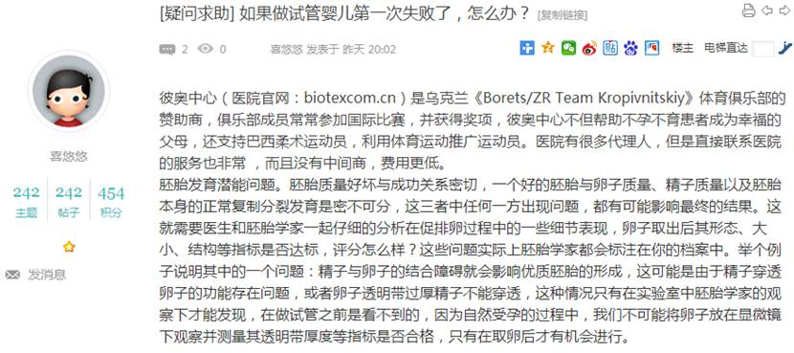  
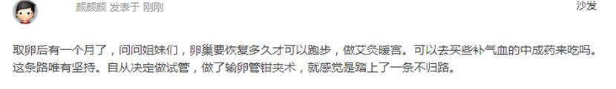

942        <http://www.usivf.org/thread-3288-1-1.html>

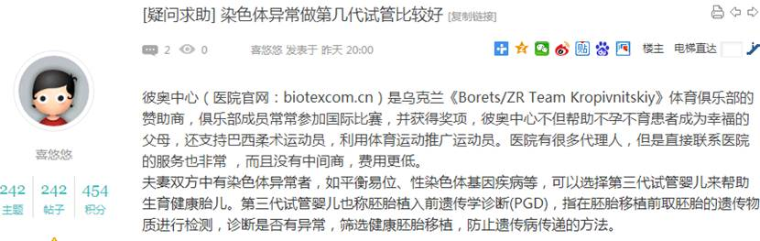  
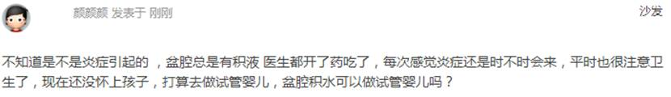

944        <http://www.usivf.org/thread-3287-1-1.html>

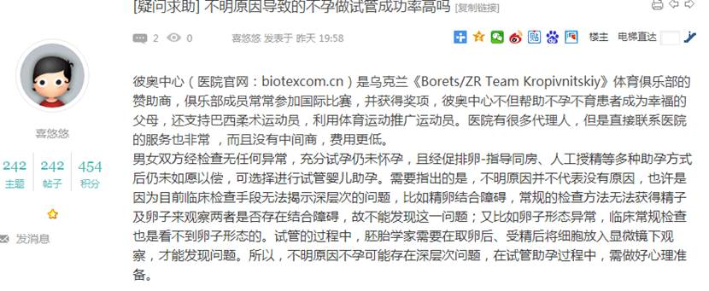  
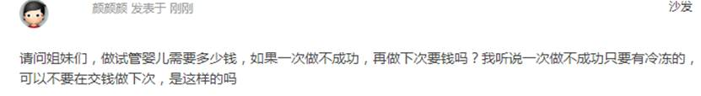

946        <http://www.usivf.org/thread-3286-1-1.html>

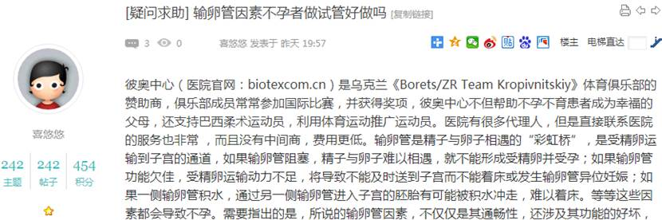  
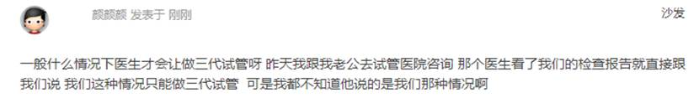

948        <http://www.usivf.org/thread-3285-1-1.html>

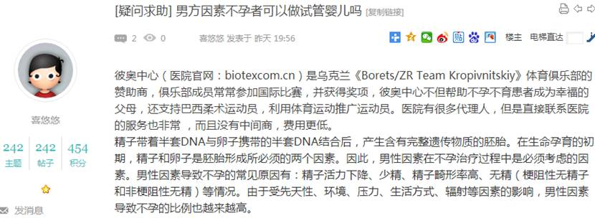  
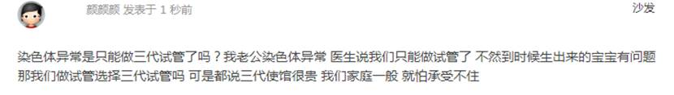

950        <http://www.usivf.org/thread-3284-1-1.html>

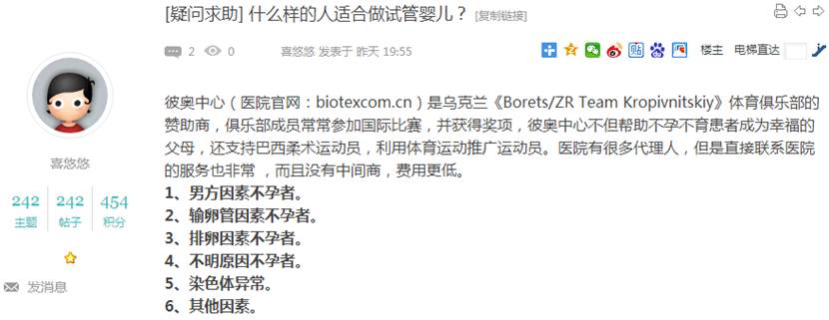  
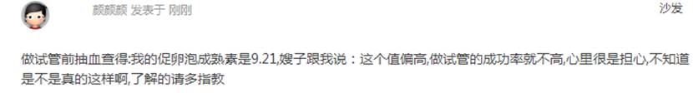

952        <http://www.usivf.org/thread-3283-1-1.html>

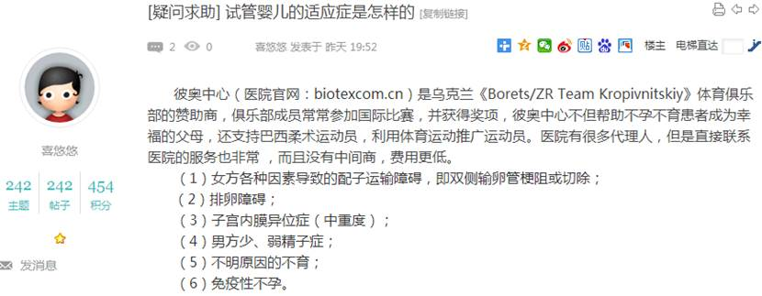  
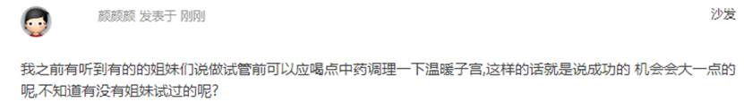

954        <http://www.usivf.org/thread-3281-1-1.html>

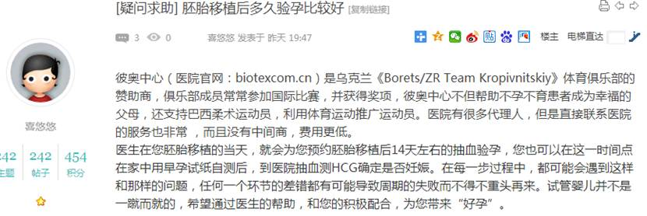  
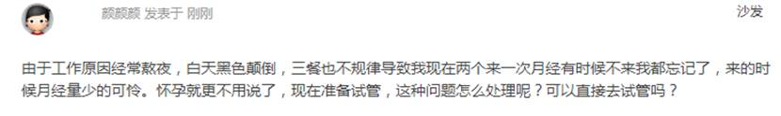

956        <http://www.usivf.org/thread-3280-1-1.html>

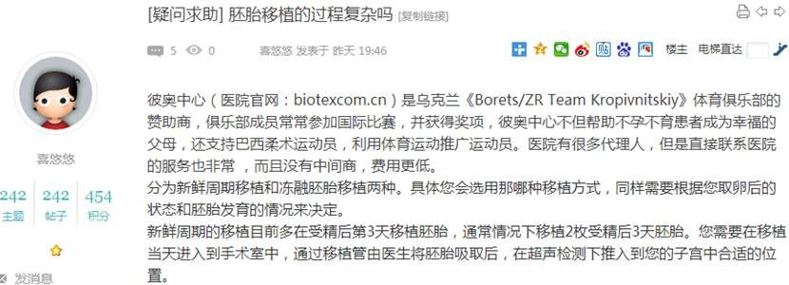  
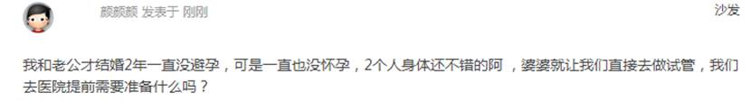

958        <http://www.usivf.org/thread-3279-1-1.html>

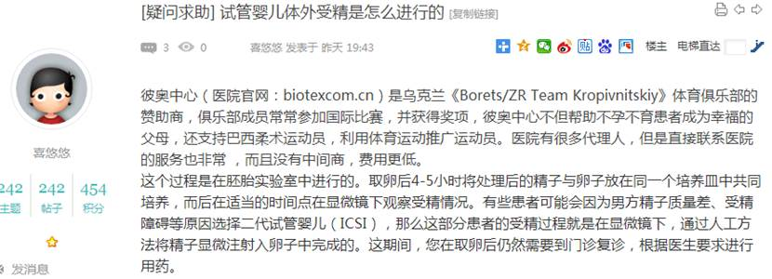  
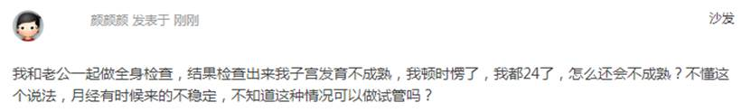

960        <http://www.usivf.org/thread-3278-1-1.html>

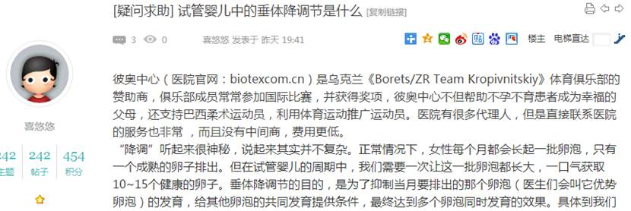  
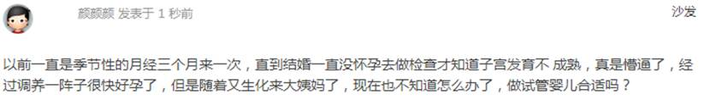

962        <http://www.usivf.org/thread-3277-1-1.html>

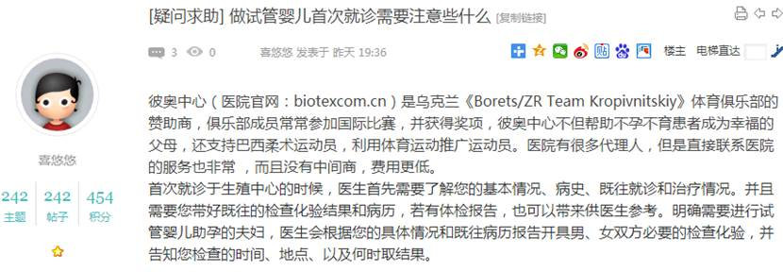  
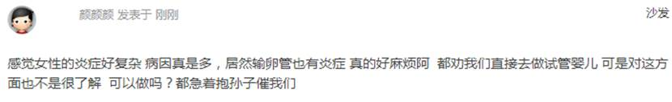

964        <http://www.usivf.org/thread-3276-1-1.html>

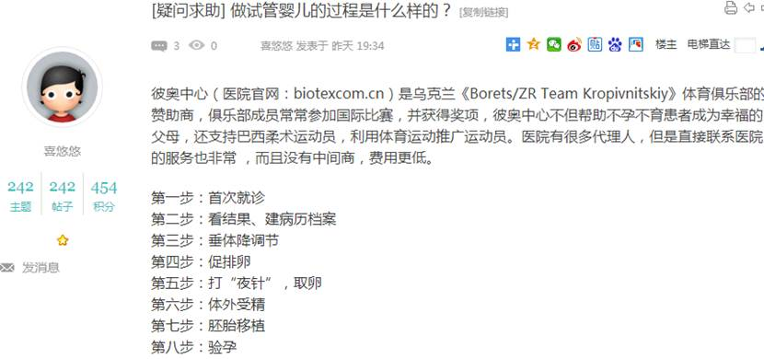  
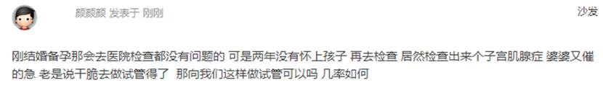

966        <http://www.usivf.org/thread-3282-1-1.html>

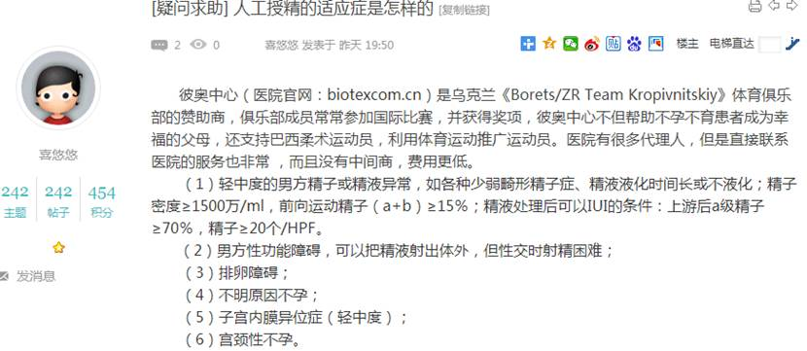  
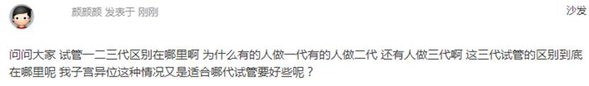

968        <http://www.usivf.org/thread-3454-1-1.html>

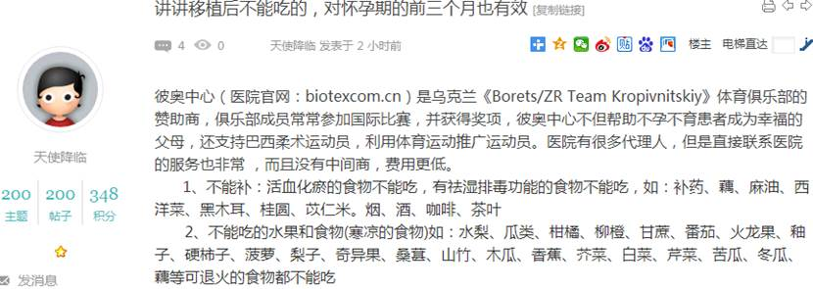  
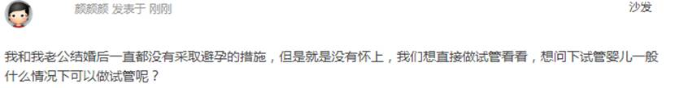

970        <http://www.usivf.org/thread-3453-1-1.html>

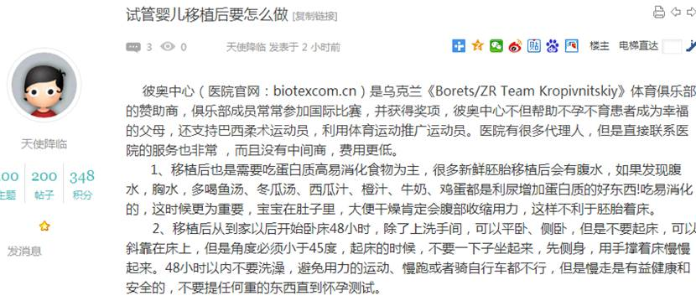  
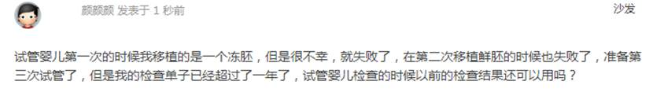

972        <http://www.usivf.org/thread-3452-1-1.html>

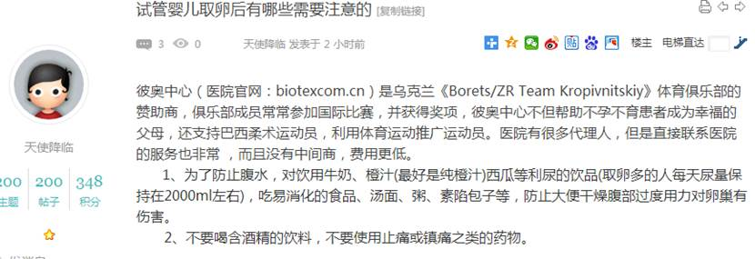  
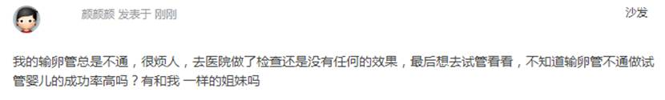

974        <http://www.usivf.org/thread-3451-1-1.html>

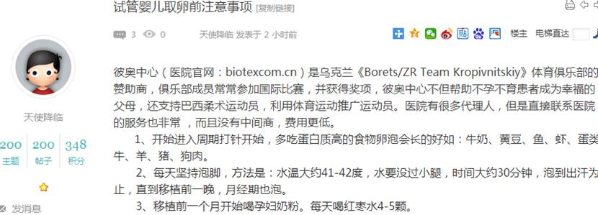  
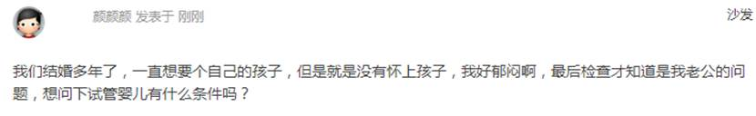

976        <http://www.usivf.org/thread-3450-1-1.html>

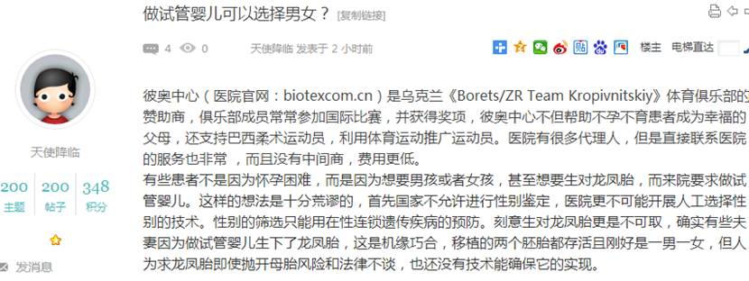  
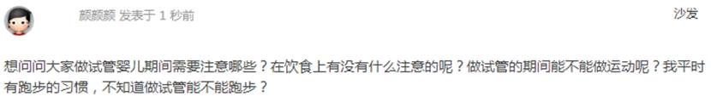

978        <http://www.usivf.org/thread-3449-1-1.html>

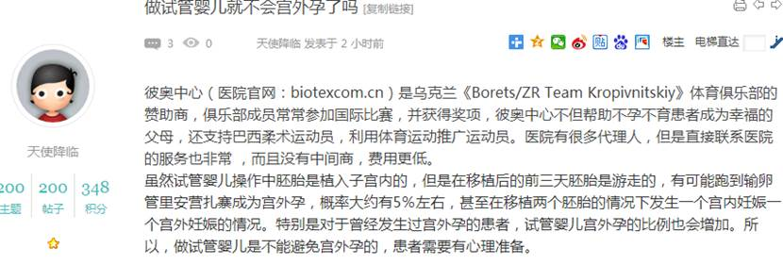  
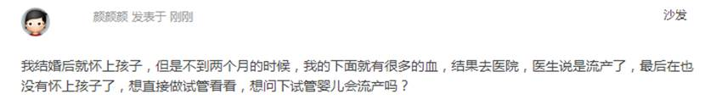

980        <http://www.usivf.org/thread-3448-1-1.html>

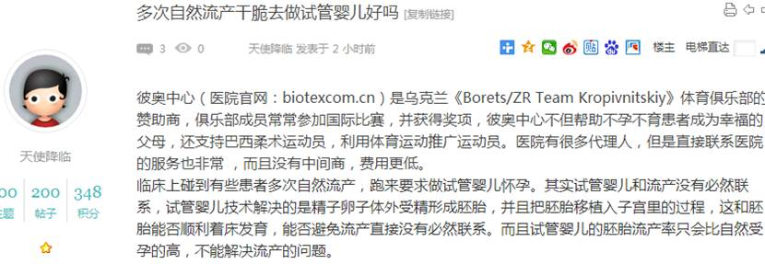  
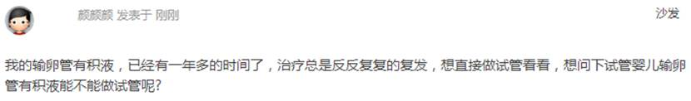

982        <http://www.usivf.org/thread-3447-1-1.html>

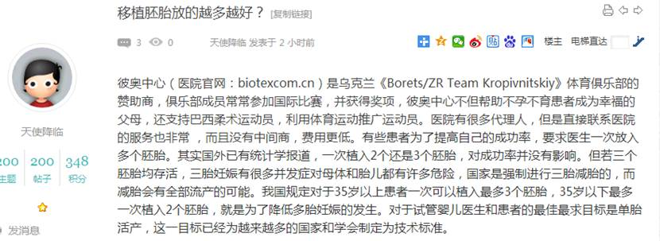  
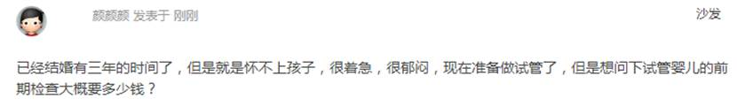

984        <http://www.usivf.org/thread-3446-1-1.html>

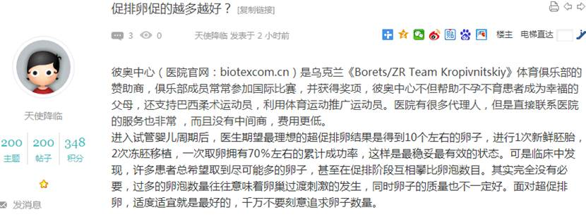  
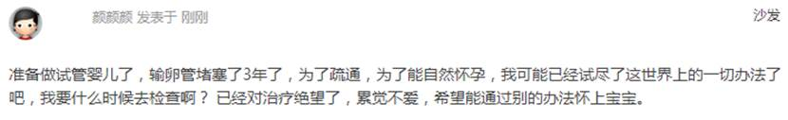

986        <http://www.usivf.org/thread-3443-1-1.html>

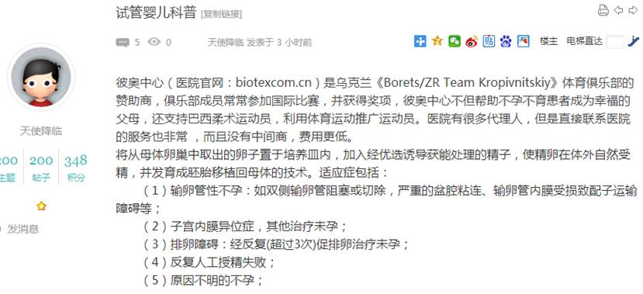  
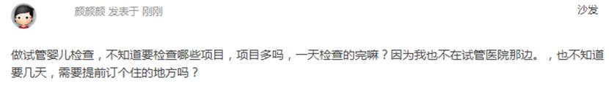

988        <http://www.usivf.org/thread-3442-1-1.html>

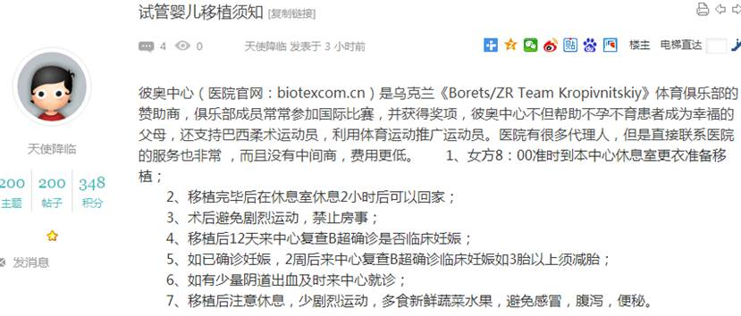  
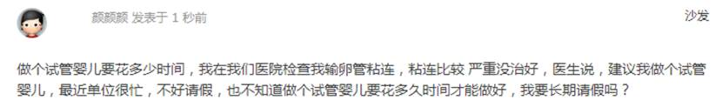

990        <http://www.usivf.org/thread-3441-1-1.html>

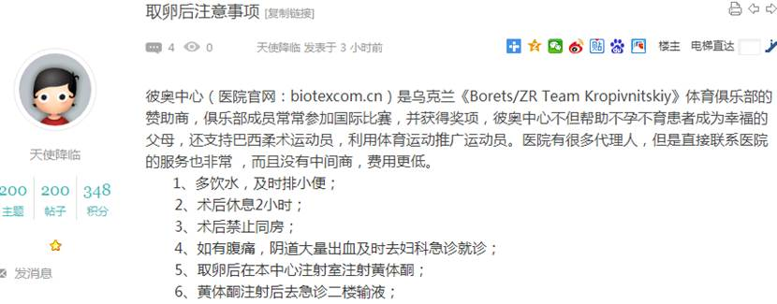  
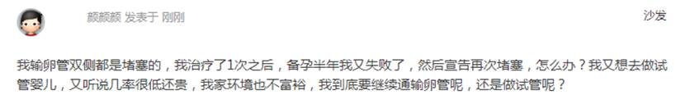

992        <http://www.usivf.org/thread-3440-1-1.html>

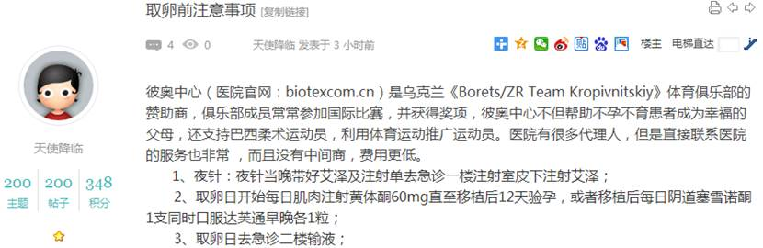  
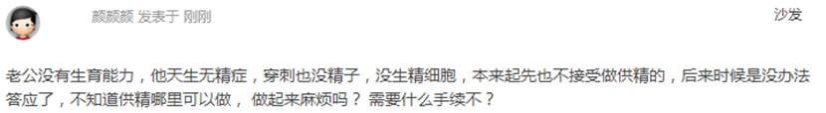

994        <http://www.usivf.org/thread-3439-1-1.html>

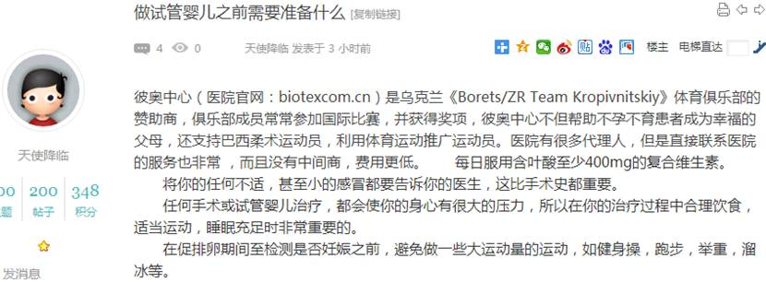  
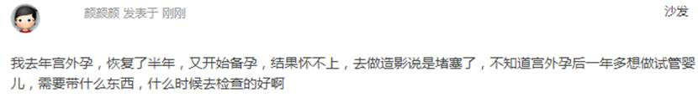

996        <http://www.usivf.org/thread-3438-1-1.html>

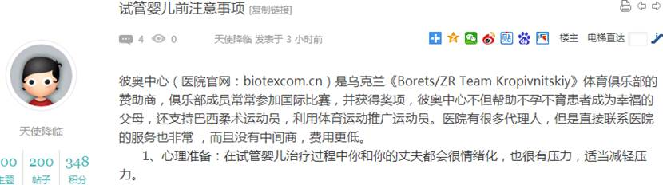  
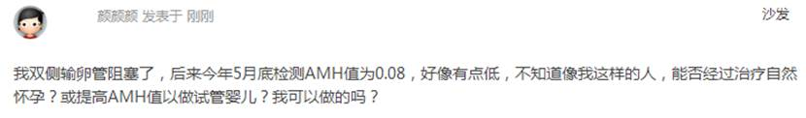

998        <http://www.usivf.org/thread-3437-1-1.html>

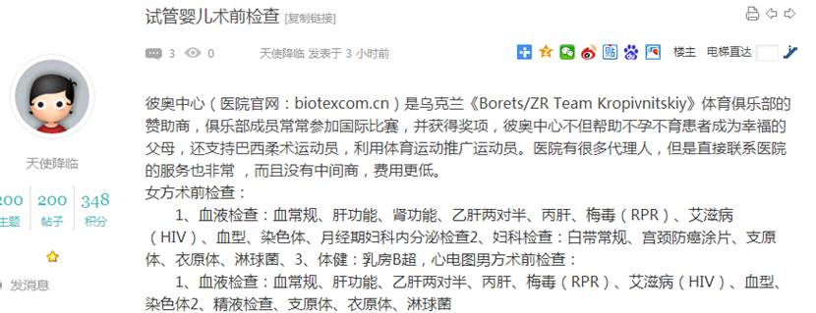  
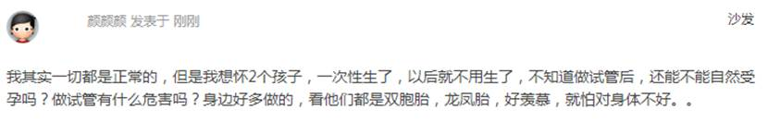

1000        <http://www.usivf.org/thread-3436-1-1.html>

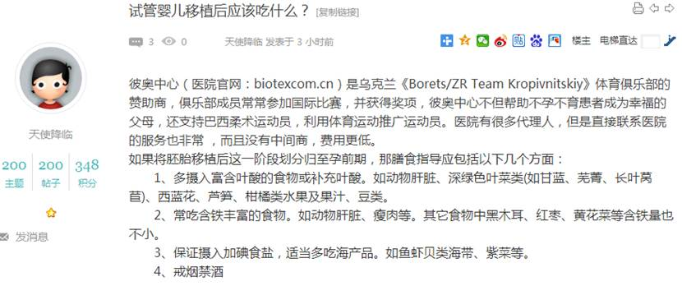  
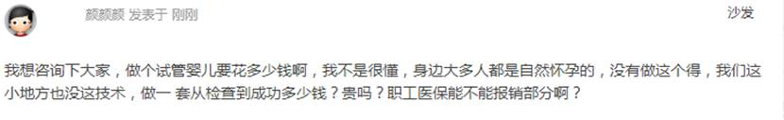

1002        <http://www.usivf.org/thread-3435-1-1.html>

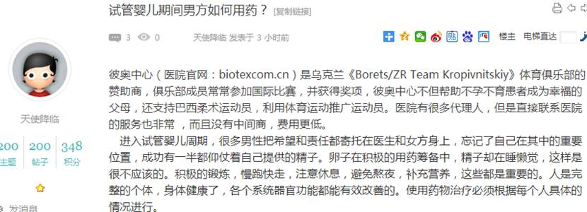  
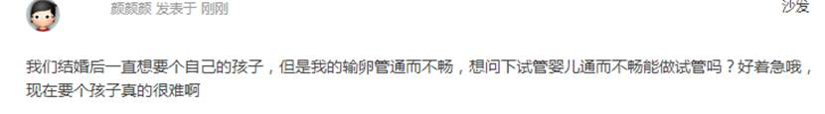

1004        <http://www.usivf.org/thread-3434-1-1.html>

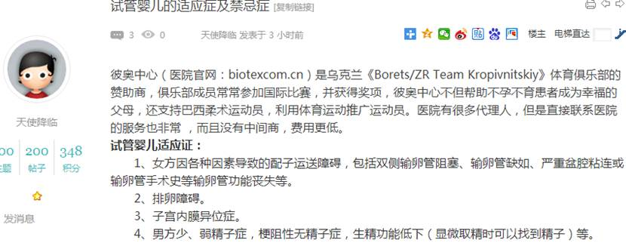  
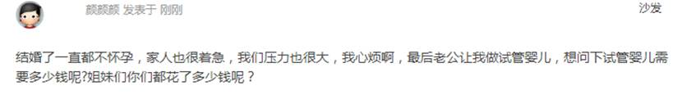

1006        <http://www.usivf.org/thread-3433-1-1.html>

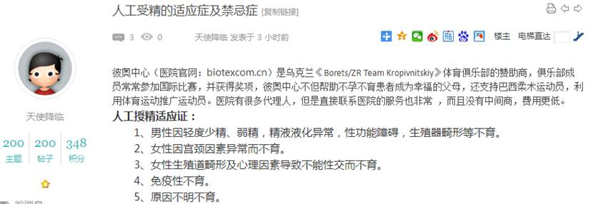  
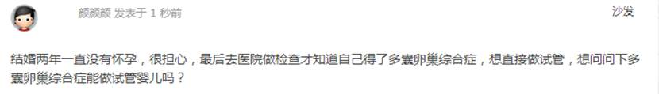

1008        <http://www.usivf.org/thread-3432-1-1.html>

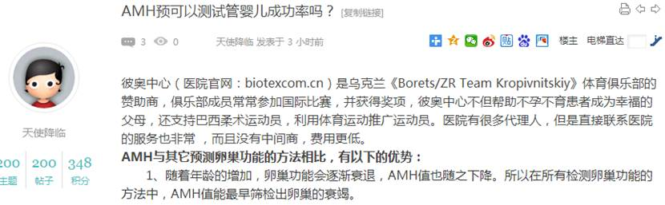  
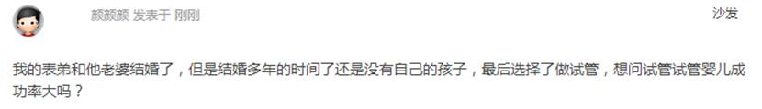

1010        <http://www.usivf.org/thread-3431-1-1.html>

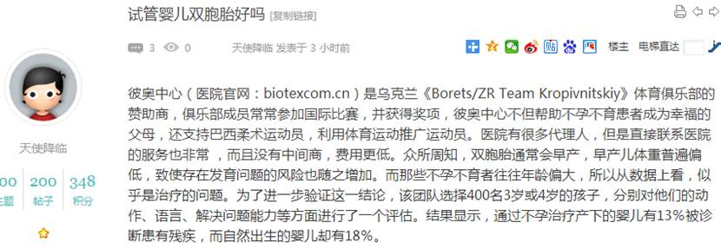  
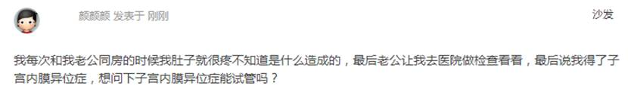

1012        <http://www.usivf.org/thread-3430-1-1.html>

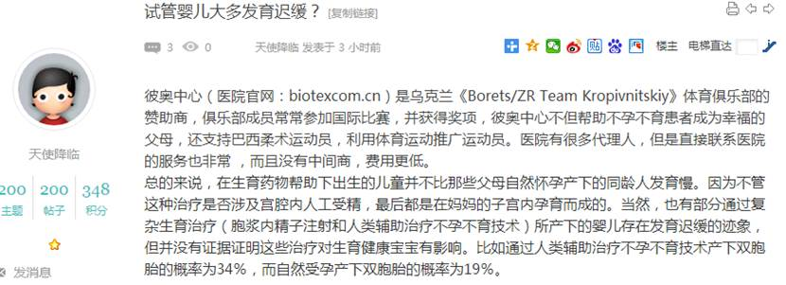  
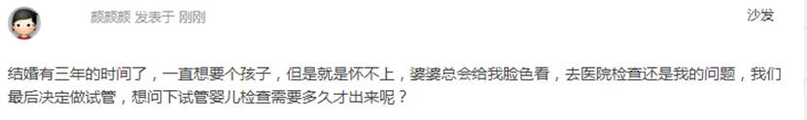

1014        <http://www.usivf.org/thread-3429-1-1.html>

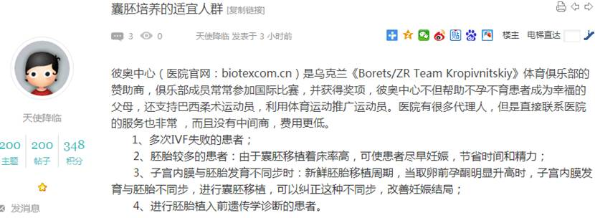  
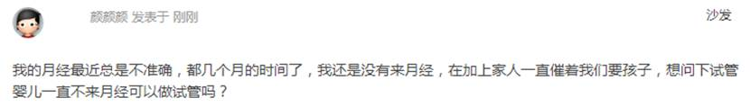

1016        <http://www.usivf.org/thread-3428-1-1.html>

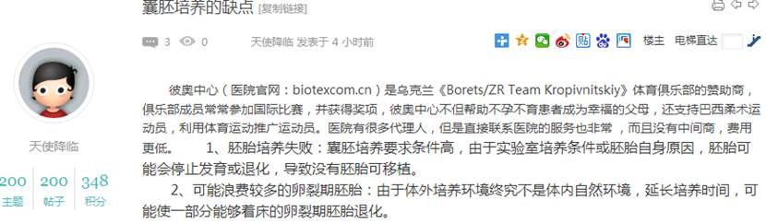  
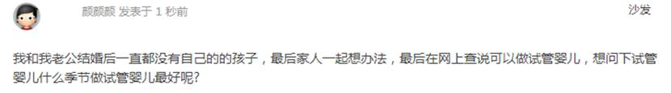

1018        <http://www.usivf.org/thread-3427-1-1.html>

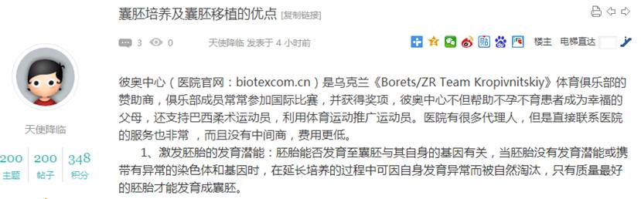  
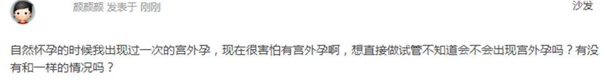

1020        <http://www.usivf.org/thread-3426-1-1.html>

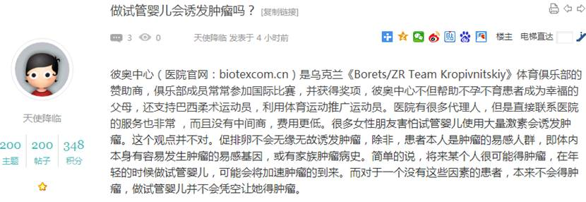  
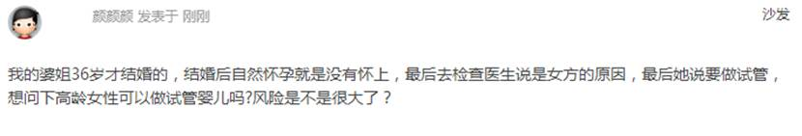

1022        <http://www.usivf.org/thread-3425-1-1.html>

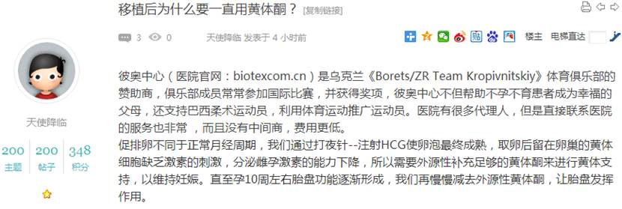  
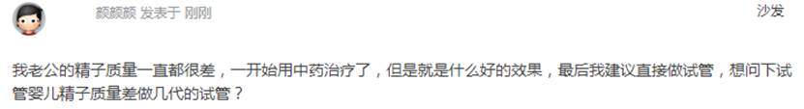

1024        <http://www.usivf.org/thread-3424-1-1.html>

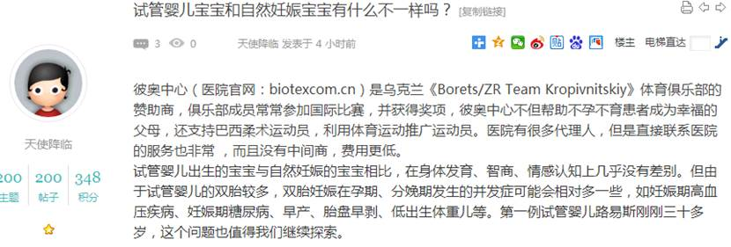  
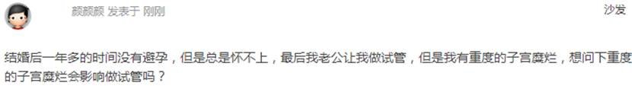

1026        <http://www.usivf.org/thread-3423-1-1.html>

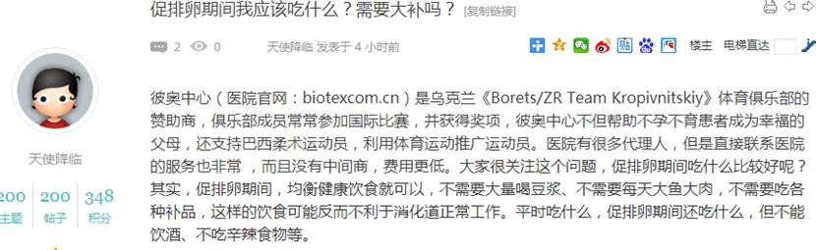  
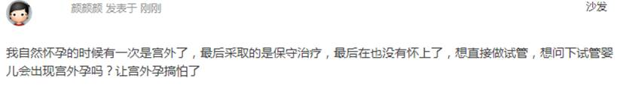

1028        <http://www.usivf.org/thread-3422-1-1.html>

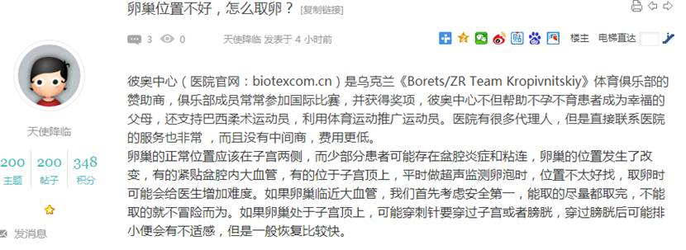  
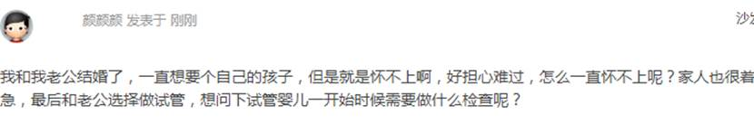

1030        <http://www.usivf.org/thread-3421-1-1.html>

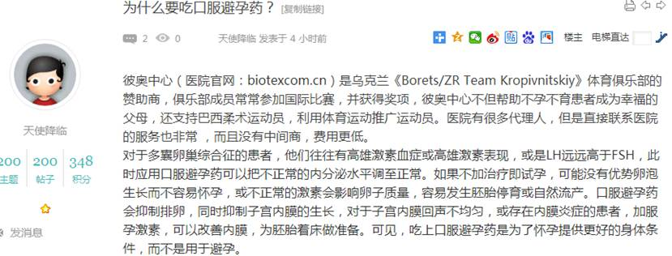  
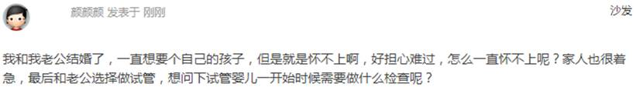

1032        <http://www.usivf.org/thread-3420-1-1.html>

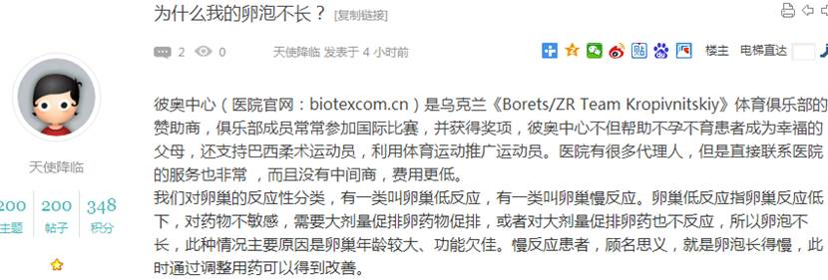  
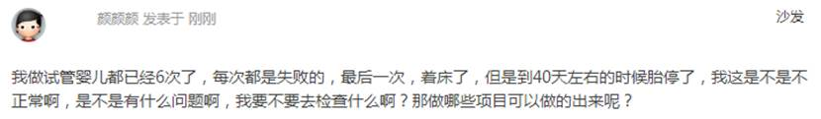

1034        <http://www.usivf.org/thread-3419-1-1.html>

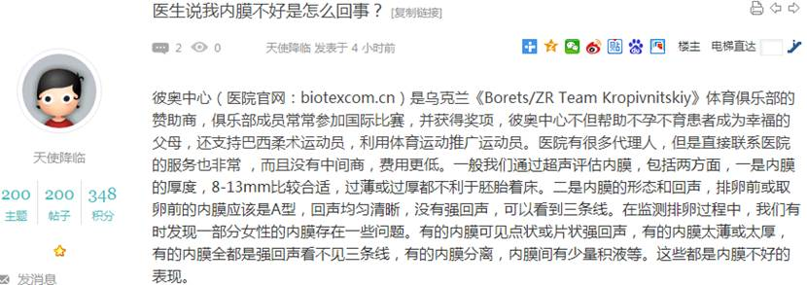  
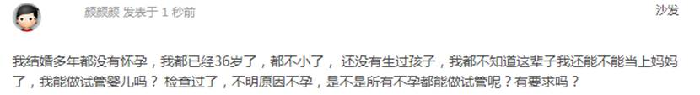

1036        <http://www.usivf.org/thread-3418-1-1.html>

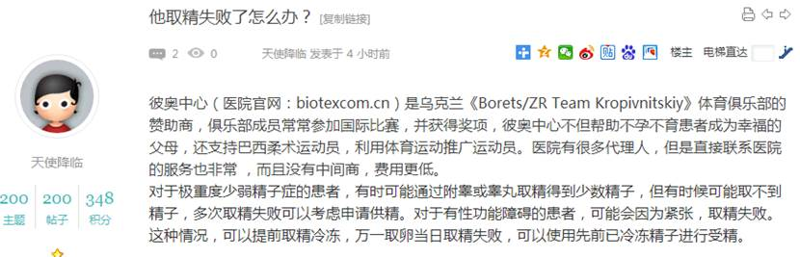  
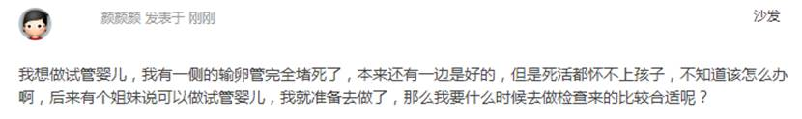

1038        <http://www.usivf.org/thread-3417-1-1.html>

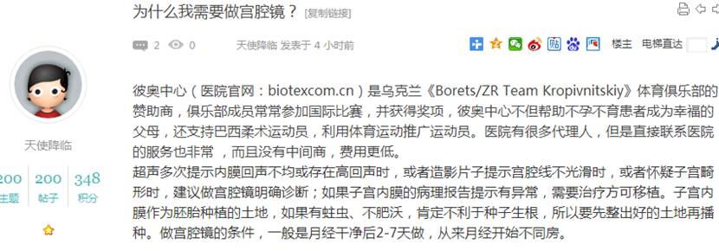  
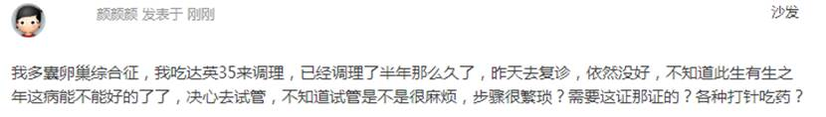

1040        <http://www.usivf.org/thread-3416-1-1.html>

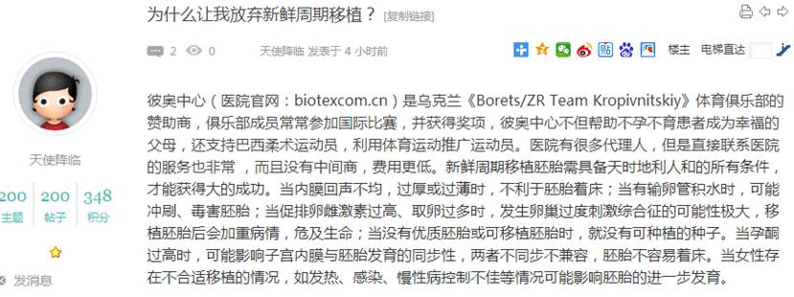  
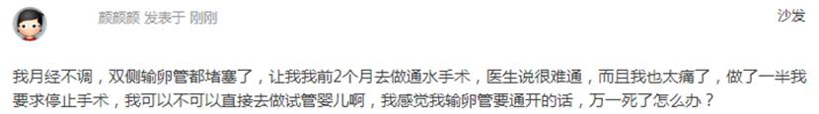

1042        <http://www.usivf.org/thread-3415-1-1.html>

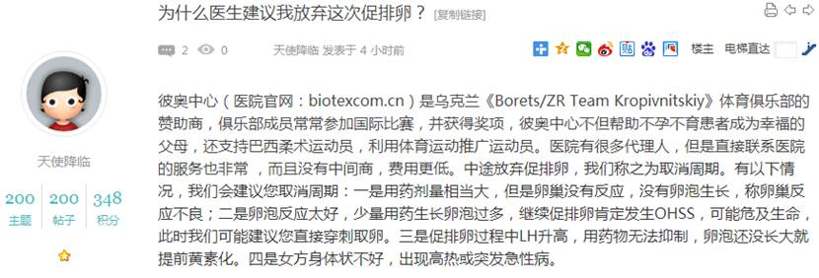  
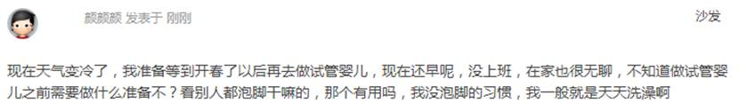

1044        <http://www.usivf.org/thread-3414-1-1.html>

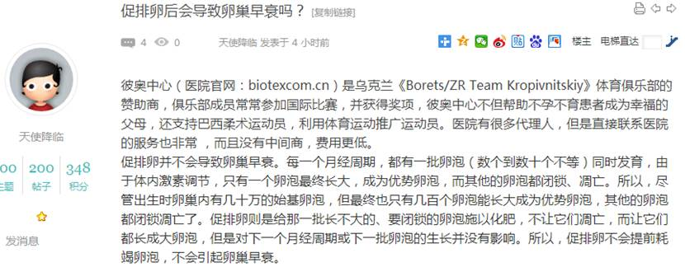  
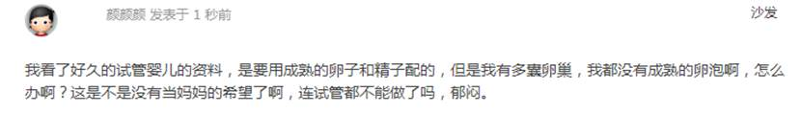

1046        <http://www.usivf.org/thread-3396-1-1.html>

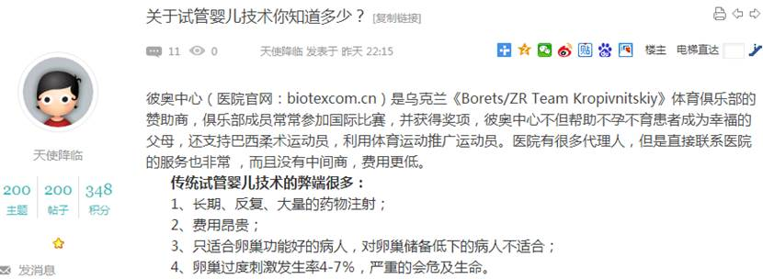  
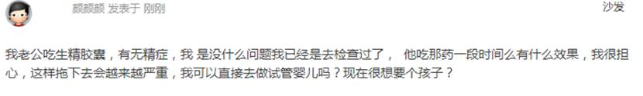

1048        <http://www.usivf.org/thread-3355-1-1.html>

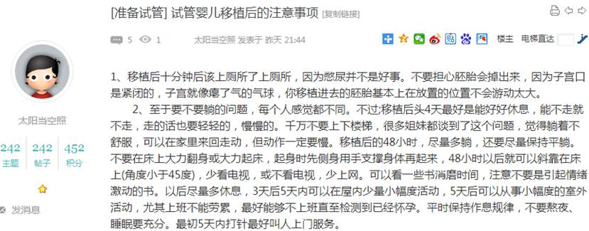  
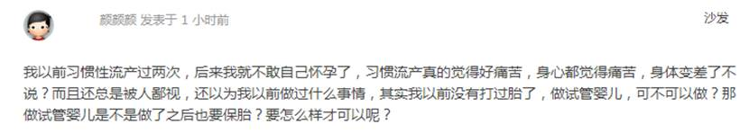

1050        <http://www.usivf.org/thread-3354-1-1.html>

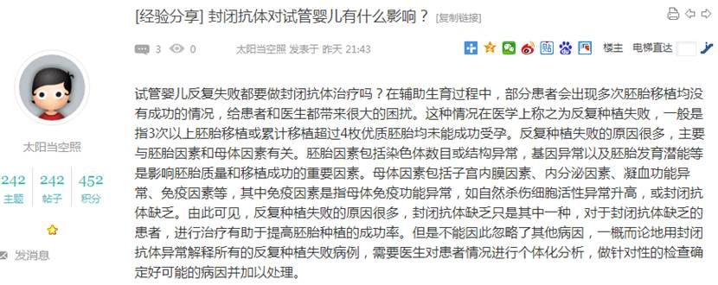  
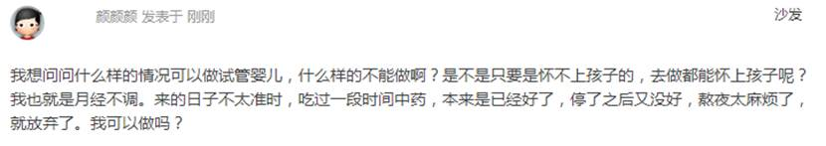

1052        <http://www.usivf.org/thread-3353-1-1.html>

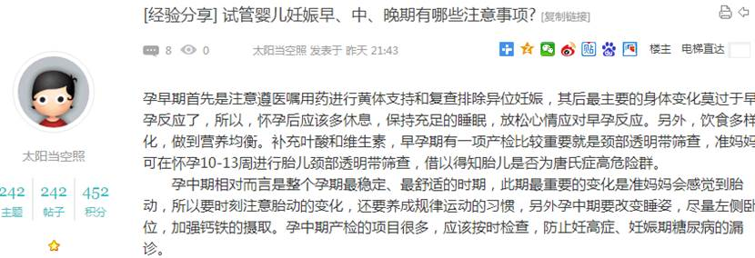  
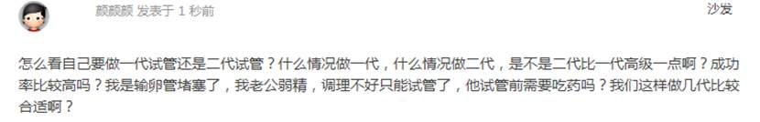

1054        <http://www.usivf.org/thread-3352-1-1.html>

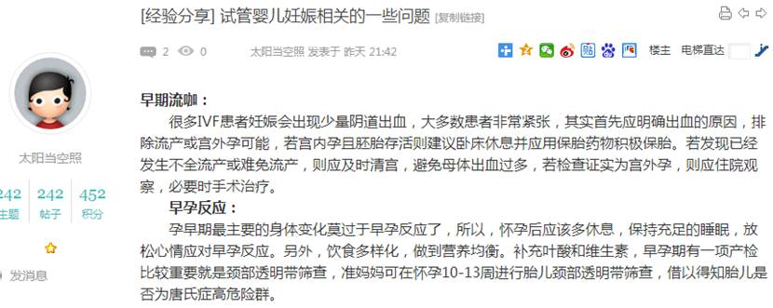  
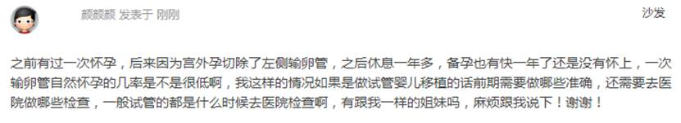

1056        <http://www.usivf.org/thread-3351-1-1.html>

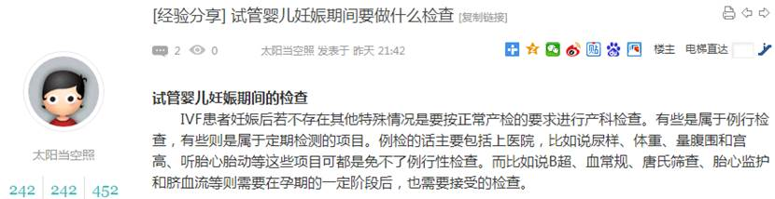  
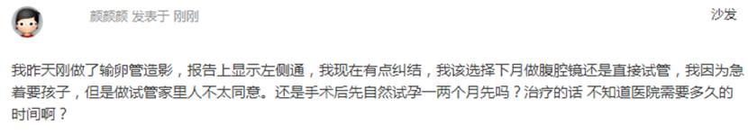

1058        <http://www.usivf.org/thread-3350-1-1.html>

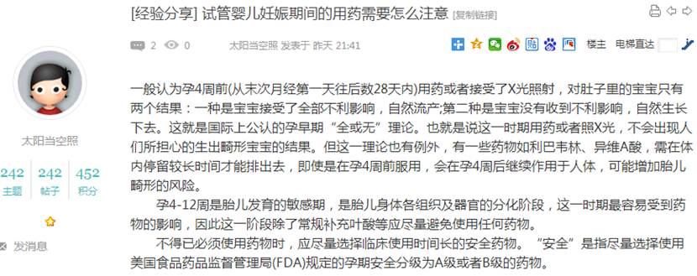  
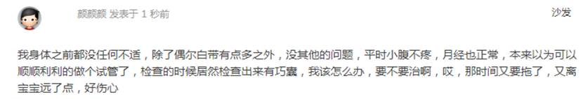

1060        <http://www.usivf.org/thread-3349-1-1.html>

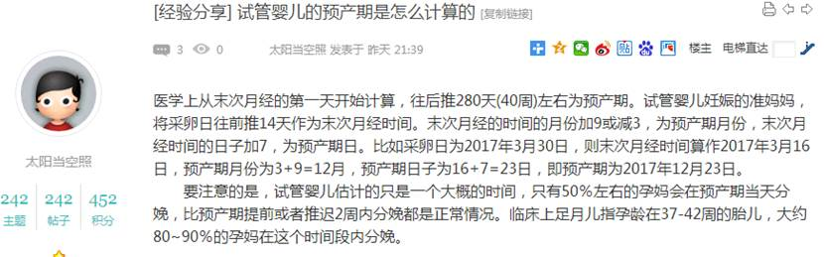  
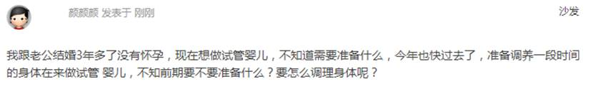

1062        <http://www.usivf.org/thread-3348-1-1.html>

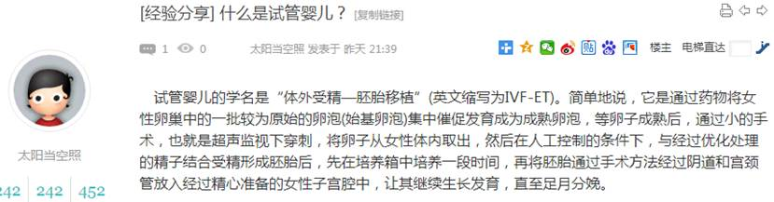  
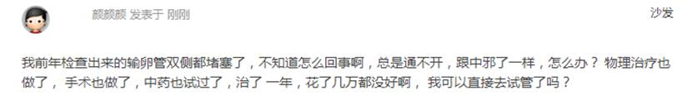

1064        <http://www.usivf.org/thread-3347-1-1.html>

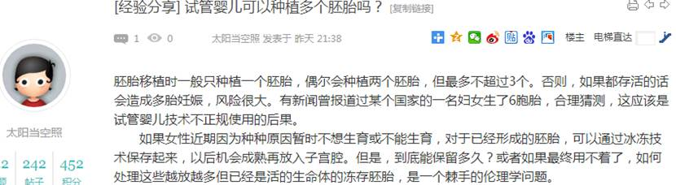  
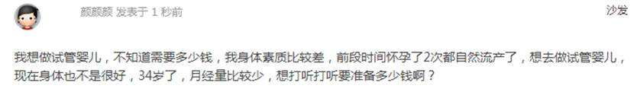

1066        <http://www.usivf.org/thread-3346-1-1.html>

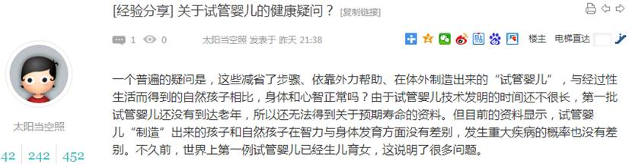  
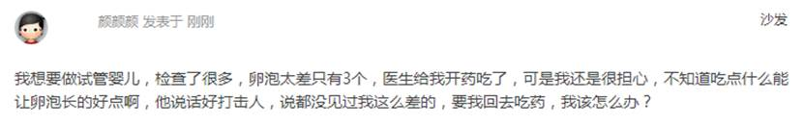

1068        <http://www.usivf.org/thread-3345-1-1.html>

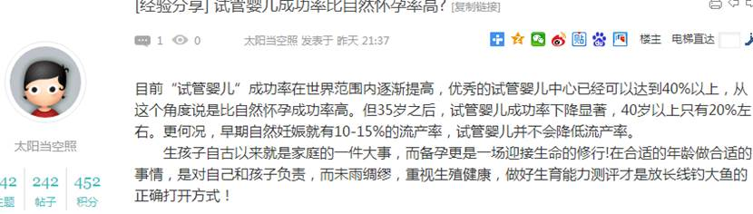  
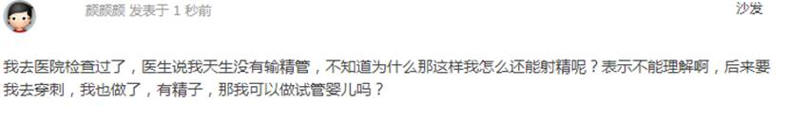

1070        <http://www.usivf.org/thread-3344-1-1.html>

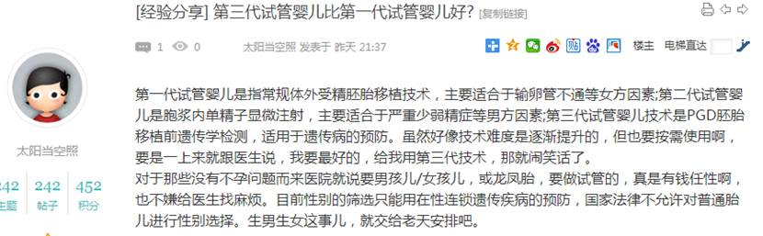  
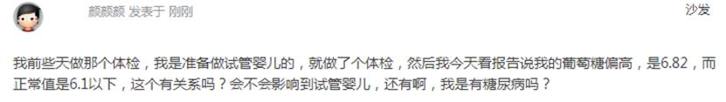

1072        <http://www.usivf.org/thread-3343-1-1.html>

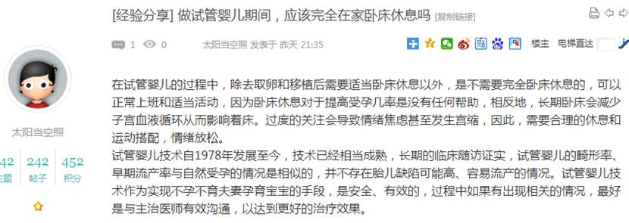  
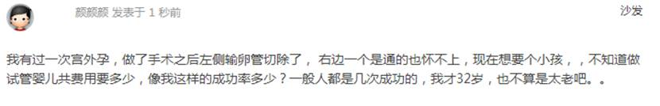

1074        <http://www.usivf.org/thread-3342-1-1.html>

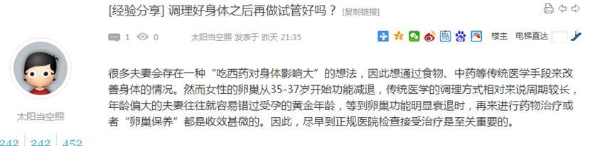  
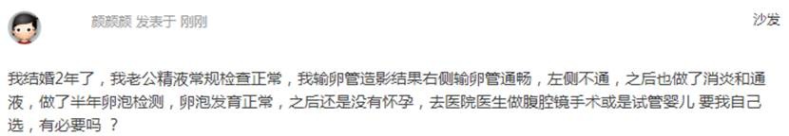

1076        <http://www.usivf.org/thread-3341-1-1.html>

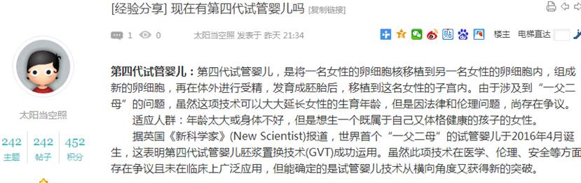  
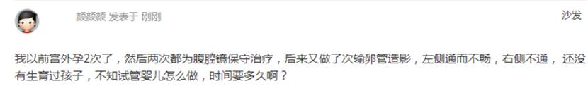

1078        <http://www.usivf.org/thread-3340-1-1.html>

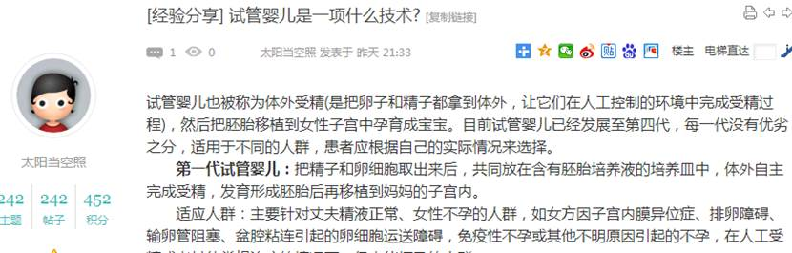  
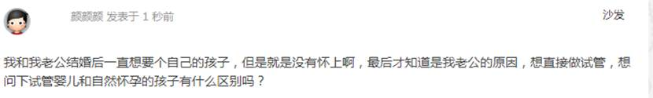

1080        <http://www.usivf.org/thread-3339-1-1.html>

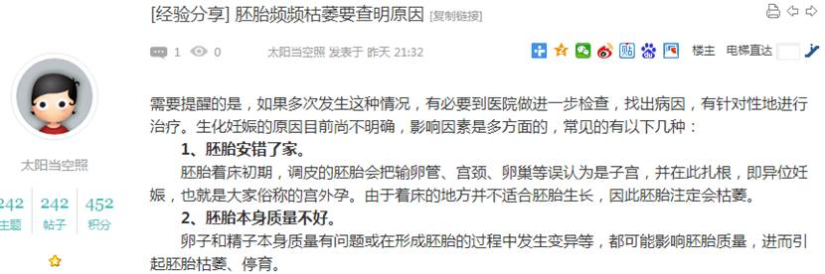  
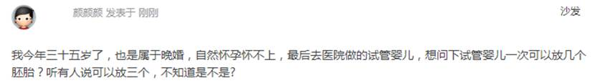

1082        <http://www.usivf.org/thread-3338-1-1.html>

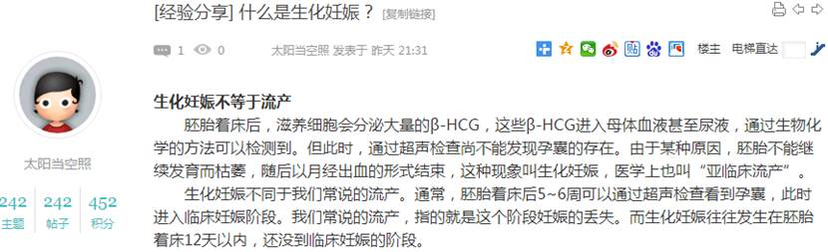  
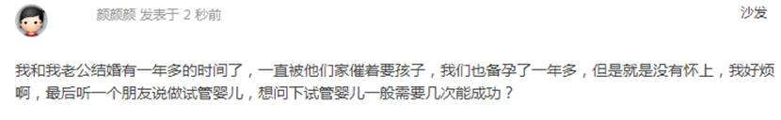

1084        <http://www.usivf.org/thread-3337-1-1.html>

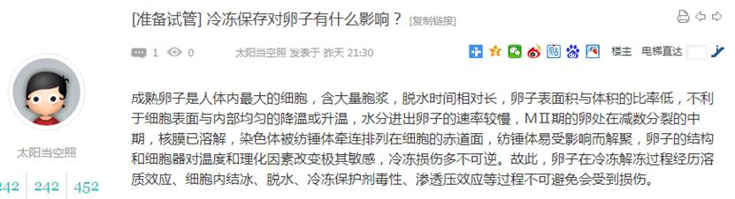  
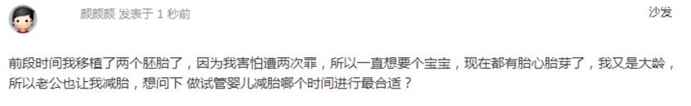

1086        <http://www.usivf.org/thread-3336-1-1.html>

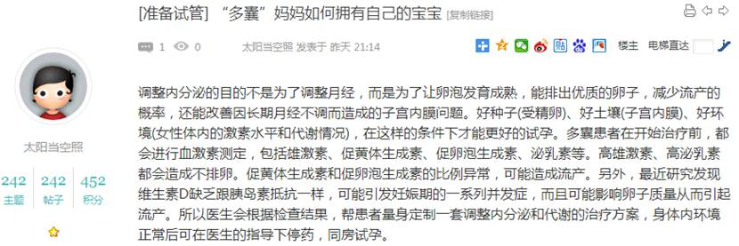  
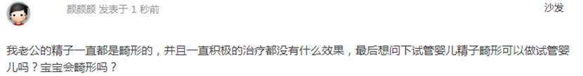

1088        <http://www.usivf.org/thread-3335-1-1.html>

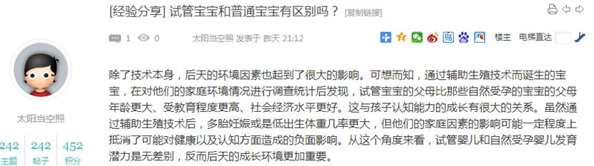  
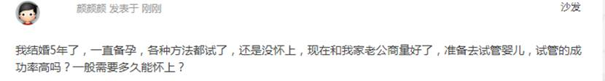

1090        <http://www.usivf.org/thread-3334-1-1.html>

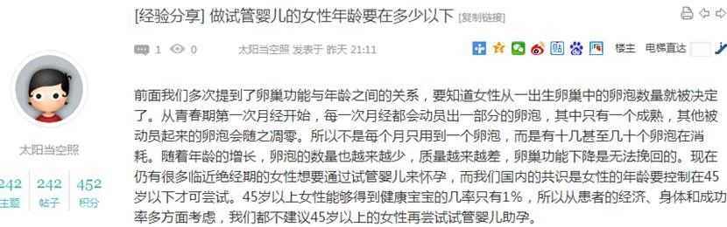  
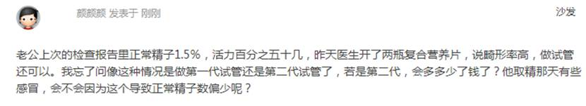

1092        <http://www.usivf.org/thread-3333-1-1.html>

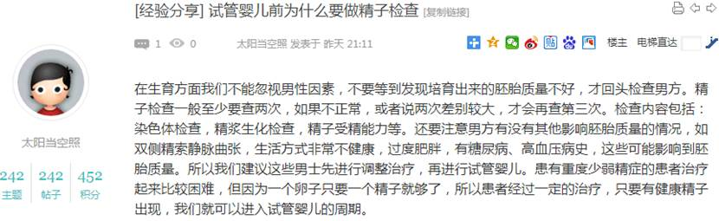  
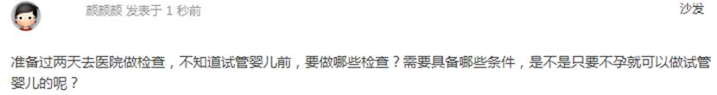

1094        <http://www.usivf.org/thread-3332-1-1.html>

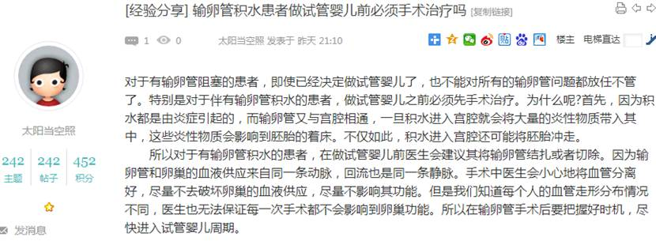  
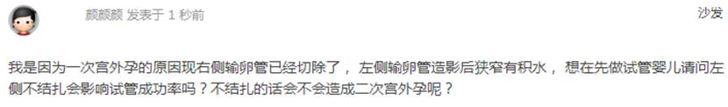

1096        <http://www.usivf.org/thread-3331-1-1.html>

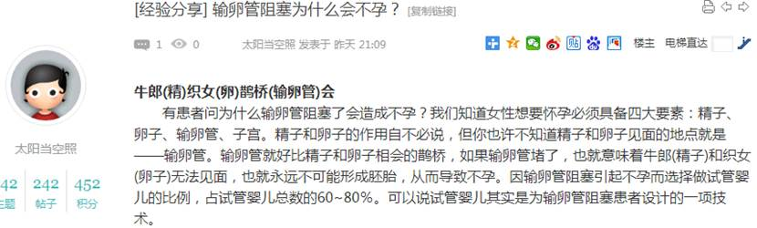  
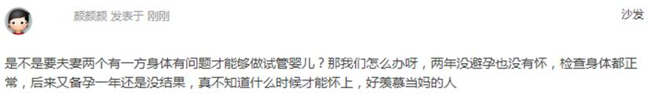

1098        <http://www.usivf.org/thread-3330-1-1.html>

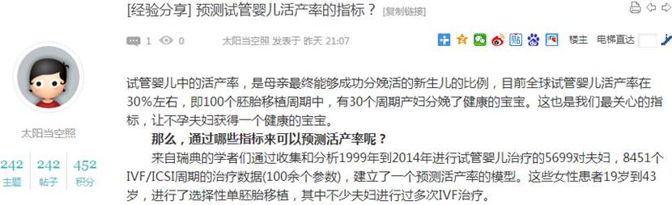  
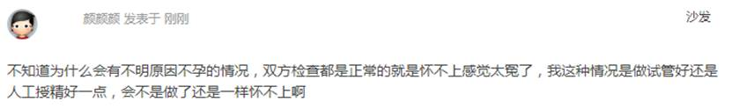

1100        <http://www.usivf.org/thread-3329-1-1.html>

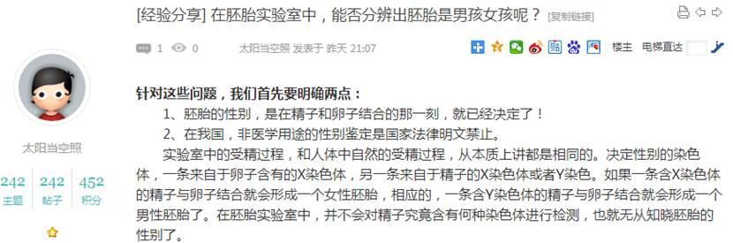  
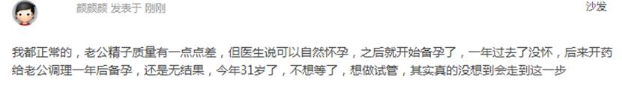

1102        <http://www.usivf.org/thread-3328-1-1.html>

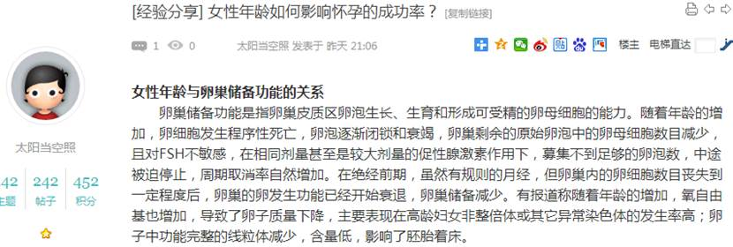  
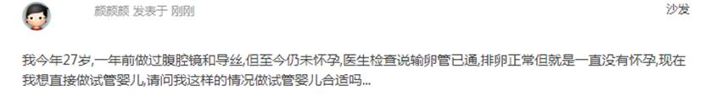

1104        <http://www.usivf.org/thread-3327-1-1.html>

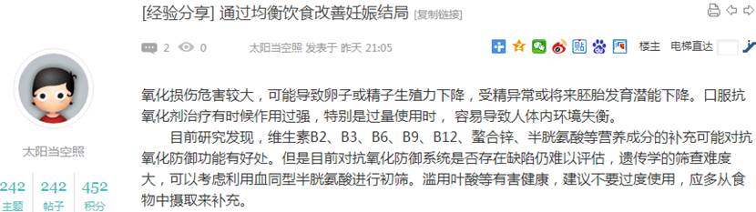  


1106        <http://www.usivf.org/thread-3326-1-1.html>

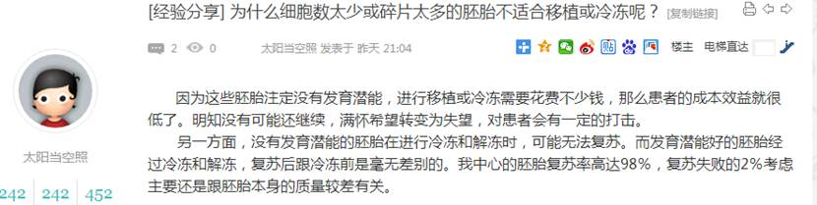  
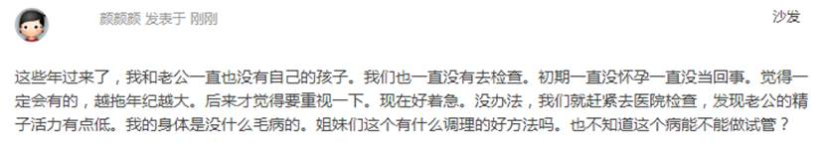

1108        <http://www.usivf.org/thread-3325-1-1.html>

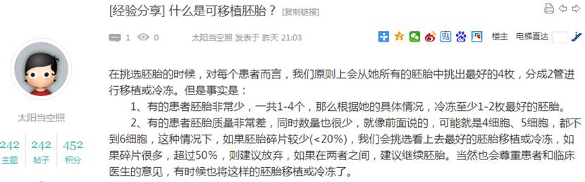  
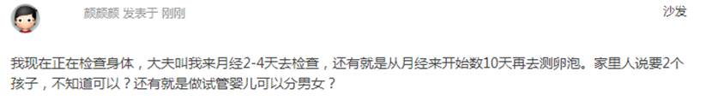

1110        <http://www.usivf.org/thread-3324-1-1.html>

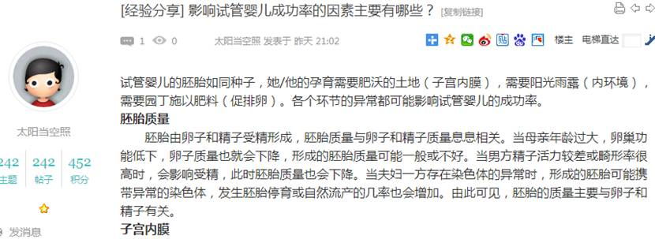  
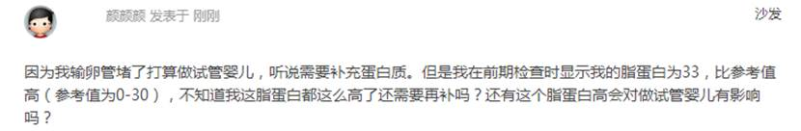

1112        <http://www.usivf.org/thread-3323-1-1.html>

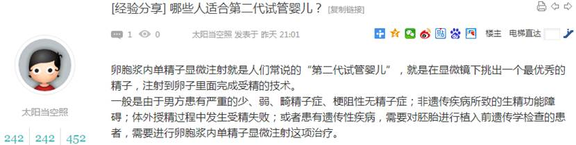  
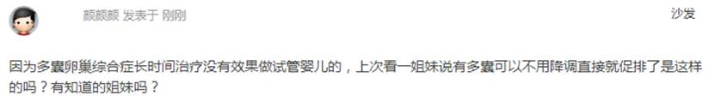

1114        <http://www.usivf.org/thread-3322-1-1.html>

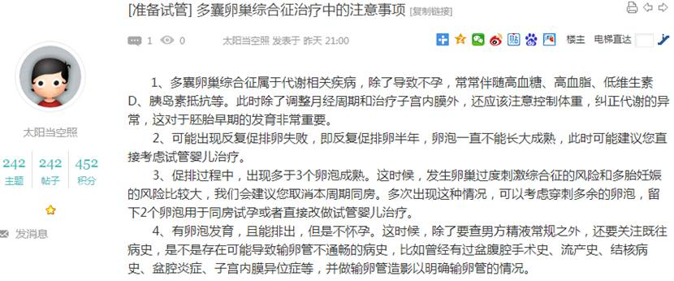  
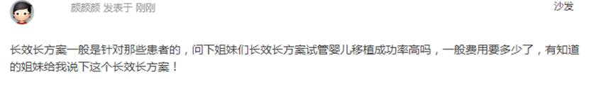

1116        <http://www.usivf.org/thread-3321-1-1.html>

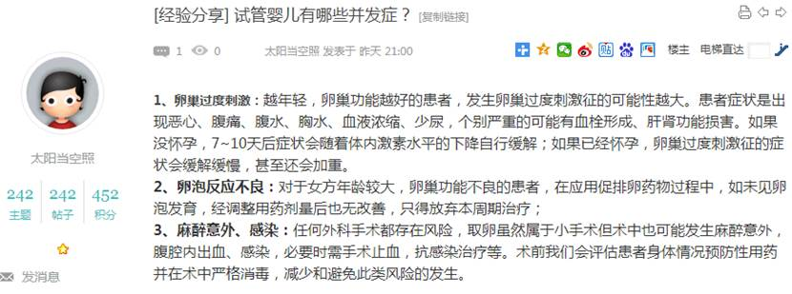  
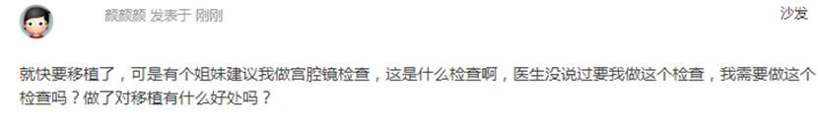

1118        <http://www.usivf.org/thread-3320-1-1.html>

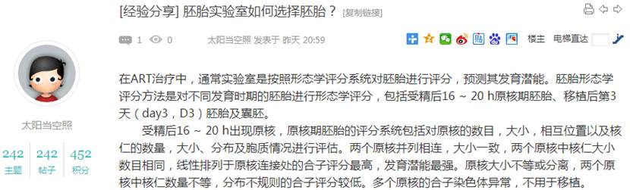  
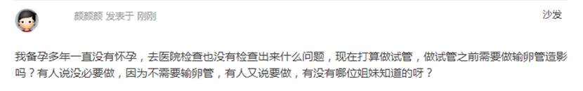

1120        <http://www.usivf.org/thread-3319-1-1.html>

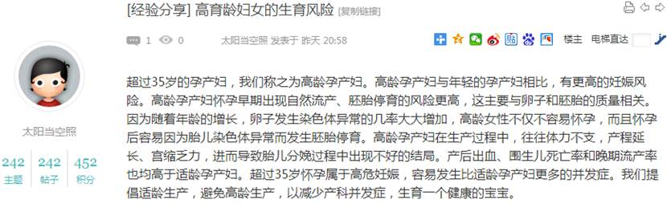  
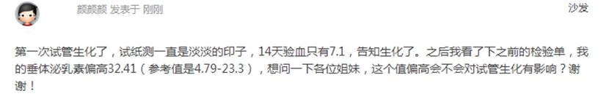

1122        <http://www.usivf.org/thread-3318-1-1.html>

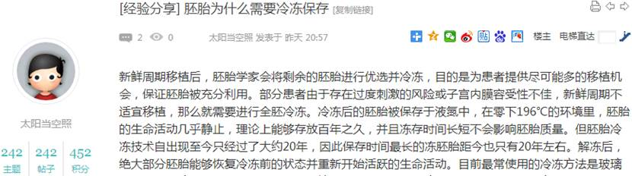  
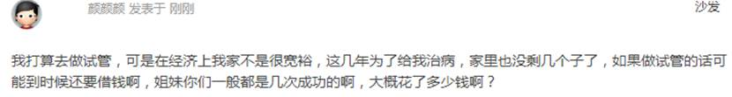

1124        <http://www.usivf.org/thread-3317-1-1.html>

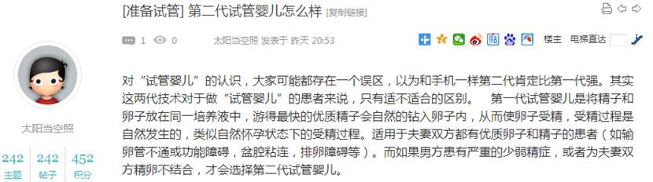  
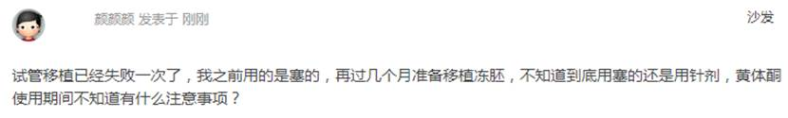

1126        <http://www.usivf.org/thread-3316-1-1.html>

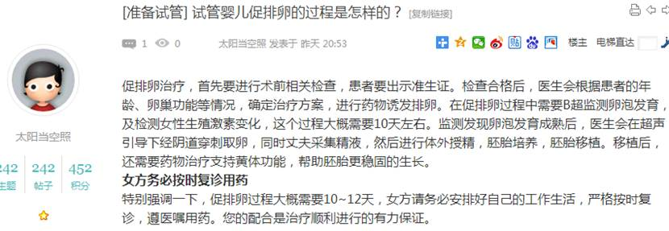  
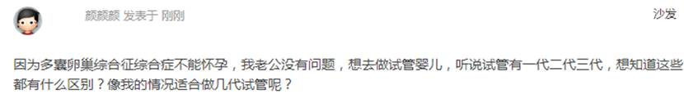

1128        <http://www.usivf.org/thread-3395-1-1.html>

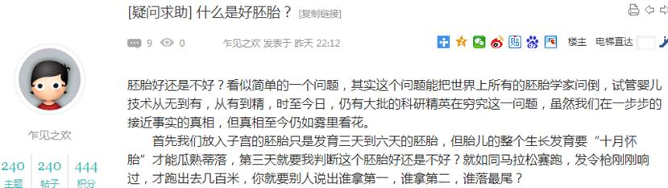  


1130        <http://www.usivf.org/thread-3394-1-1.html>

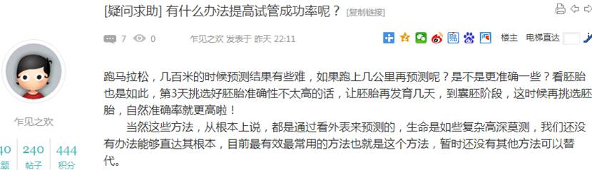  
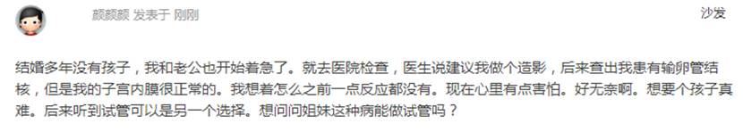

1132        <http://www.usivf.org/thread-3393-1-1.html>

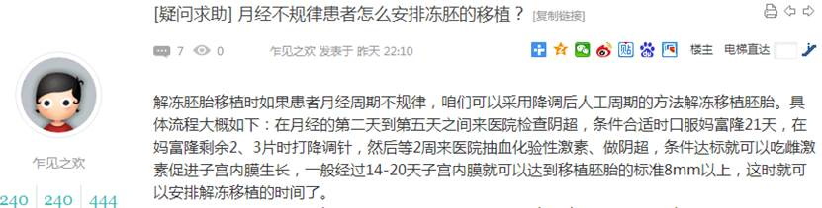  
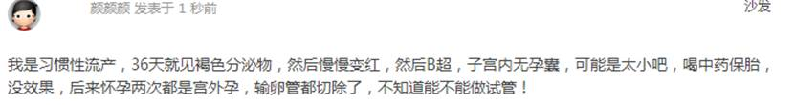

1134        <http://www.usivf.org/thread-3392-1-1.html>

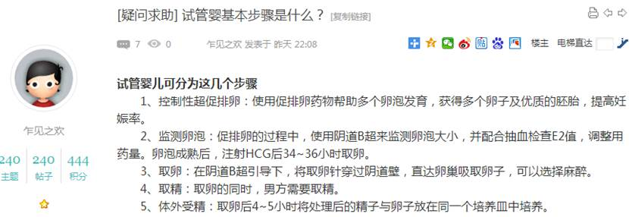  
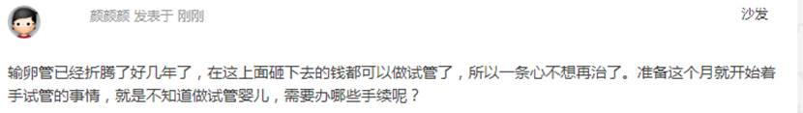

1136        <http://www.usivf.org/thread-3391-1-1.html>

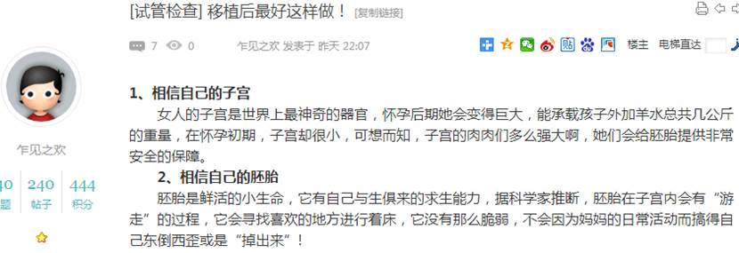  
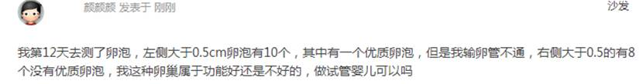

1138        <http://www.usivf.org/thread-3390-1-1.html>

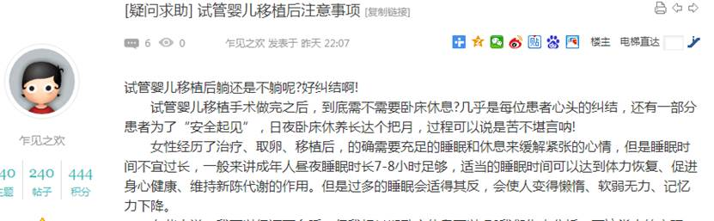  
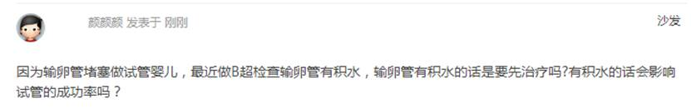

1140        <http://www.usivf.org/thread-3389-1-1.html>

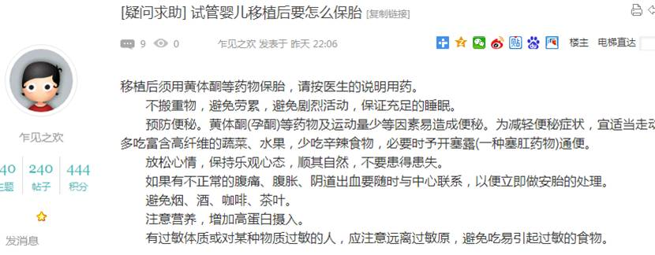  
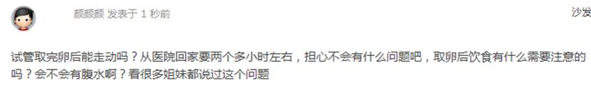

1142        <http://www.usivf.org/thread-3388-1-1.html>

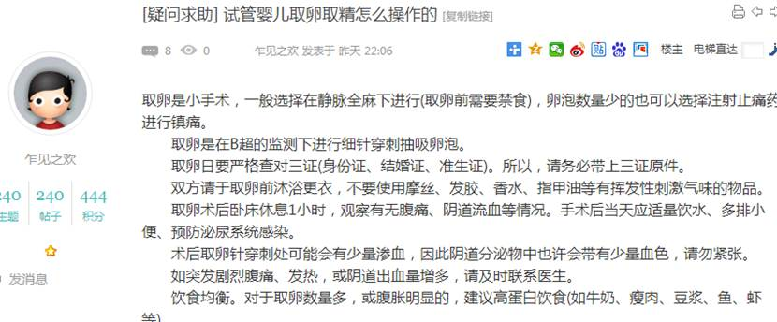  


1144        <http://www.usivf.org/thread-3387-1-1.html>

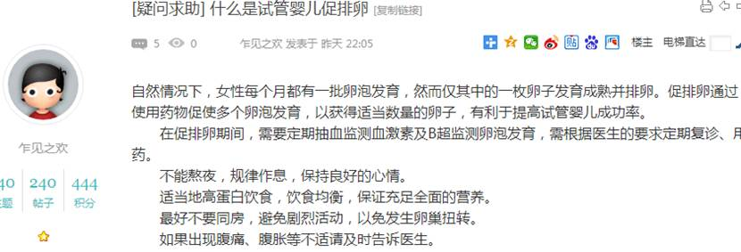  


1146        <http://www.usivf.org/thread-3386-1-1.html>

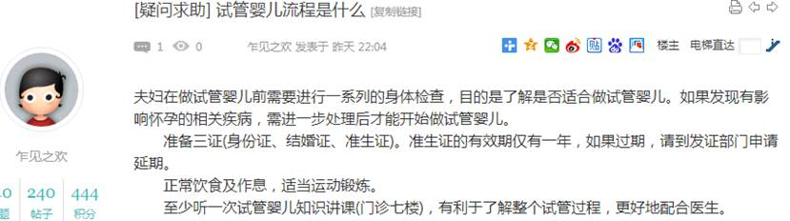  
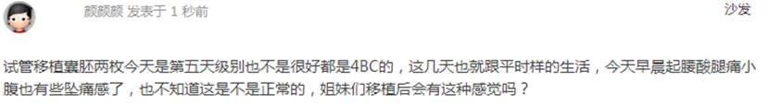

1148        <http://www.usivf.org/thread-3385-1-1.html>

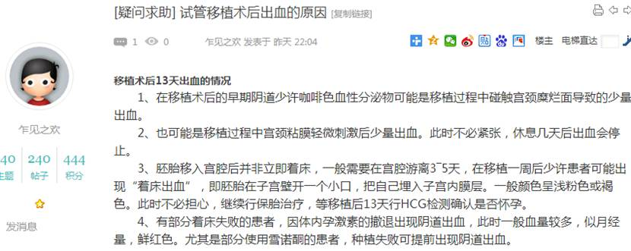  
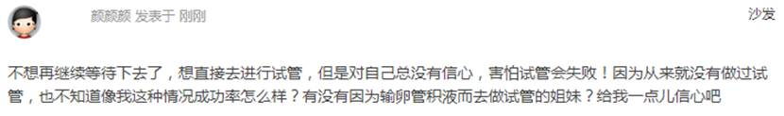

1150        <http://www.usivf.org/thread-3384-1-1.html>

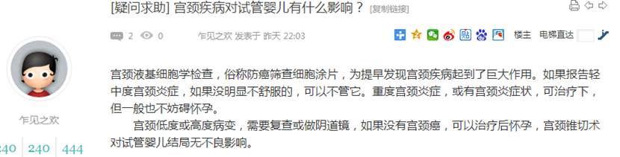  


1152        <http://www.usivf.org/thread-3383-1-1.html>

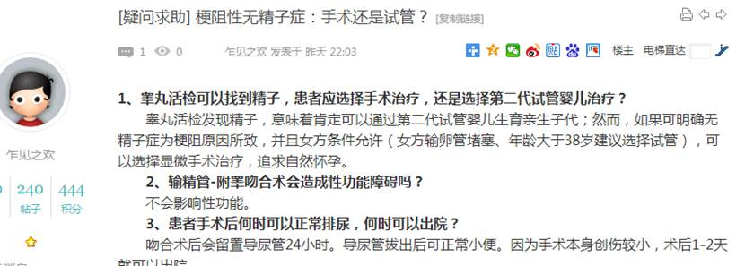  
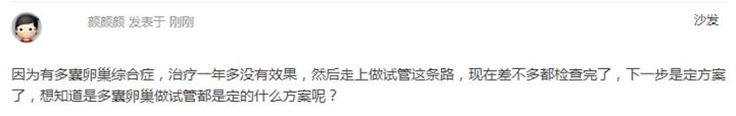

1154        <http://www.usivf.org/thread-3382-1-1.html>

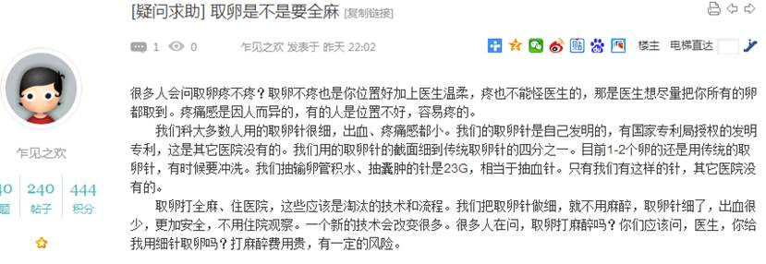  
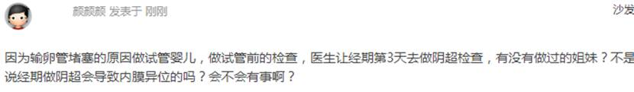

1156        <http://www.usivf.org/thread-3381-1-1.html>

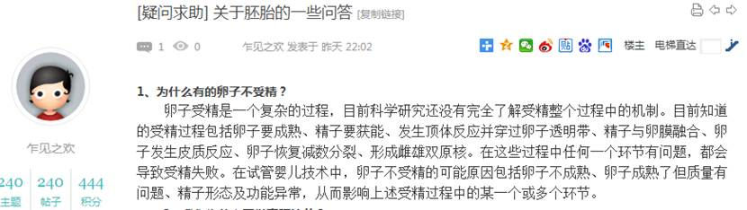  
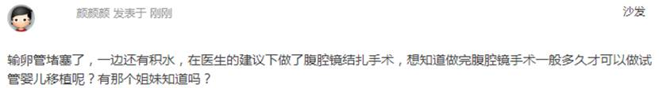

1158        <http://www.usivf.org/thread-3380-1-1.html>

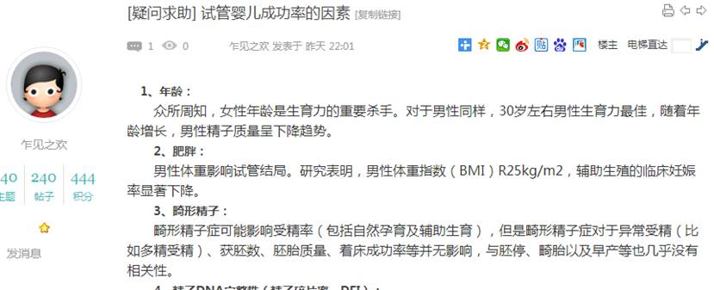  
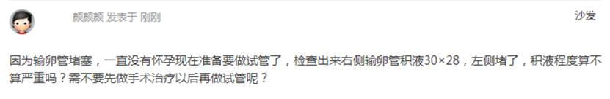

1160        <http://www.usivf.org/thread-3379-1-1.html>

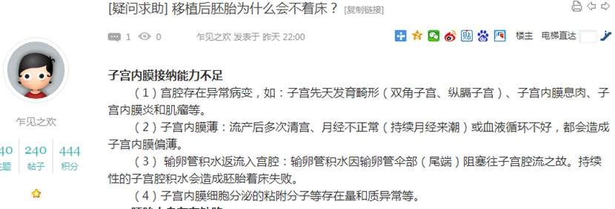  
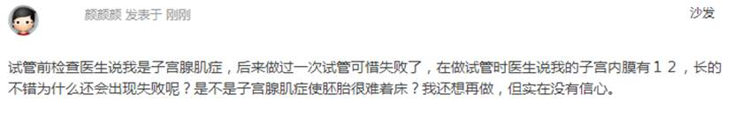

1162        <http://www.usivf.org/thread-3378-1-1.html>

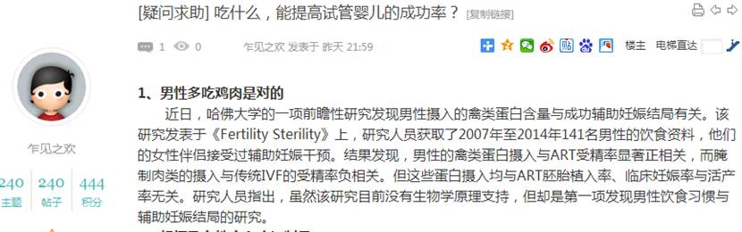  
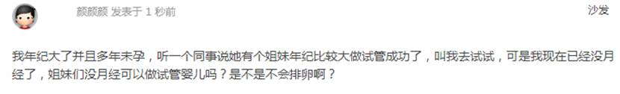

1164        <http://www.usivf.org/thread-3377-1-1.html>

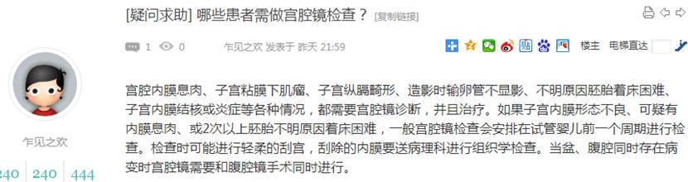  
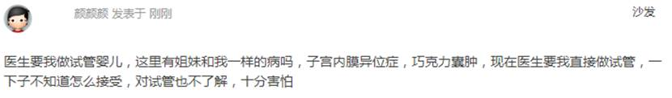

1166        <http://www.usivf.org/thread-3376-1-1.html>

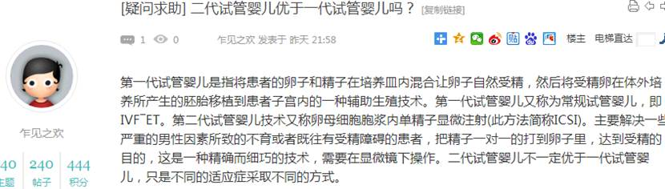  
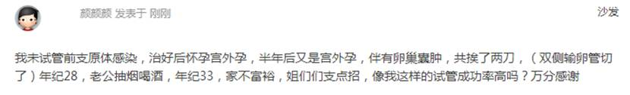

1168        <http://www.usivf.org/thread-3375-1-1.html>

  
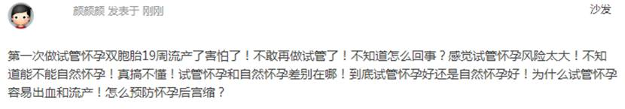

1170        <http://www.usivf.org/thread-3374-1-1.html>

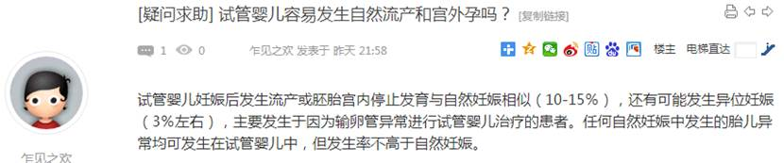  
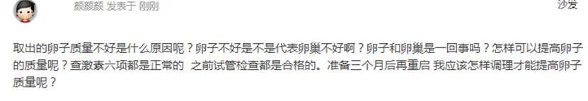

1172        <http://www.usivf.org/thread-3373-1-1.html>

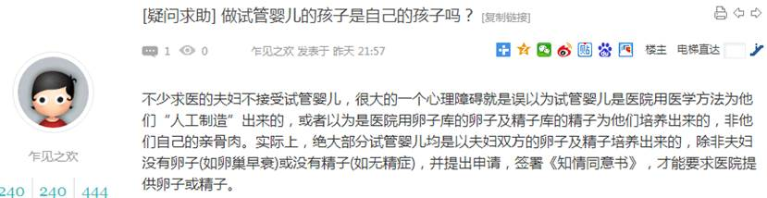  
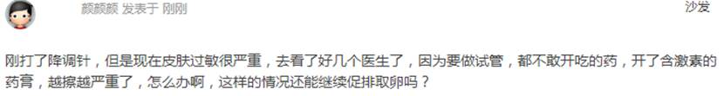

1174        <http://www.usivf.org/thread-3372-1-1.html>

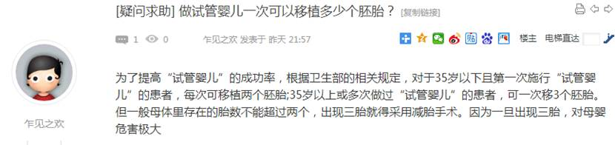  
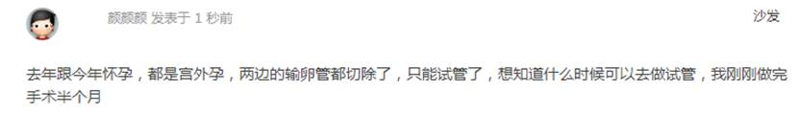

1176        <http://www.usivf.org/thread-3371-1-1.html>

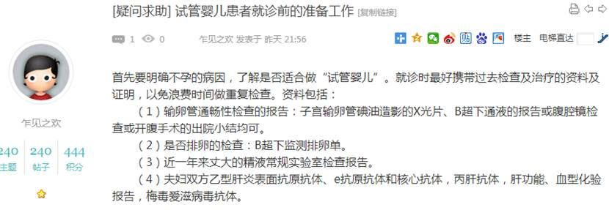  
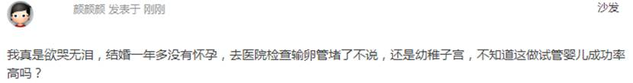

1178        <http://www.usivf.org/thread-3370-1-1.html>

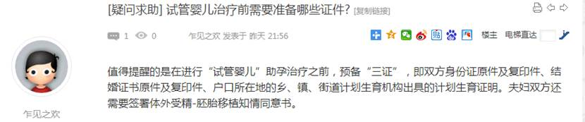  
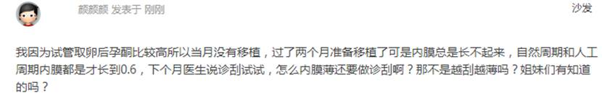

1180        <http://www.usivf.org/thread-3369-1-1.html>

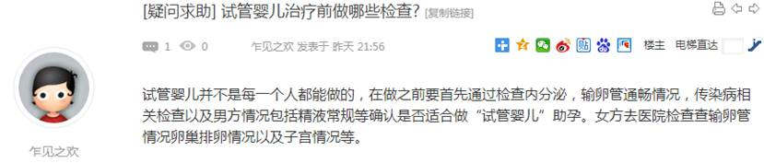  
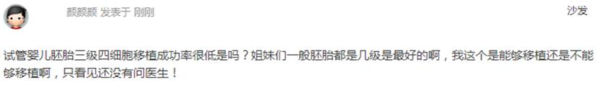

1182        <http://www.usivf.org/thread-3368-1-1.html>

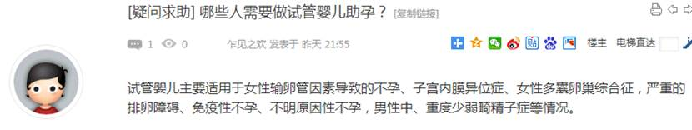  
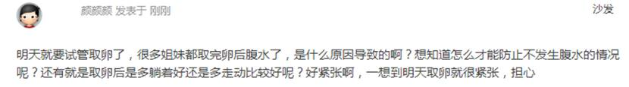

1184        <http://www.usivf.org/thread-3367-1-1.html>

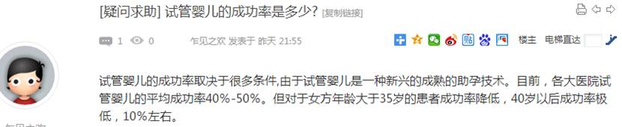  
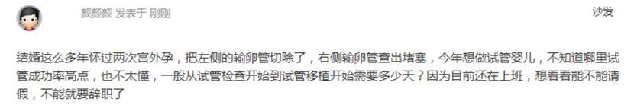

1186        <http://www.usivf.org/thread-3366-1-1.html>

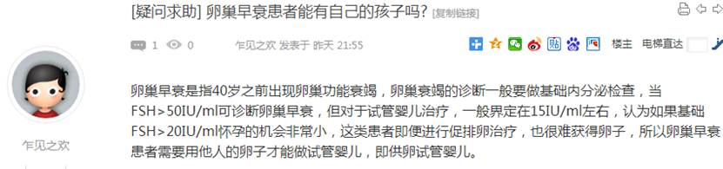  
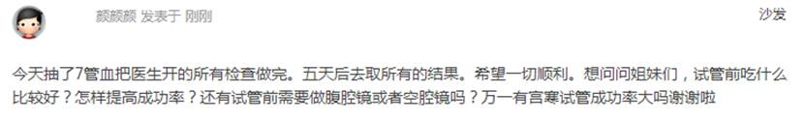

1188        <http://www.usivf.org/thread-3365-1-1.html>

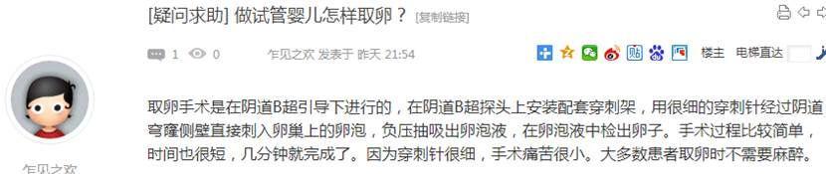  
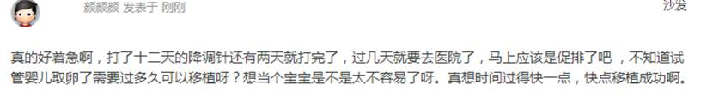

1190        <http://www.usivf.org/thread-3364-1-1.html>

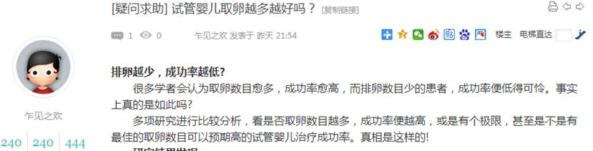  
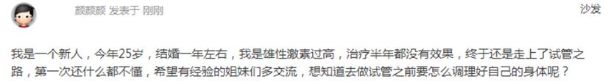

1192        <http://www.usivf.org/thread-3363-1-1.html>

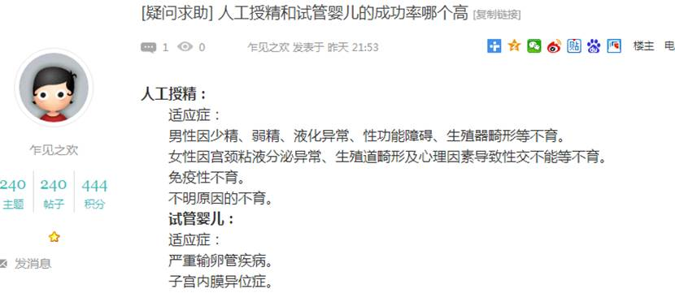  
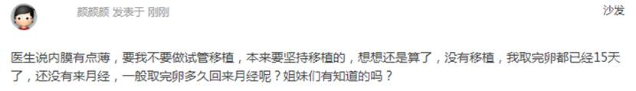

1194        <http://www.usivf.org/thread-3362-1-1.html>

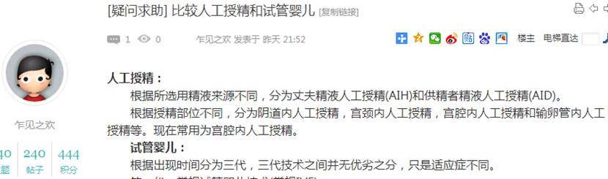  
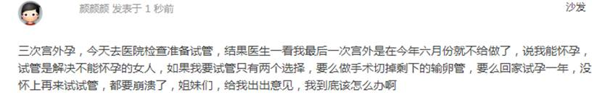

1196        <http://www.usivf.org/thread-3361-1-1.html>

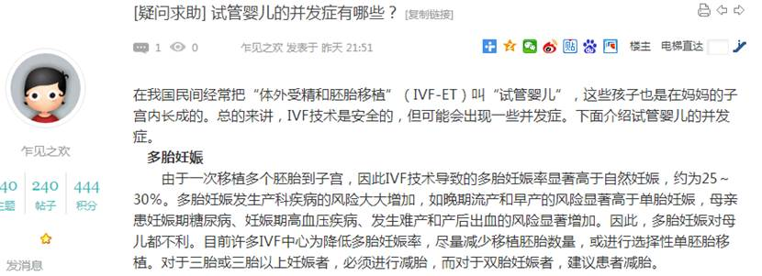  
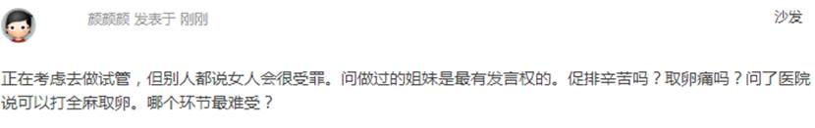

1198        <http://www.usivf.org/thread-3360-1-1.html>

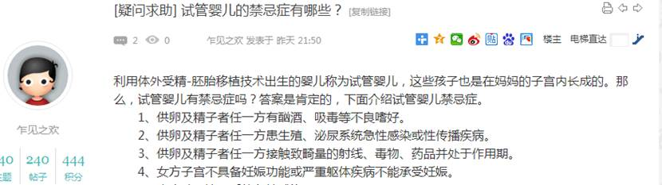  
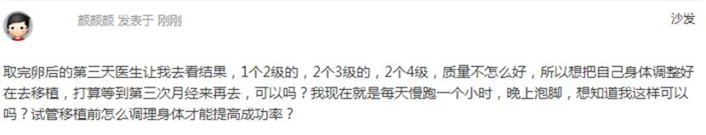

1200        <http://www.usivf.org/thread-3359-1-1.html>

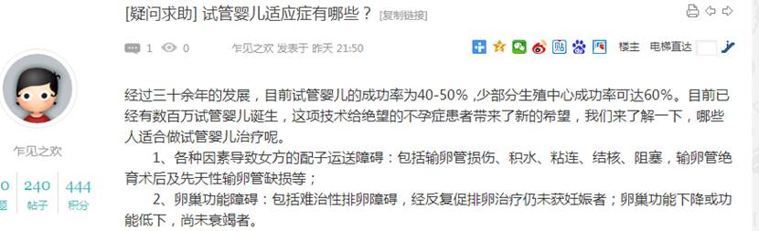  
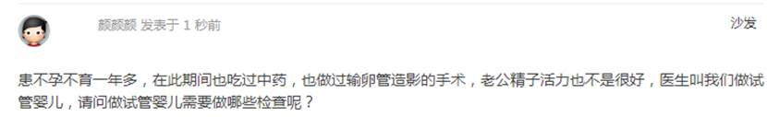

1202        <http://www.usivf.org/thread-3358-1-1.html>

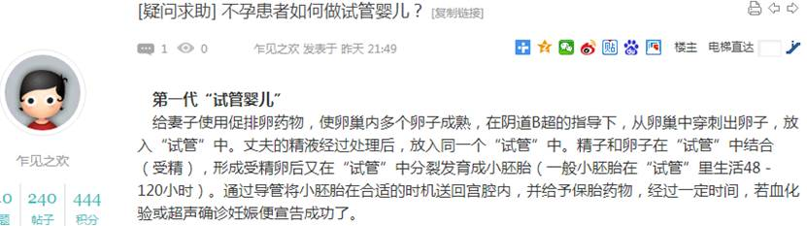  
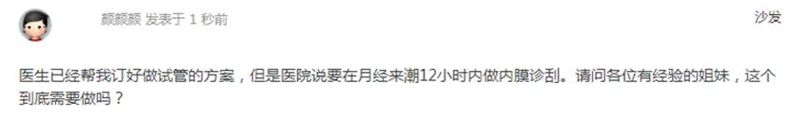

1204        <http://www.usivf.org/thread-3357-1-1.html>

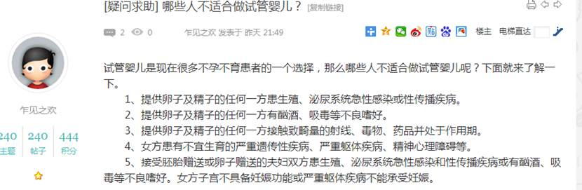  
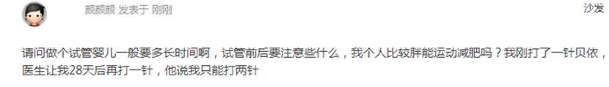

1206        <http://www.usivf.org/thread-3356-1-1.html>

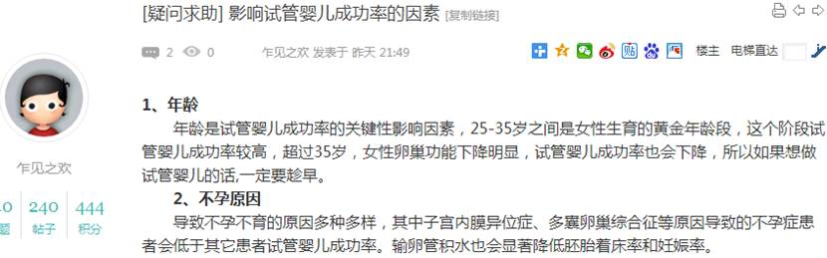  
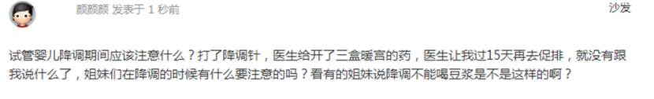

1208        <http://www.buyunbuyu8.com/forum.php?mod=viewthread&tid=658>

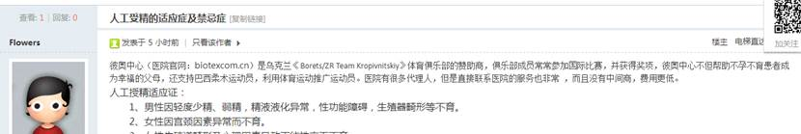  


1210        <http://www.buyunbuyu8.com/forum.php?mod=viewthread&tid=657>

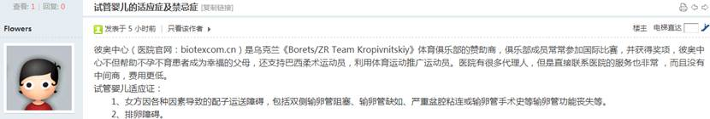  


1212        <http://www.buyunbuyu8.com/forum.php?mod=viewthread&tid=656>

  


1214        <http://www.buyunbuyu8.com/forum.php?mod=viewthread&tid=655>

  


1216        <http://www.buyunbuyu8.com/forum.php?mod=viewthread&tid=654>

  


1218        <http://www.buyunbuyu8.com/forum.php?mod=viewthread&tid=653>

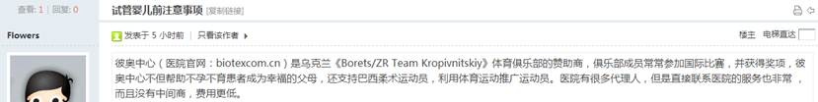  


1220        <http://www.buyunbuyu8.com/forum.php?mod=viewthread&tid=652>

  


1222        <http://www.buyunbuyu8.com/forum.php?mod=viewthread&tid=651>

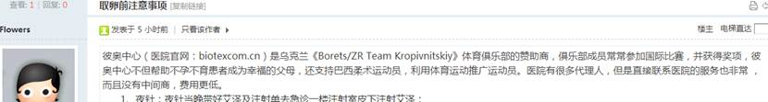  


1224        <http://www.buyunbuyu8.com/forum.php?mod=viewthread&tid=650>

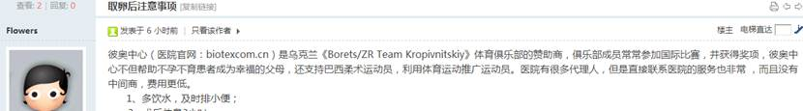  


1226        <http://www.buyunbuyu8.com/forum.php?mod=viewthread&tid=649>

  


1228        <http://www.buyunbuyu8.com/forum.php?mod=viewthread&tid=648>

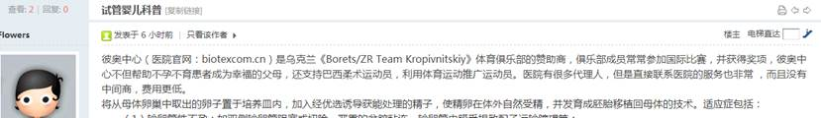  


1230        <http://www.buyunbuyu8.com/forum.php?mod=viewthread&tid=647>

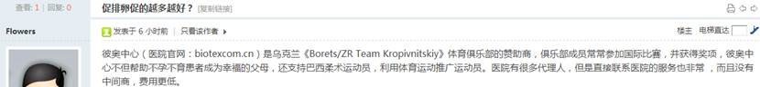  


1232        <http://www.buyunbuyu8.com/forum.php?mod=viewthread&tid=646>

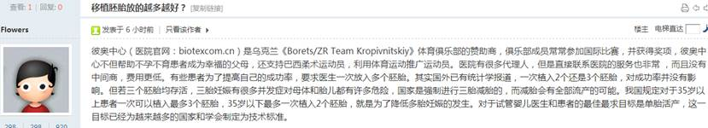  


1234        <http://www.buyunbuyu8.com/forum.php?mod=viewthread&tid=645>

  


1236        <http://www.buyunbuyu8.com/forum.php?mod=viewthread&tid=644>

  


1238        <http://www.buyunbuyu8.com/forum.php?mod=viewthread&tid=643>

  


1240        <http://www.buyunbuyu8.com/forum.php?mod=viewthread&tid=642>

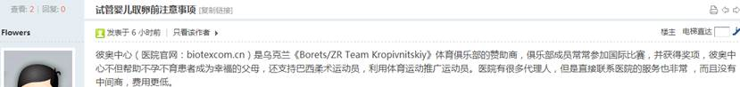  


1242        <http://www.buyunbuyu8.com/forum.php?mod=viewthread&tid=641>

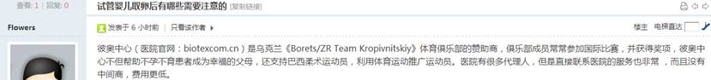  


1244        <http://www.buyunbuyu8.com/forum.php?mod=viewthread&tid=640>

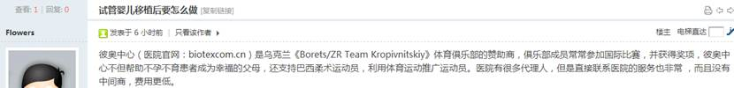  


1246        <http://www.buyunbuyu8.com/forum.php?mod=viewthread&tid=639>

  


1248        <http://www.buyunbuyu8.com/forum.php?mod=viewthread&tid=638>

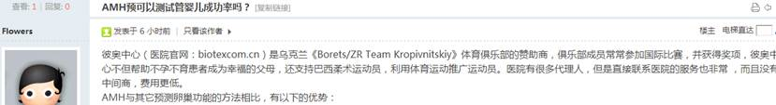  


1250        <http://www.buyunbuyu8.com/forum.php?mod=viewthread&tid=637>

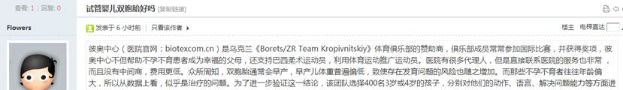  


1252        <http://www.buyunbuyu8.com/forum.php?mod=viewthread&tid=636>

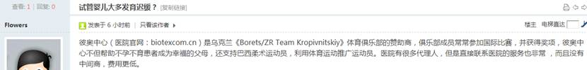  


1254        <http://www.buyunbuyu8.com/forum.php?mod=viewthread&tid=635>

  


1256        <http://www.buyunbuyu8.com/forum.php?mod=viewthread&tid=634>

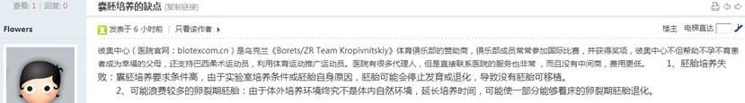  


1258        <http://www.buyunbuyu8.com/forum.php?mod=viewthread&tid=633>

  


1260        <http://www.buyunbuyu8.com/forum.php?mod=viewthread&tid=632>

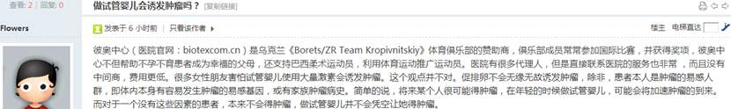  


1262        <http://www.buyunbuyu8.com/forum.php?mod=viewthread&tid=631>

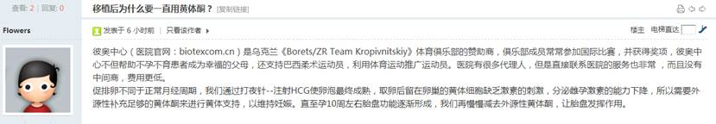  


1264        <http://www.buyunbuyu8.com/forum.php?mod=viewthread&tid=630>

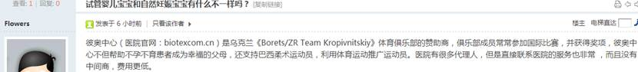  


1266        <http://www.buyunbuyu8.com/forum.php?mod=viewthread&tid=629>

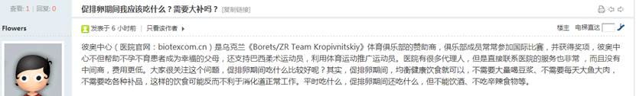  


1268        <http://www.buyunbuyu8.com/forum.php?mod=viewthread&tid=628>

  


1270        <http://www.buyunbuyu8.com/forum.php?mod=viewthread&tid=627>

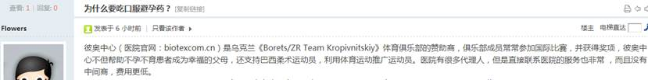  


1272        <http://www.buyunbuyu8.com/forum.php?mod=viewthread&tid=626>

  


1274        <http://www.buyunbuyu8.com/forum.php?mod=viewthread&tid=625>

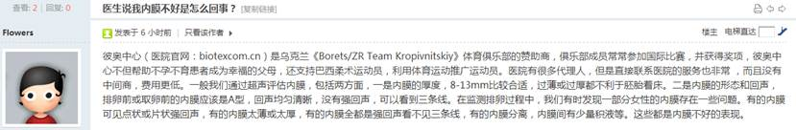  


1276        <http://www.buyunbuyu8.com/forum.php?mod=viewthread&tid=624>

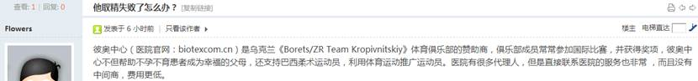  


1278        <http://www.buyunbuyu8.com/forum.php?mod=viewthread&tid=623>

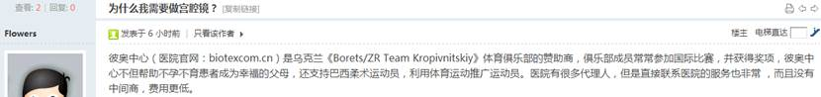  


1280        <http://www.buyunbuyu8.com/forum.php?mod=viewthread&tid=622>

  


1282        <http://www.buyunbuyu8.com/forum.php?mod=viewthread&tid=621>

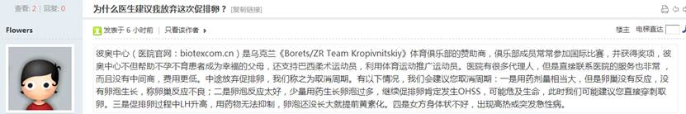  


1284        <http://www.buyunbuyu8.com/forum.php?mod=viewthread&tid=620>

  


1286        <http://www.buyunbuyu8.com/forum.php?mod=viewthread&tid=619>

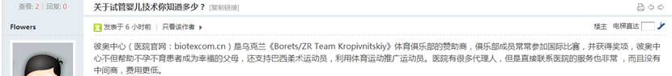  


1288        <http://www.buyunbuyu8.com/forum.php?mod=viewthread&tid=618>

  


1290        <http://www.buyunbuyu8.com/forum.php?mod=viewthread&tid=617>

  


1292        <http://www.buyunbuyu8.com/forum.php?mod=viewthread&tid=616>

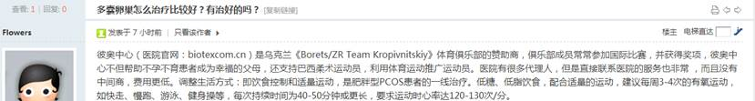  


1294        <http://www.buyunbuyu8.com/forum.php?mod=viewthread&tid=615>

  


1296        <http://www.buyunbuyu8.com/forum.php?mod=viewthread&tid=614>

  


1298        <http://www.buyunbuyu8.com/forum.php?mod=viewthread&tid=613>

  


1300        <http://www.buyunbuyu8.com/forum.php?mod=viewthread&tid=612>

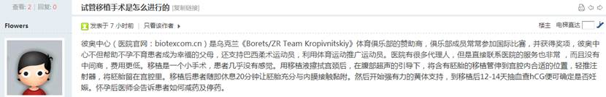  


1302        <http://www.buyunbuyu8.com/forum.php?mod=viewthread&tid=611>

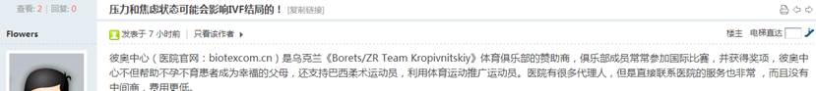  


1304        <http://www.buyunbuyu8.com/forum.php?mod=viewthread&tid=609>

  


1306        <http://www.buyunbuyu8.com/forum.php?mod=viewthread&tid=608>

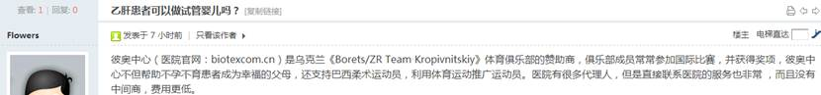  


1308        <http://www.buyunbuyu8.com/forum.php?mod=viewthread&tid=607>

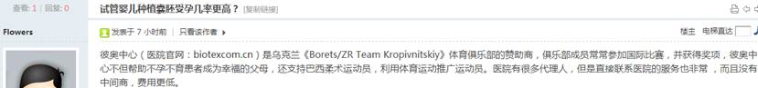  


1310        <http://www.buyunbuyu8.com/forum.php?mod=viewthread&tid=606>

  


1312        <http://www.buyunbuyu8.com/forum.php?mod=viewthread&tid=605>

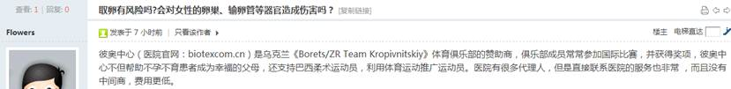  


1314        <http://www.buyunbuyu8.com/forum.php?mod=viewthread&tid=604>

  


1316        <http://www.buyunbuyu8.com/forum.php?mod=viewthread&tid=603>

  


1318        <http://www.buyunbuyu8.com/forum.php?mod=viewthread&tid=602>

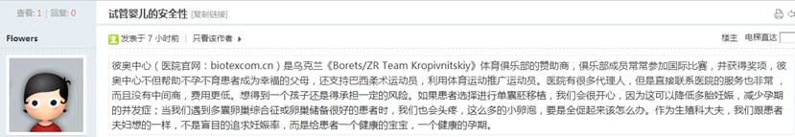  


1320        <http://www.buyunbuyu8.com/forum.php?mod=viewthread&tid=601>

  


1322        <http://www.buyunbuyu8.com/forum.php?mod=viewthread&tid=600>

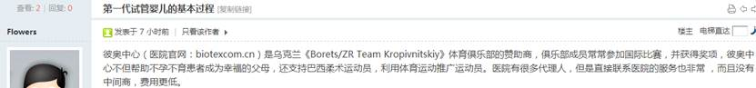  


1324        <http://www.buyunbuyu8.com/forum.php?mod=viewthread&tid=599>

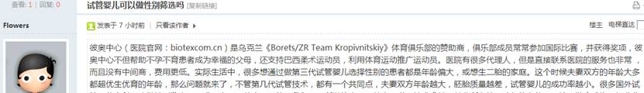  


1326        <http://www.buyunbuyu8.com/forum.php?mod=viewthread&tid=610>

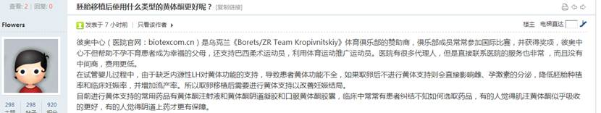  


1328        <http://www.buyunbuyu8.com/forum.php?mod=viewthread&tid=598>

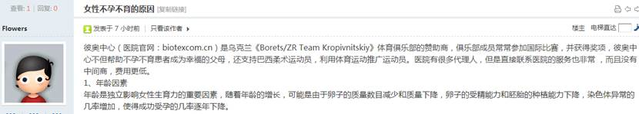  


1330        <http://www.buyunbuyu8.com/forum.php?mod=viewthread&tid=597>

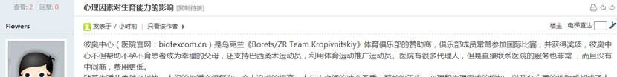  


1332        <http://www.buyunbuyu8.com/forum.php?mod=viewthread&tid=596>

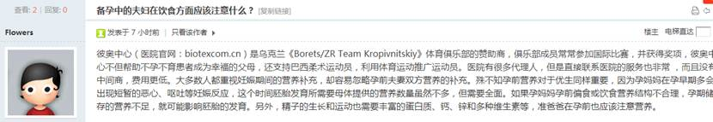  


1334        <http://www.buyunbuyu8.com/forum.php?mod=viewthread&tid=595>

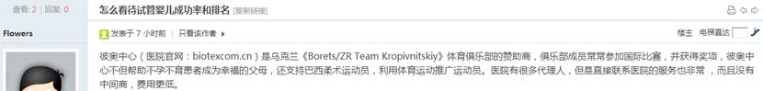  


1336        <http://www.buyunbuyu8.com/forum.php?mod=viewthread&tid=594>

  


1338        <http://www.buyunbuyu8.com/forum.php?mod=viewthread&tid=593>

  


1340        <http://www.buyunbuyu8.com/forum.php?mod=viewthread&tid=592>

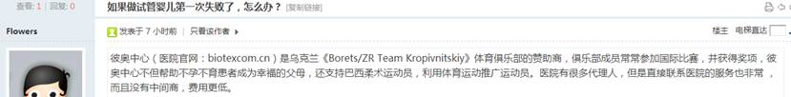  


1342        <http://www.buyunbuyu8.com/forum.php?mod=viewthread&tid=591>

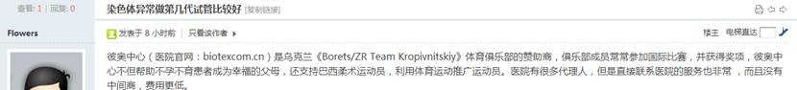  


1344        <http://www.buyunbuyu8.com/forum.php?mod=viewthread&tid=590>

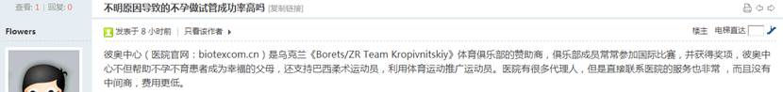  


1346        <http://www.buyunbuyu8.com/forum.php?mod=viewthread&tid=589>

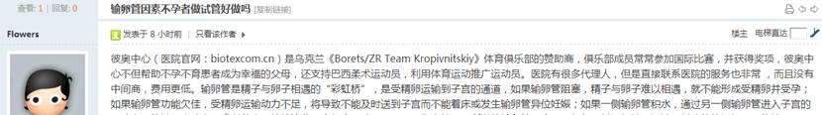  


1348        <http://www.buyunbuyu8.com/forum.php?mod=viewthread&tid=588>

  


1350        <http://www.buyunbuyu8.com/forum.php?mod=viewthread&tid=587>

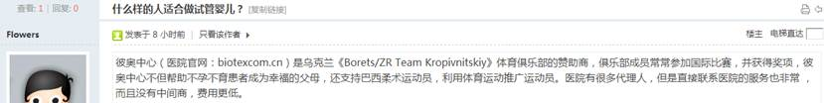  


1352        <http://www.buyunbuyu8.com/forum.php?mod=viewthread&tid=586>

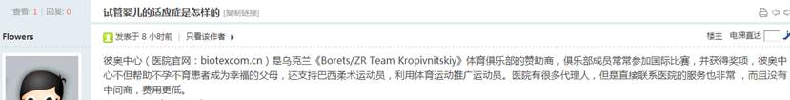  


1354        <http://www.buyunbuyu8.com/forum.php?mod=viewthread&tid=585>

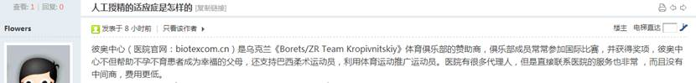  


1356        <http://www.buyunbuyu8.com/forum.php?mod=viewthread&tid=584>

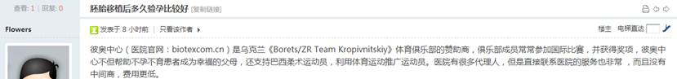  


1358        <http://www.buyunbuyu8.com/forum.php?mod=viewthread&tid=583>

  


1360        <http://www.buyunbuyu8.com/forum.php?mod=viewthread&tid=582>

  


1362        <http://www.buyunbuyu8.com/forum.php?mod=viewthread&tid=581>

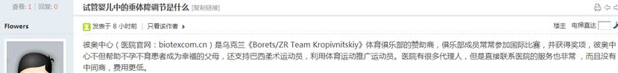  


1364        <http://www.buyunbuyu8.com/forum.php?mod=viewthread&tid=580>

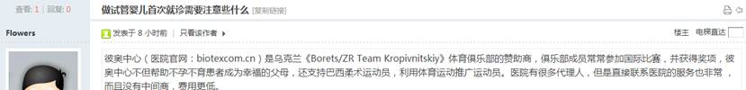  


1366        <http://www.buyunbuyu8.com/forum.php?mod=viewthread&tid=579>

  


1368        <http://www.usivf.org/thread-3507-1-1.html>

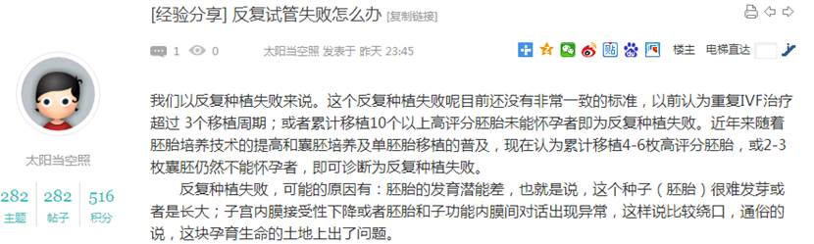  
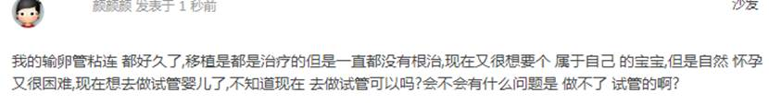

1370        <http://www.usivf.org/thread-3506-1-1.html>

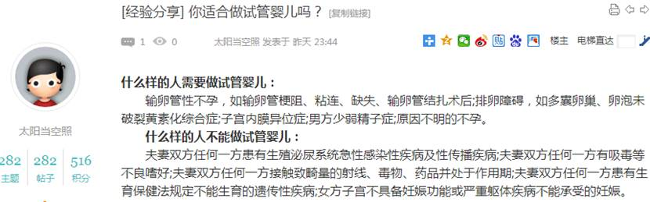  
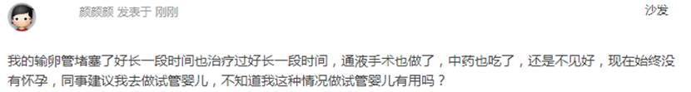

1372        <http://www.usivf.org/thread-3505-1-1.html>

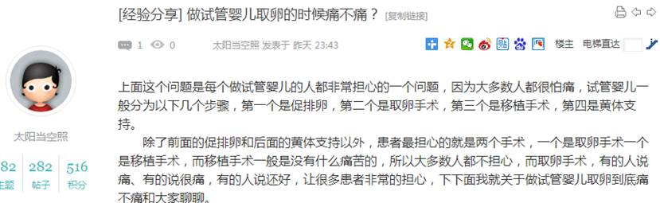  
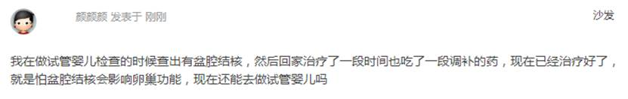

1374        <http://www.usivf.org/thread-3504-1-1.html>

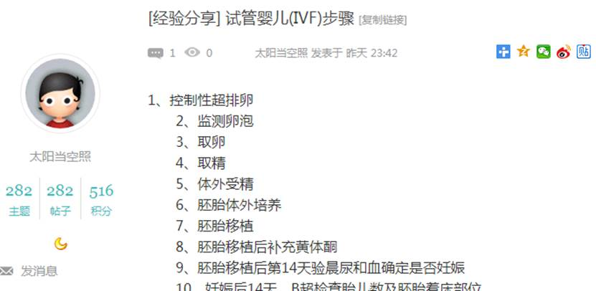  
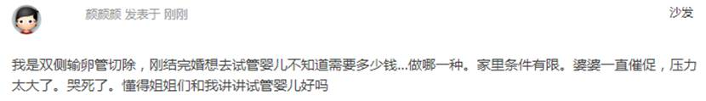

1376        <http://www.usivf.org/thread-3503-1-1.html>

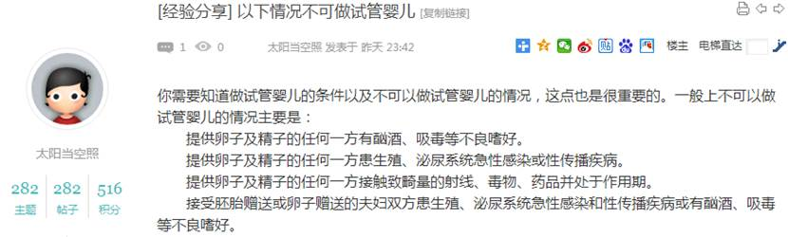  
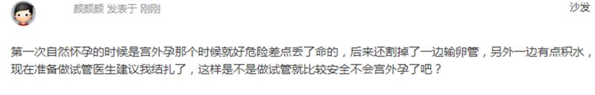

1378        <http://www.usivf.org/thread-3502-1-1.html>

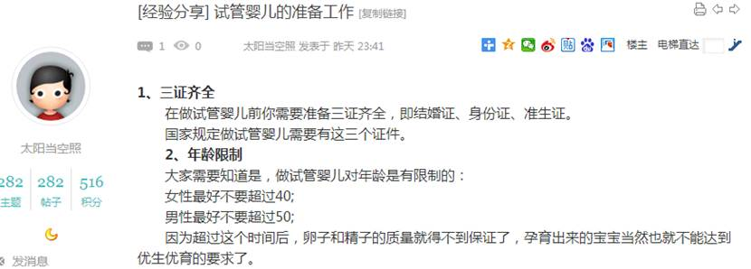  
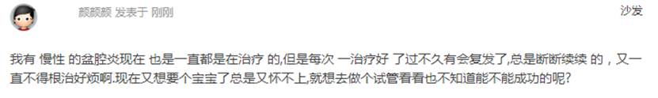

1380        <http://www.usivf.org/thread-3501-1-1.html>

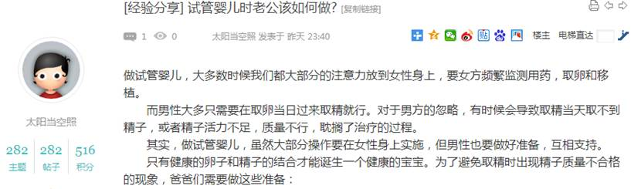  
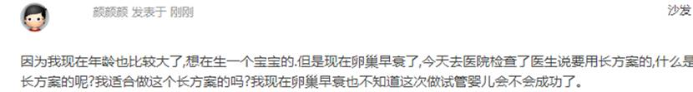

1382        <http://www.usivf.org/thread-3500-1-1.html>

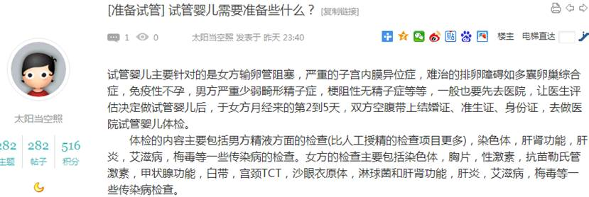  
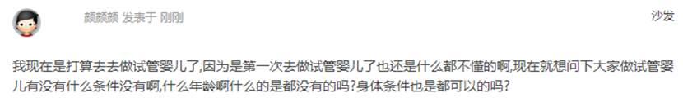

1384        <http://www.usivf.org/thread-3499-1-1.html>

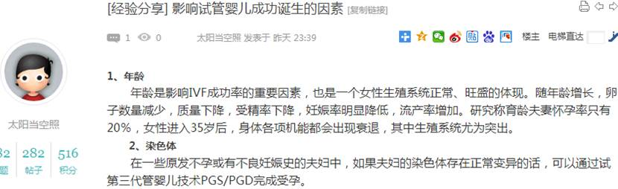  
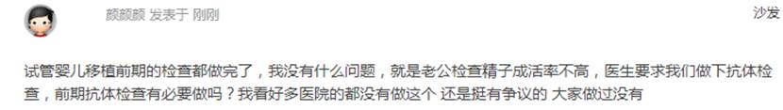

1386        <http://www.usivf.org/thread-3498-1-1.html>

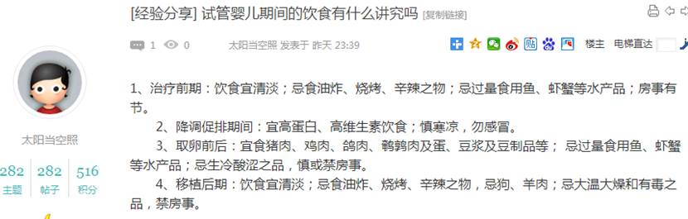  
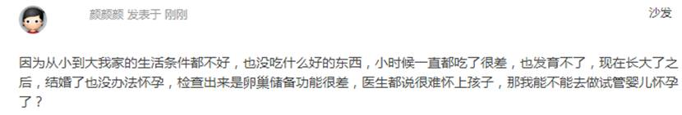

1388        <http://www.usivf.org/thread-3497-1-1.html>

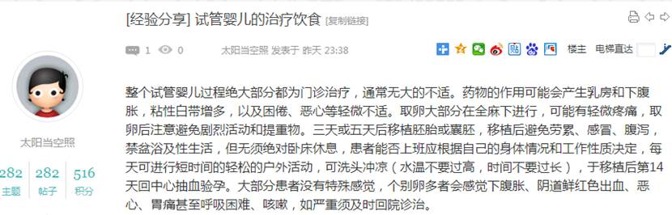  
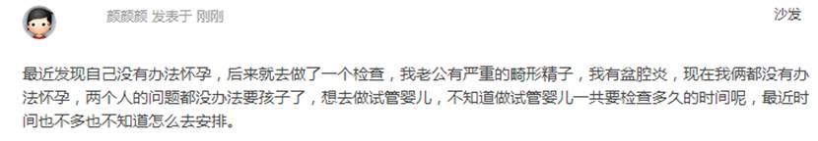

1390        <http://www.usivf.org/thread-3496-1-1.html>

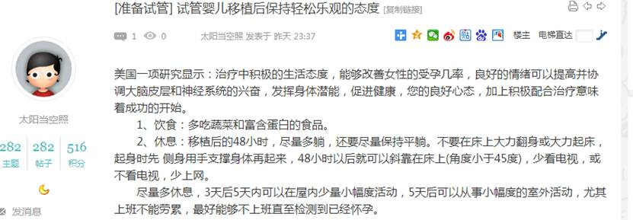  
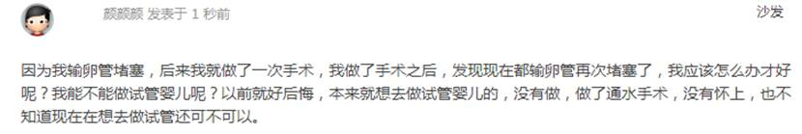

1392        <http://www.usivf.org/thread-3495-1-1.html>

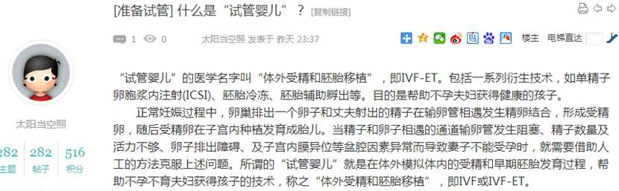  
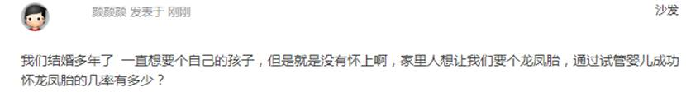

1394        <http://www.usivf.org/thread-3494-1-1.html>

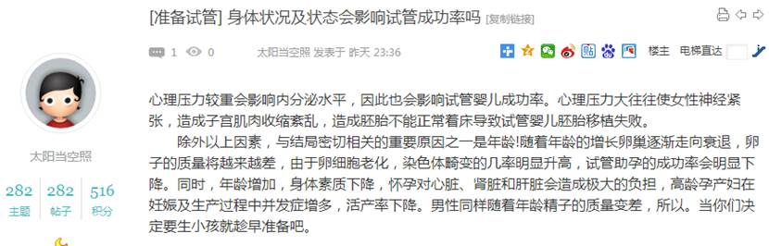  
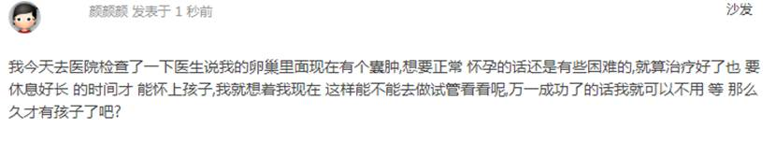

1396        <http://www.usivf.org/thread-3493-1-1.html>

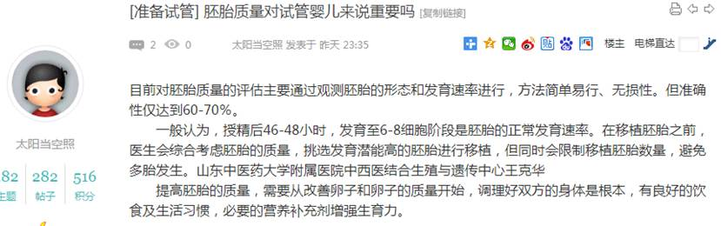  
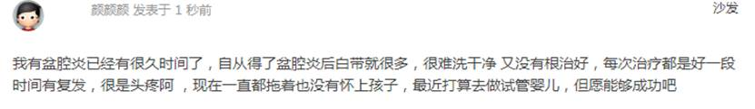

1398        <http://www.usivf.org/thread-3492-1-1.html>

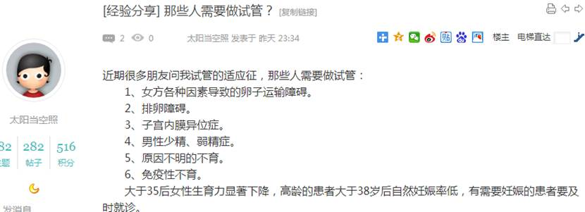  
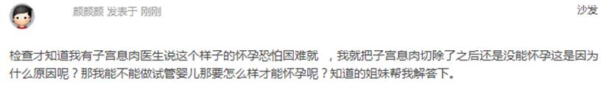

1400        <http://www.usivf.org/thread-3491-1-1.html>

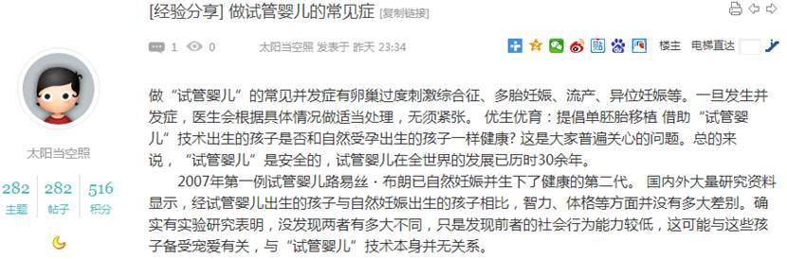  
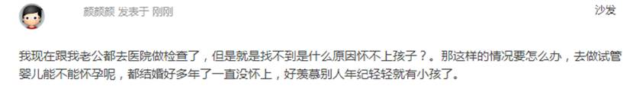

1402        <http://www.usivf.org/thread-3490-1-1.html>

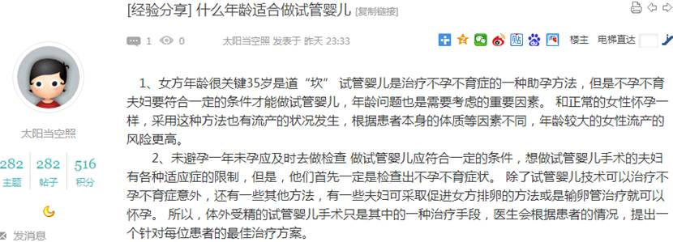  
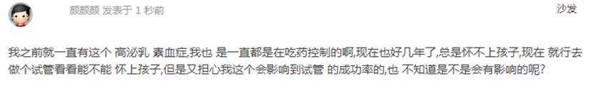

1404        <http://www.usivf.org/thread-3489-1-1.html>

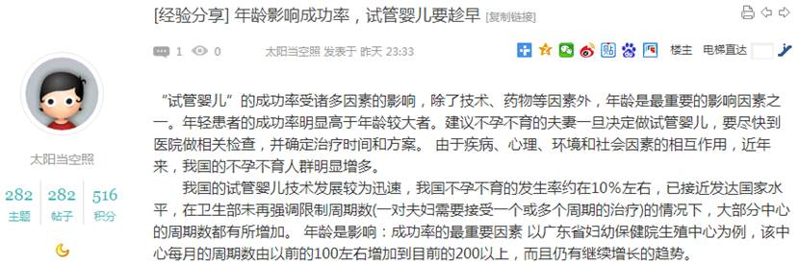  
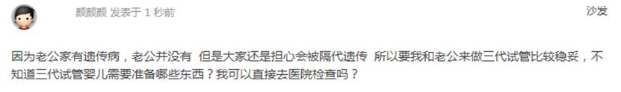

1406        <http://www.usivf.org/thread-3488-1-1.html>

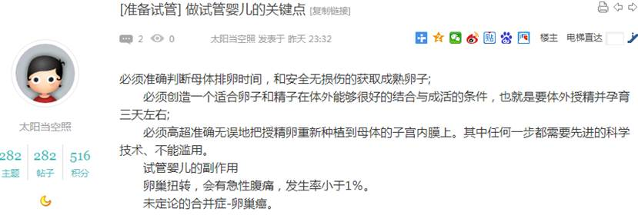  
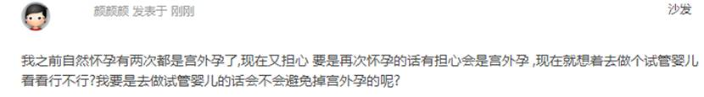

1408        <http://www.usivf.org/thread-3487-1-1.html>

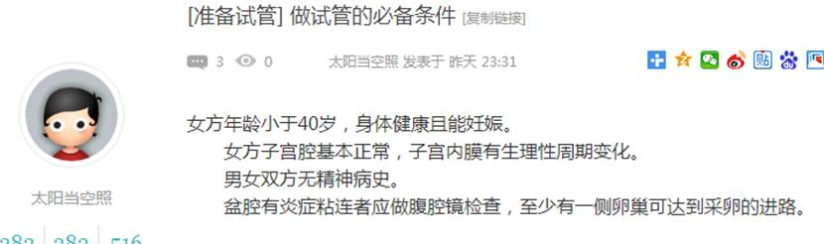  
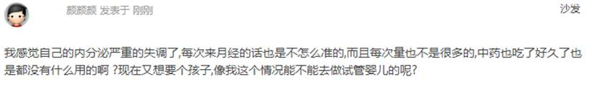

1410        <http://www.usivf.org/thread-3486-1-1.html>

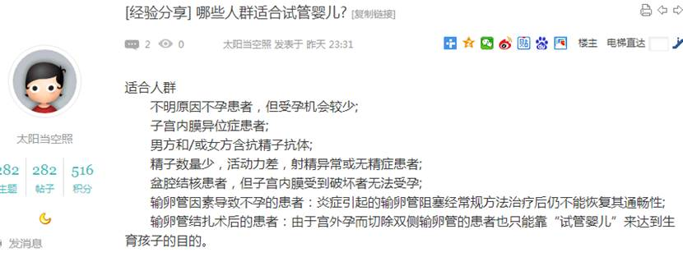  
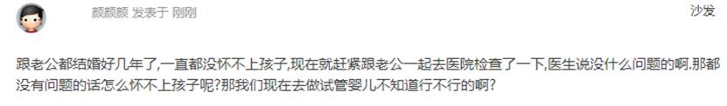

1412        <http://www.usivf.org/thread-3485-1-1.html>

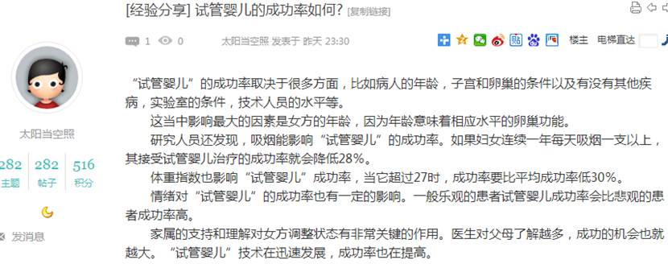  
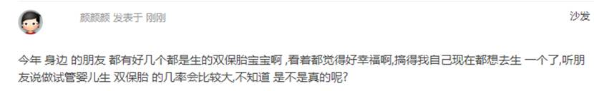

1414        <http://www.usivf.org/thread-3484-1-1.html>

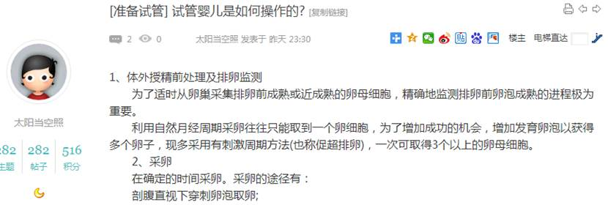  
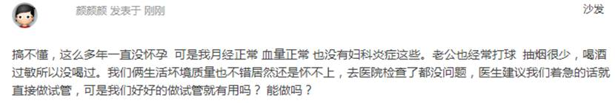

1416        <http://www.usivf.org/thread-3483-1-1.html>

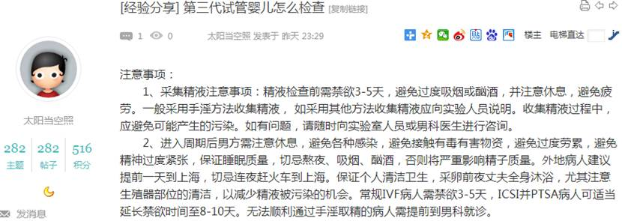  
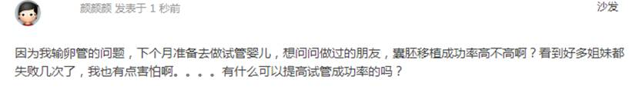

1418        <http://www.usivf.org/thread-3482-1-1.html>

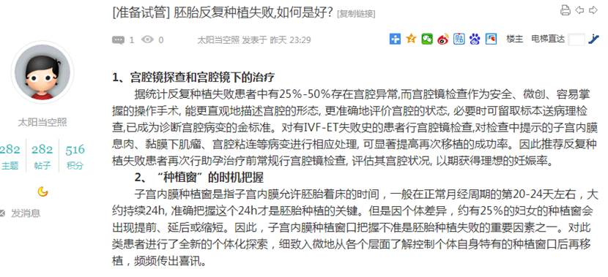  
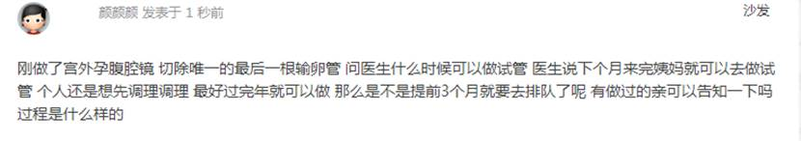

1420        <http://www.usivf.org/thread-3481-1-1.html>

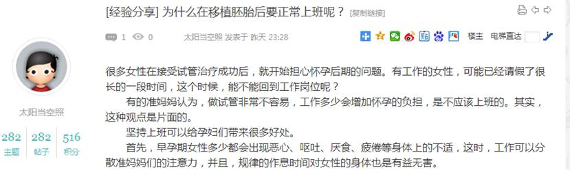  
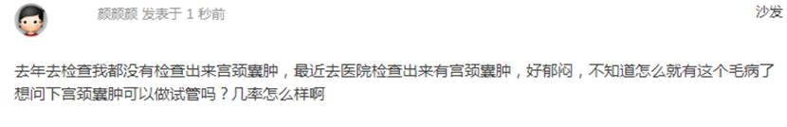

1422        <http://www.usivf.org/thread-3480-1-1.html>

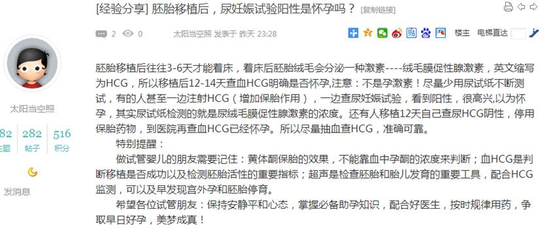  
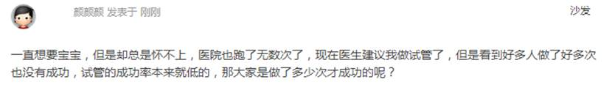

1424        <http://www.usivf.org/thread-3479-1-1.html>

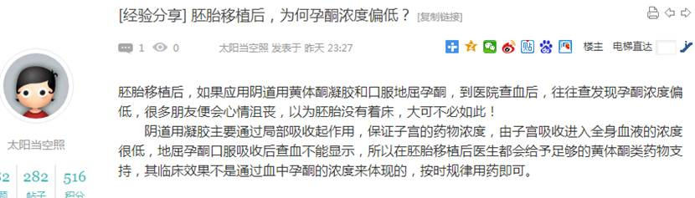  
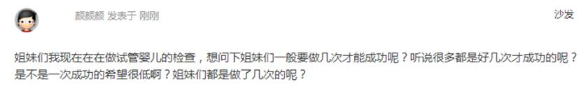

1426        <http://www.usivf.org/thread-3478-1-1.html>

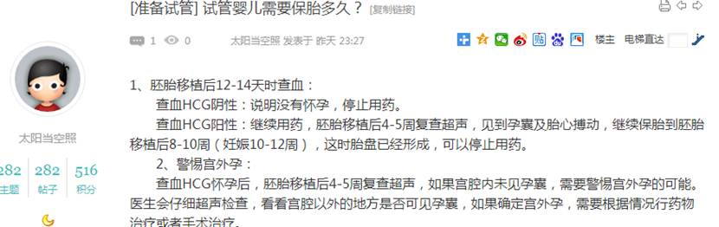  
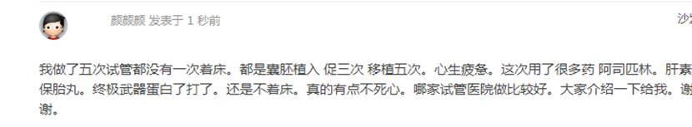

1428        <http://www.usivf.org/thread-3477-1-1.html>

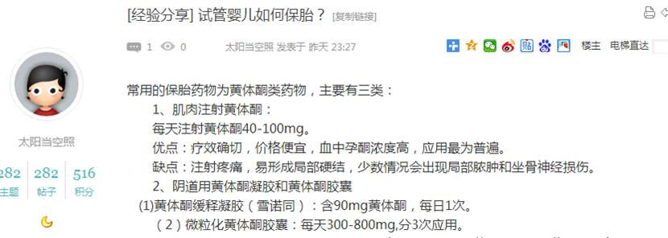  
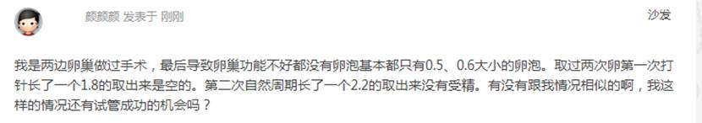

1430        <http://www.usivf.org/thread-3475-1-1.html>

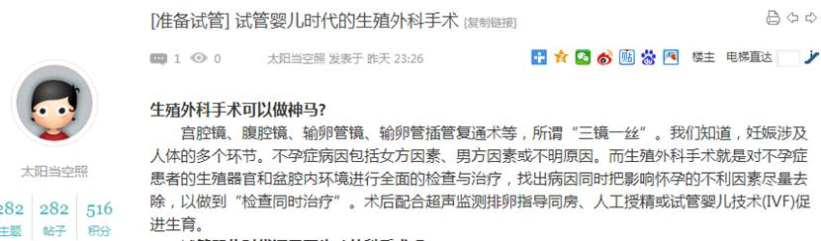  
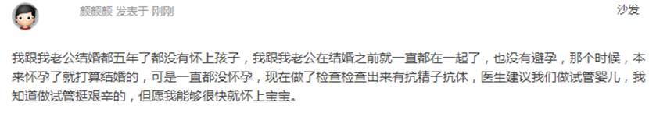

1432        <http://www.usivf.org/thread-3474-1-1.html>

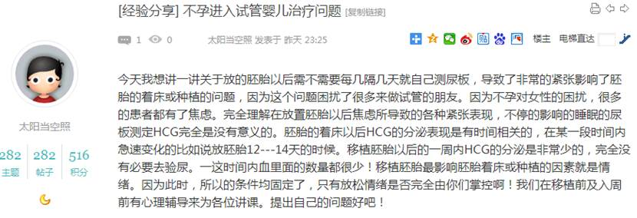  
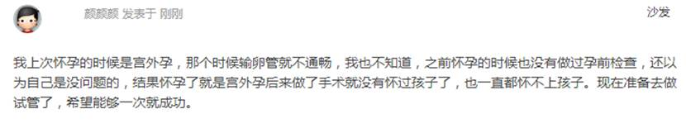

1434        <http://www.usivf.org/thread-3473-1-1.html>

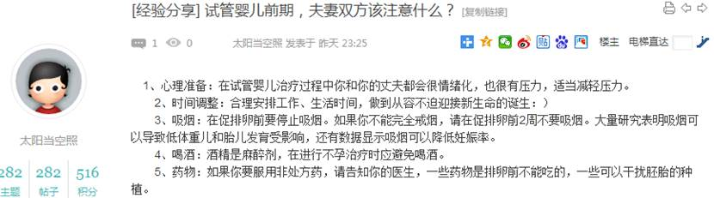  
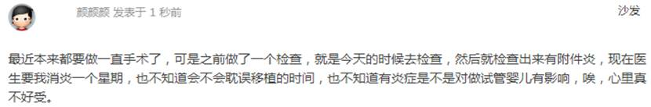

1436        <http://www.usivf.org/thread-3472-1-1.html>

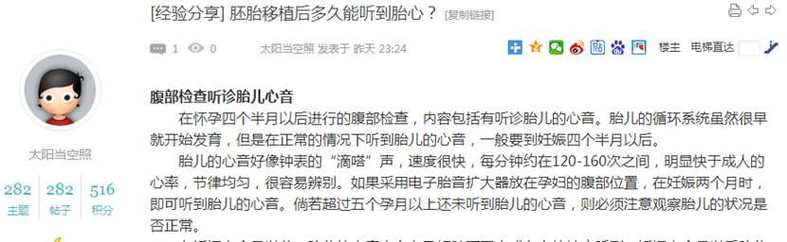  
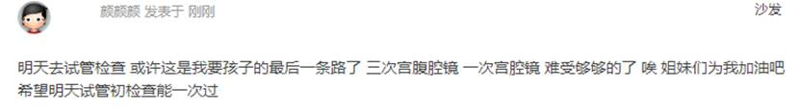

1438        <http://www.usivf.org/thread-3471-1-1.html>

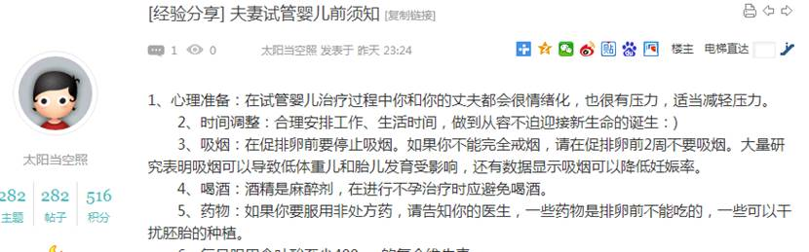  
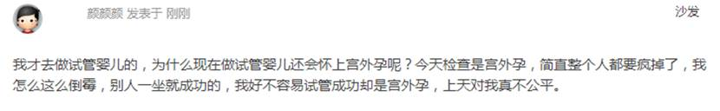

1440        <http://www.usivf.org/thread-3470-1-1.html>

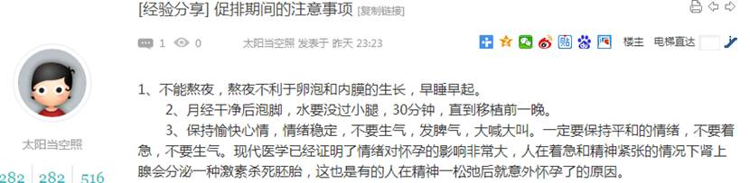  
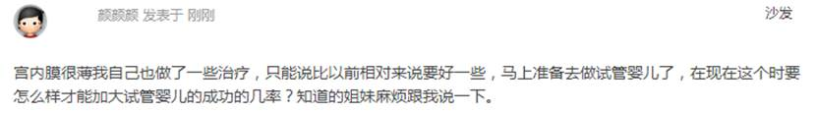

1442        <http://www.usivf.org/thread-3469-1-1.html>

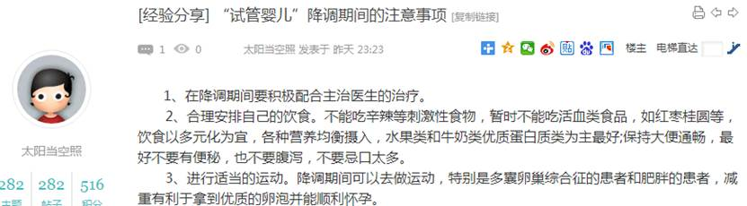  
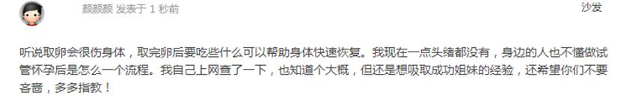

1444        <http://www.usivf.org/thread-3468-1-1.html>

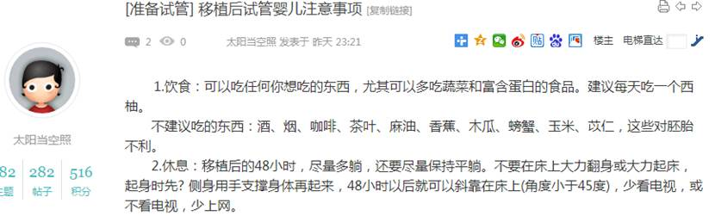  
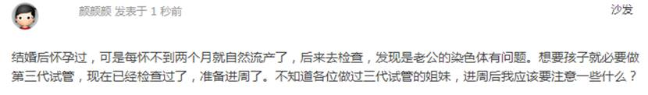

1446        <http://www.usivf.org/thread-3476-1-1.html>

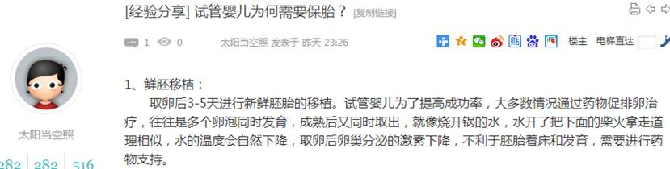  
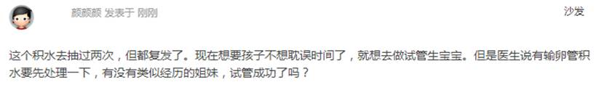

1448        <http://www.usivf.org/thread-3561-1-1.html>

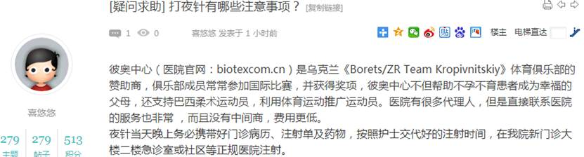  
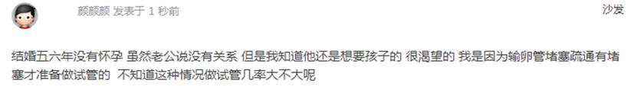

1450        <http://www.usivf.org/thread-3560-1-1.html>

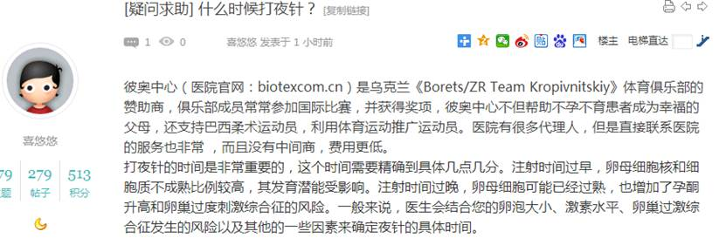  
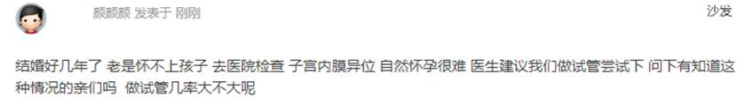

1452        <http://www.usivf.org/thread-3559-1-1.html>

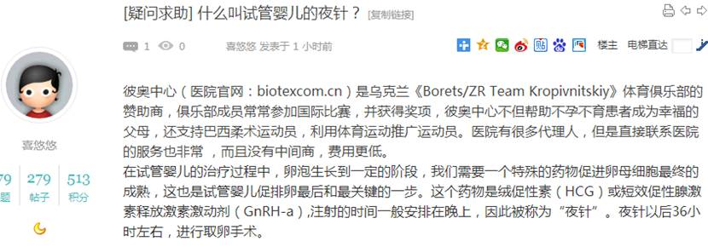  
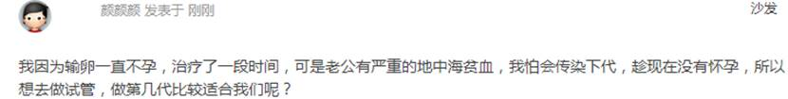

1454        <http://www.usivf.org/thread-3596-1-1.html>

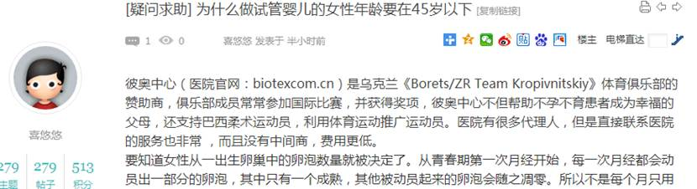  
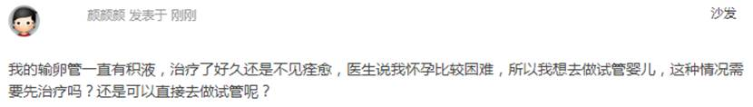

1456        <http://www.usivf.org/thread-3595-1-1.html>

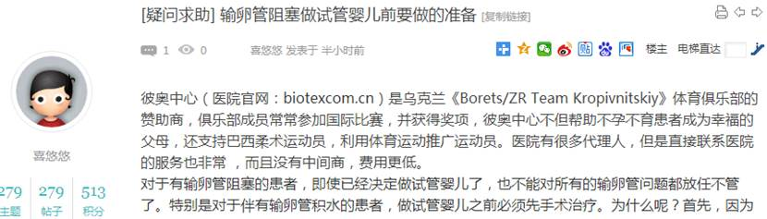  
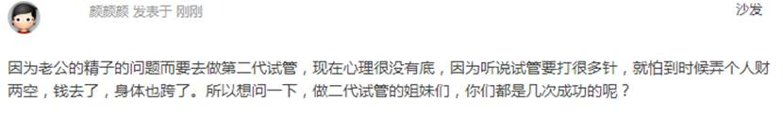

1458        <http://www.usivf.org/thread-3594-1-1.html>

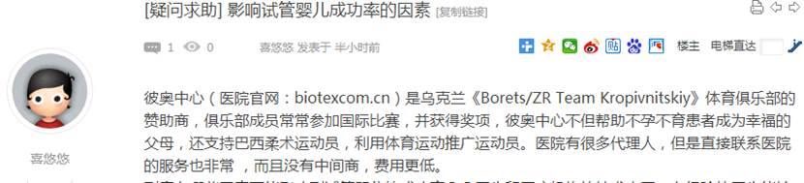  
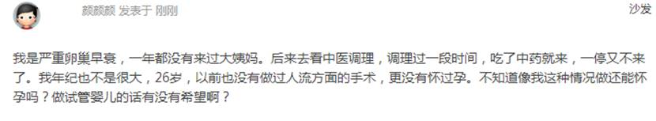

1460        <http://www.usivf.org/thread-3593-1-1.html>

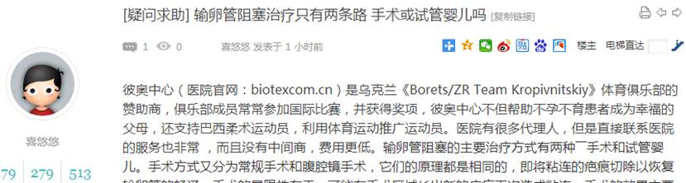  
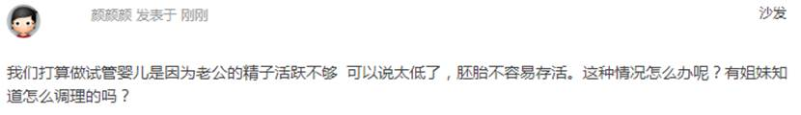

1462        <http://www.usivf.org/thread-3592-1-1.html>

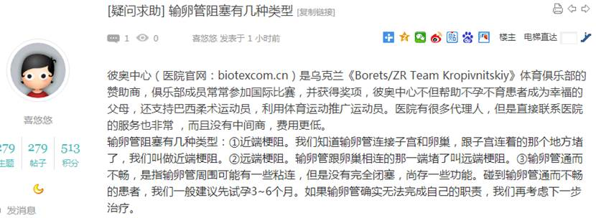  
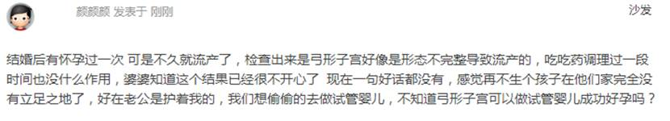

1464        <http://www.usivf.org/thread-3591-1-1.html>

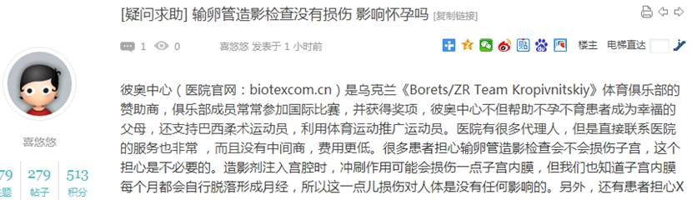  
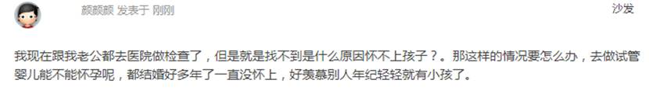

1466        <http://www.usivf.org/thread-3590-1-1.html>

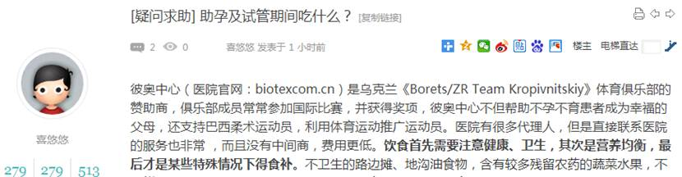  
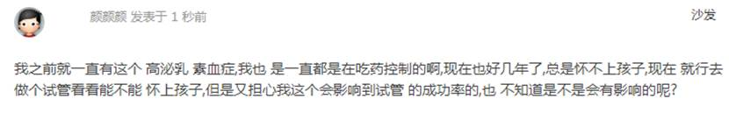

1468        <http://www.usivf.org/thread-3589-1-1.html>

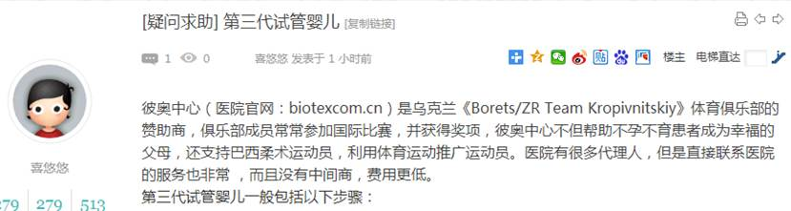  
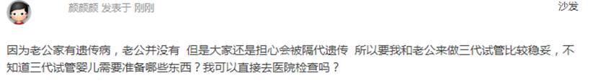

1470        <http://www.usivf.org/thread-3588-1-1.html>

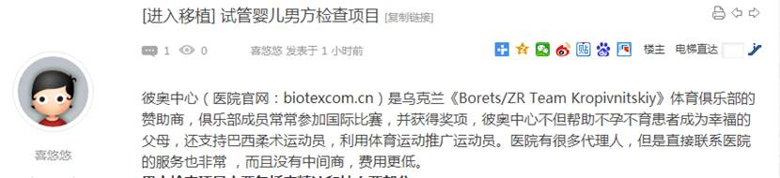  
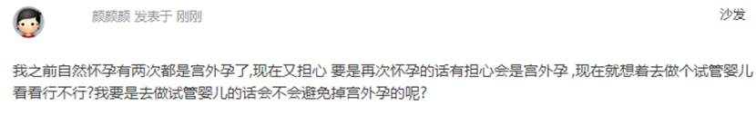

1472        <http://www.usivf.org/thread-3587-1-1.html>

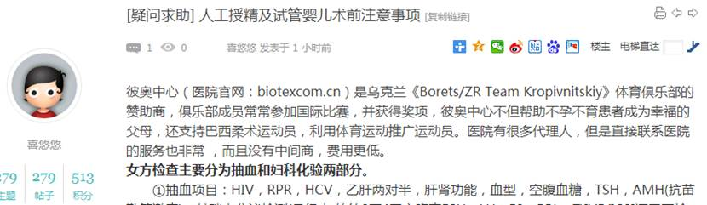  
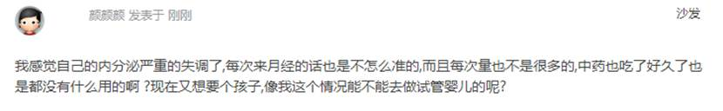

1474        <http://www.usivf.org/thread-3586-1-1.html>

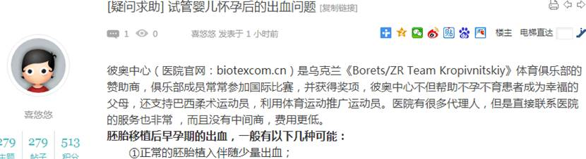  
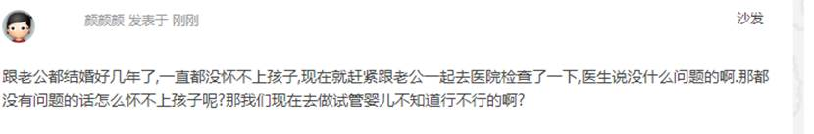

1476        <http://www.usivf.org/thread-3585-1-1.html>

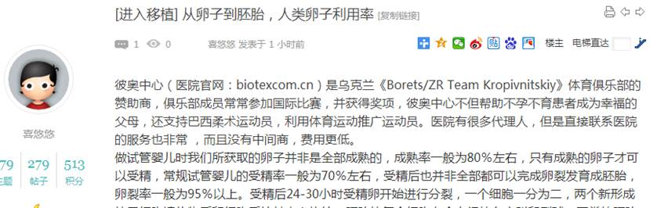  
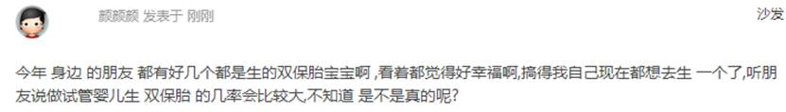

1478        <http://www.usivf.org/thread-3584-1-1.html>

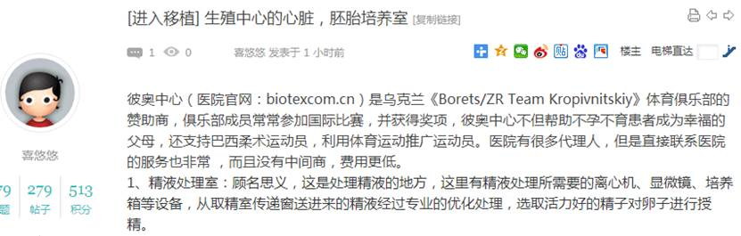  
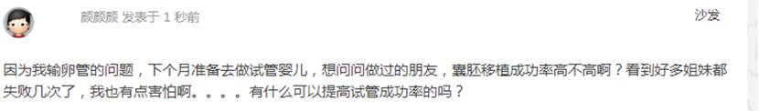

1480        <http://www.usivf.org/thread-3583-1-1.html>

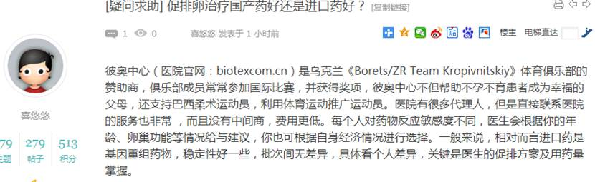  
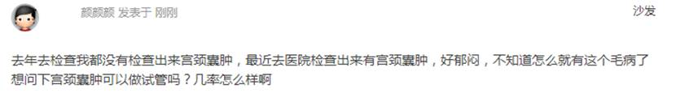

1482        <http://www.usivf.org/thread-3582-1-1.html>

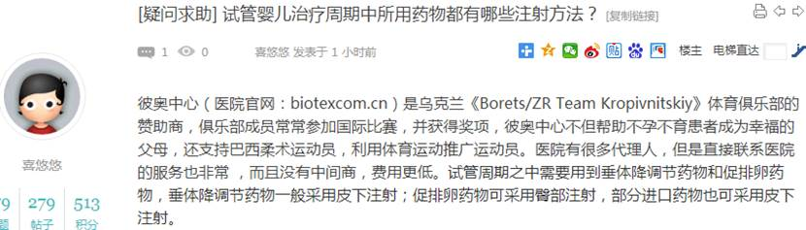  
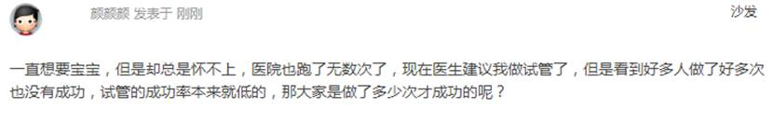

1484        <http://www.usivf.org/thread-3581-1-1.html>

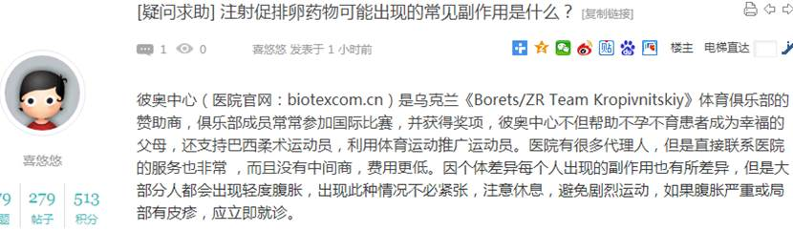  
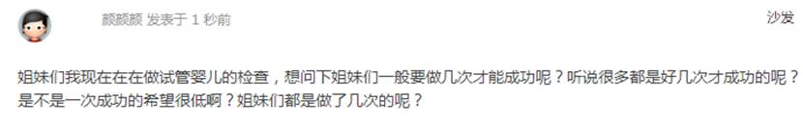

1486        <http://www.usivf.org/thread-3580-1-1.html>

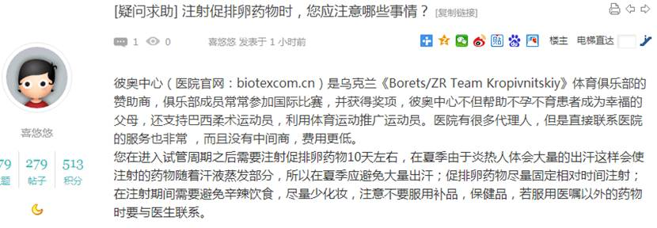  
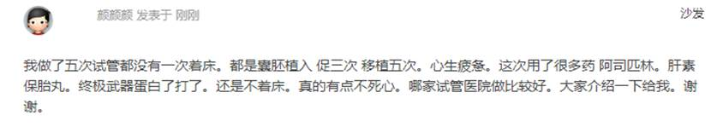

1488        <http://www.usivf.org/thread-3579-1-1.html>

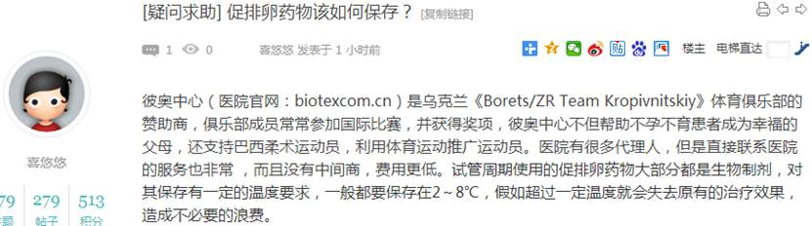  
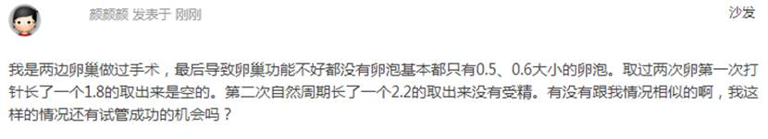

1490        <http://www.usivf.org/thread-3578-1-1.html>

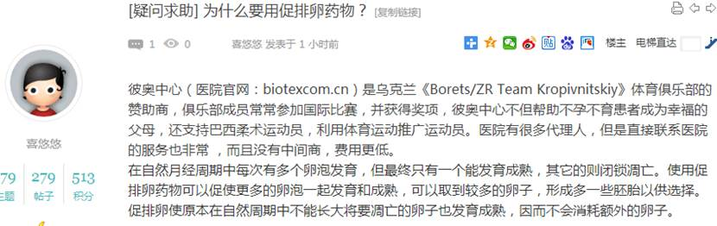  
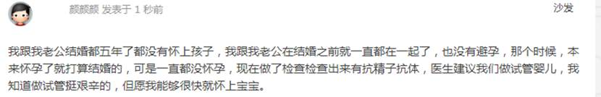

1492        <http://www.usivf.org/thread-3577-1-1.html>

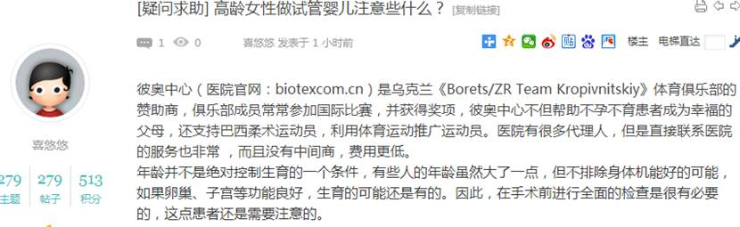  
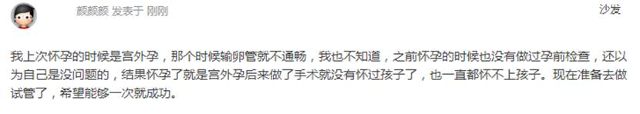

1494        <http://www.usivf.org/thread-3576-1-1.html>

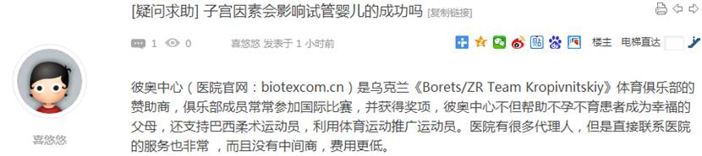  
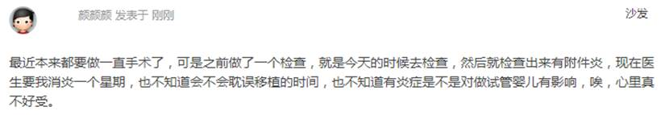

1496        <http://www.usivf.org/thread-3575-1-1.html>

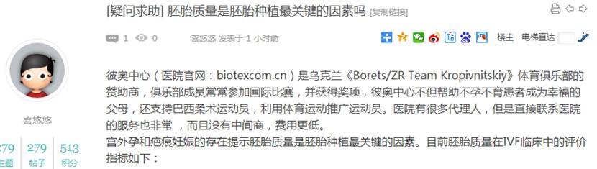  
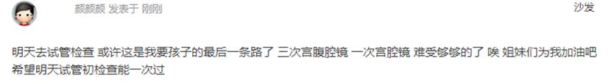

1498        <http://www.usivf.org/thread-3573-1-1.html>

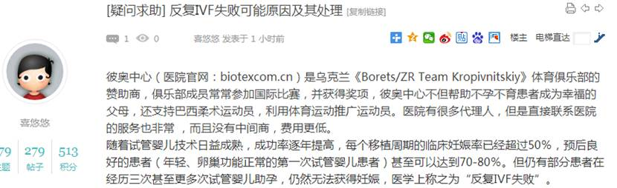  
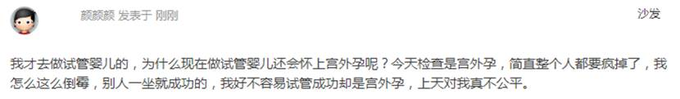

1500        <http://www.usivf.org/thread-3572-1-1.html>

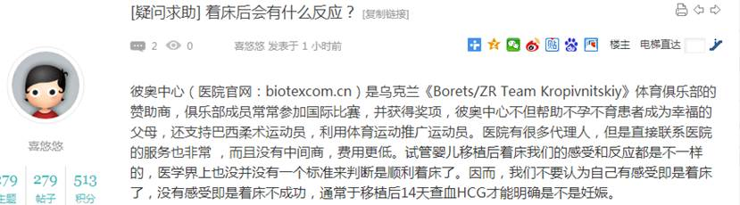  
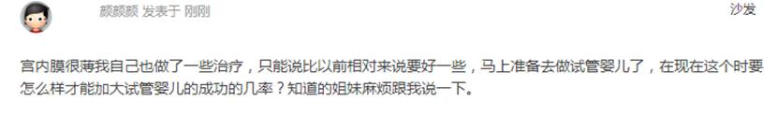

1502        <http://www.usivf.org/thread-3571-1-1.html>

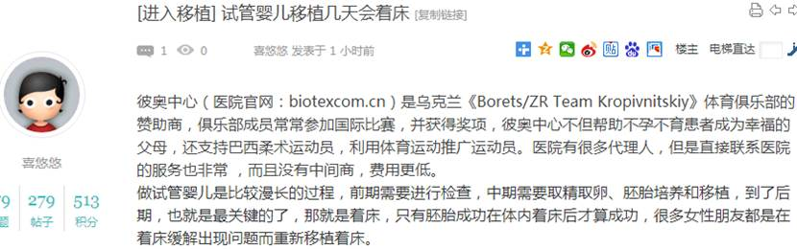  
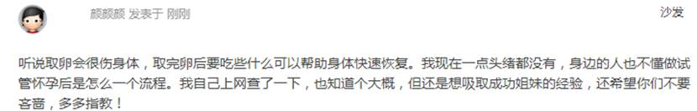

1504        <http://www.usivf.org/thread-3570-1-1.html>

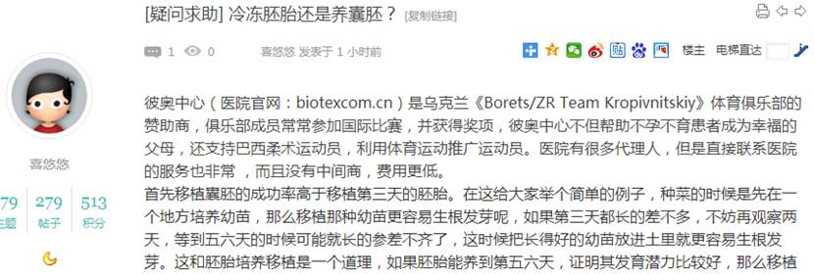  
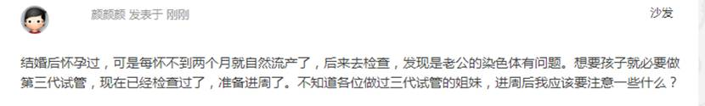

1506        <http://www.usivf.org/thread-3569-1-1.html>

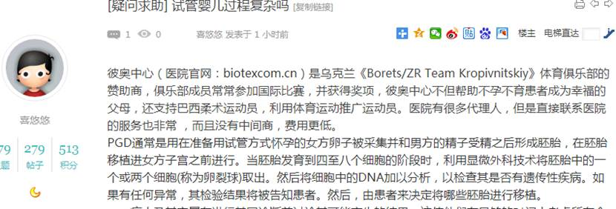  
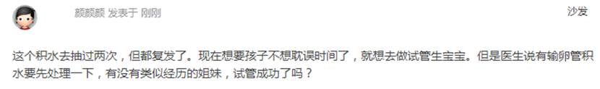

1508        <http://www.usivf.org/thread-3568-1-1.html>

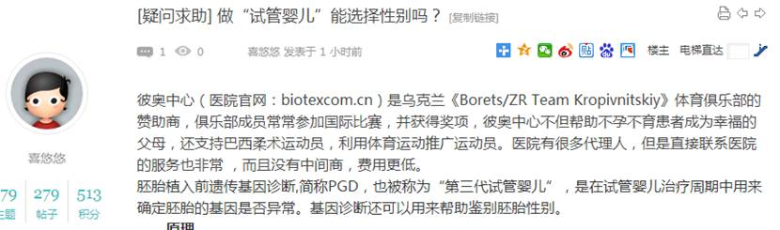  


1510        <http://www.usivf.org/thread-3567-1-1.html>

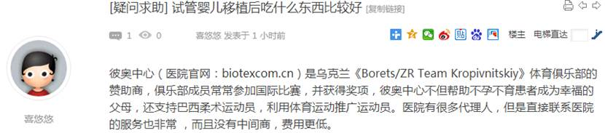  
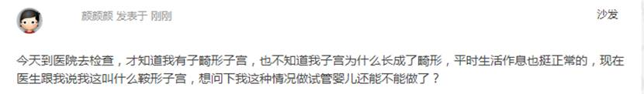

1512        <http://www.usivf.org/thread-3566-1-1.html>

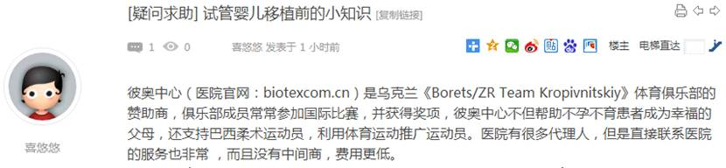  
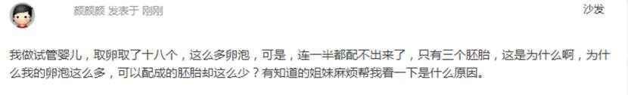

1514        <http://www.usivf.org/thread-3565-1-1.html>

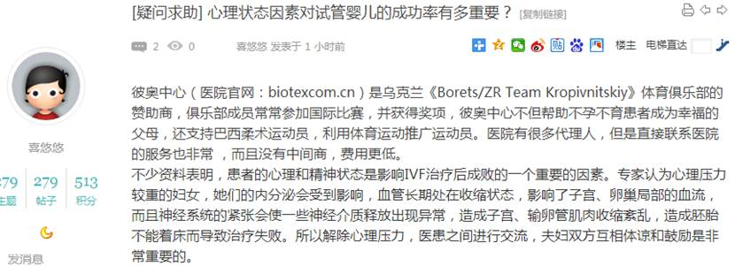  
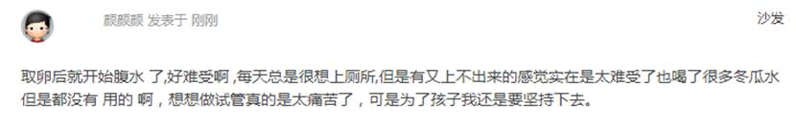

1516        <http://www.usivf.org/thread-3564-1-1.html>

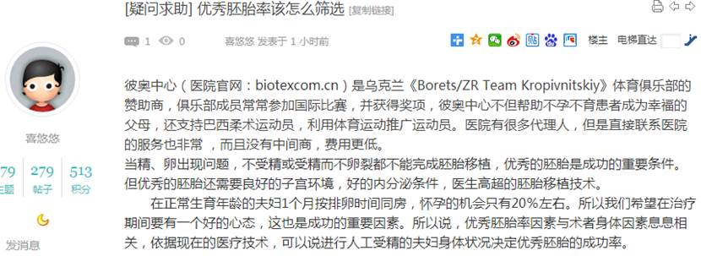  
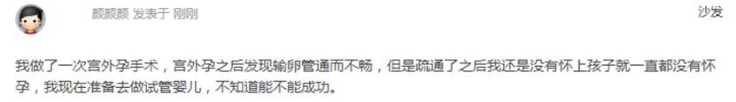

1518        <http://www.usivf.org/thread-3563-1-1.html>

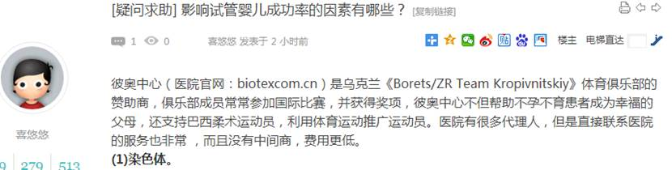  
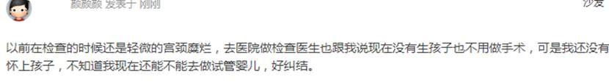

1520        <http://www.usivf.org/thread-3562-1-1.html>

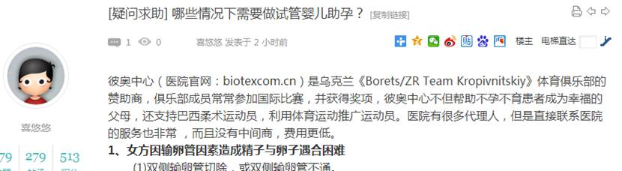  
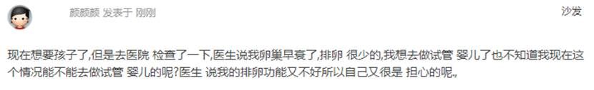

1522        <http://www.usivf.org/thread-3642-1-1.html>

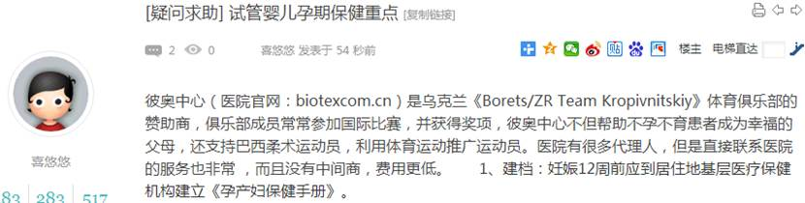  
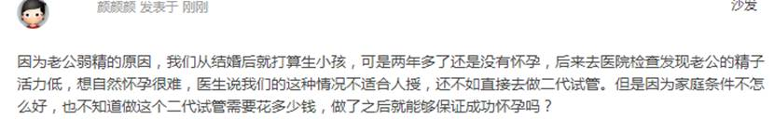

1524        <http://www.usivf.org/thread-3641-1-1.html>

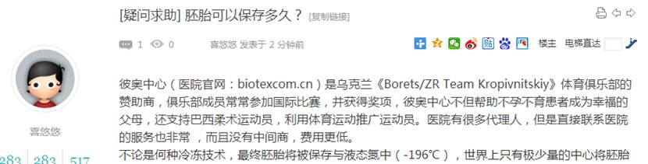  
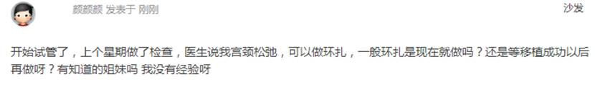

1526        <http://www.usivf.org/thread-3640-1-1.html>

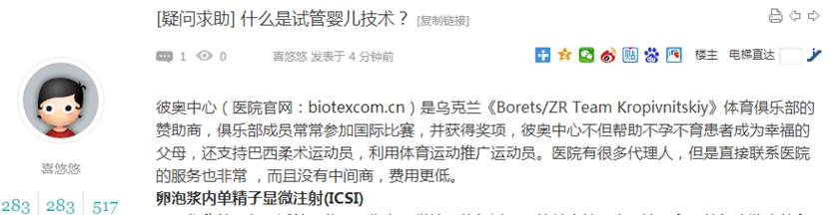  
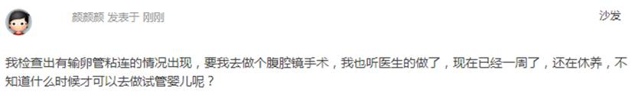

1528        <http://www.usivf.org/thread-3558-1-1.html>

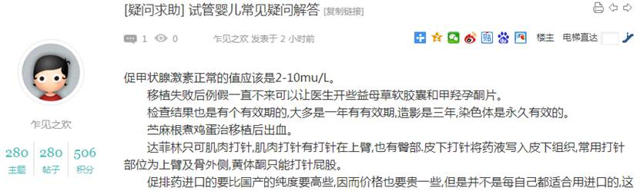  
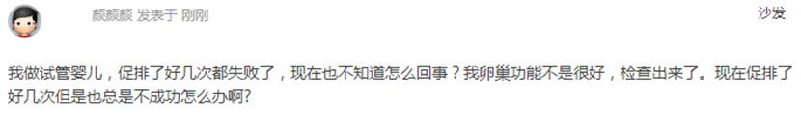

1530        <http://www.usivf.org/thread-3557-1-1.html>

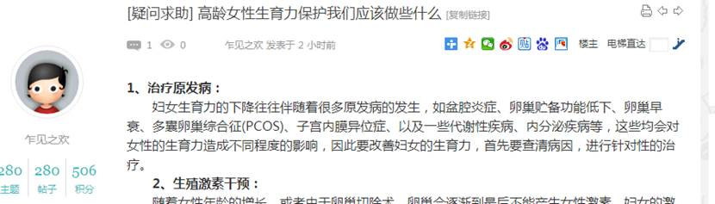  
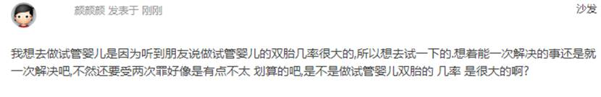

1532        <http://www.usivf.org/thread-3556-1-1.html>

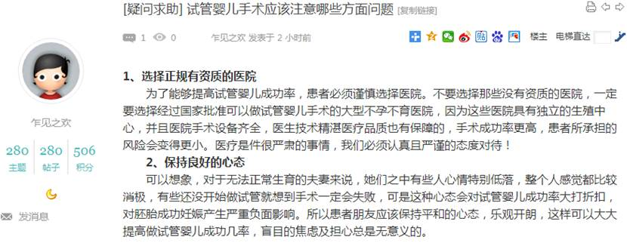  
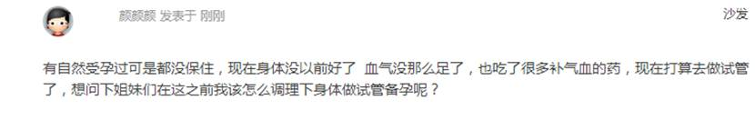

1534        <http://www.usivf.org/thread-3555-1-1.html>

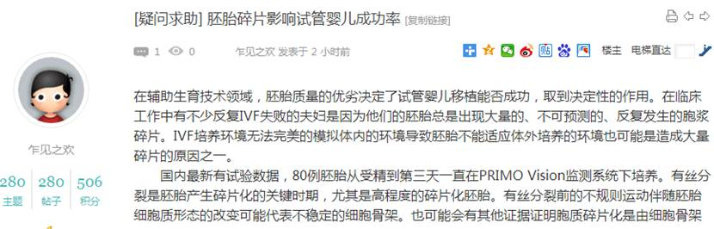  
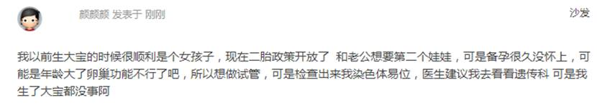

1536        <http://www.usivf.org/thread-3554-1-1.html>

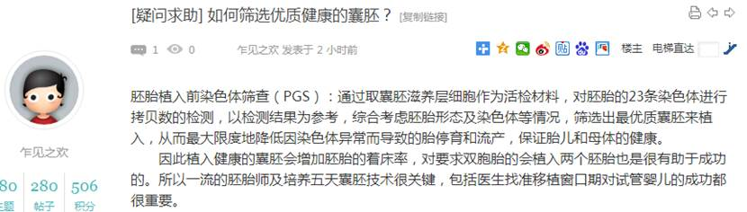  
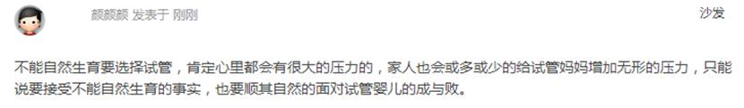

1538        <http://www.usivf.org/thread-3553-1-1.html>

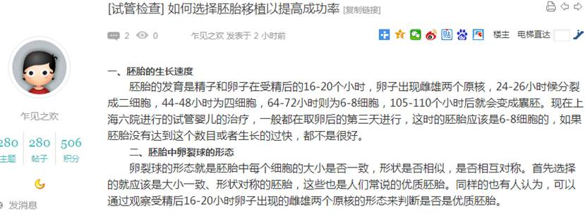  
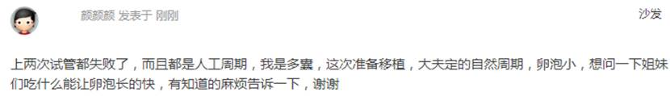

1540        <http://www.usivf.org/thread-3543-1-1.html>

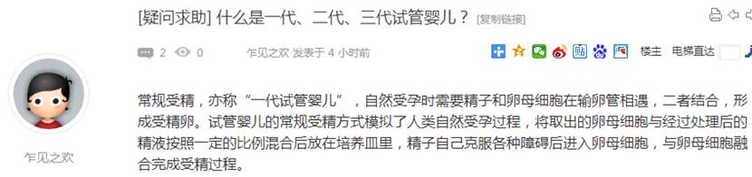  
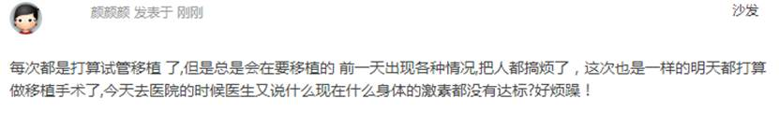

1542        <http://www.usivf.org/thread-3542-1-1.html>

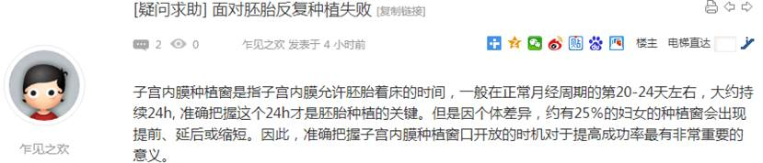  
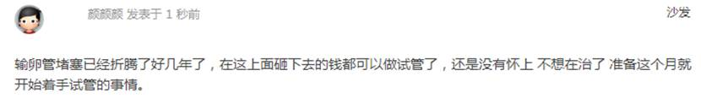

1544        <http://www.usivf.org/thread-3541-1-1.html>

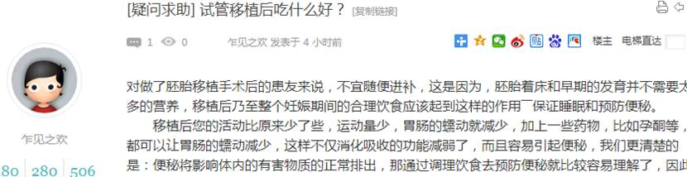  
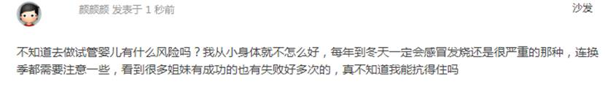

1546        <http://www.usivf.org/thread-3540-1-1.html>

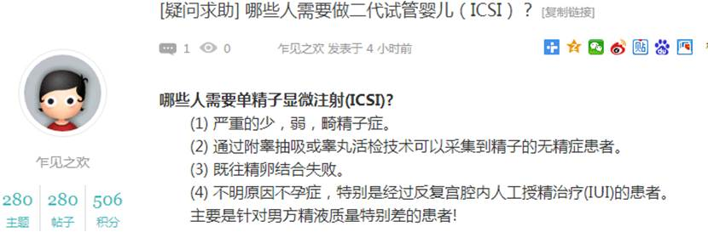  
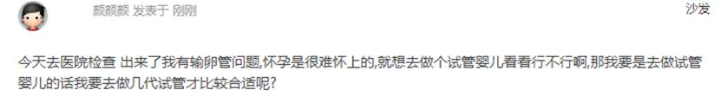

1548        <http://www.usivf.org/thread-3539-1-1.html>

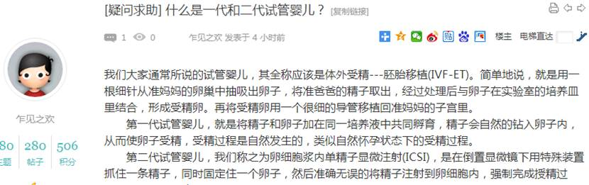  
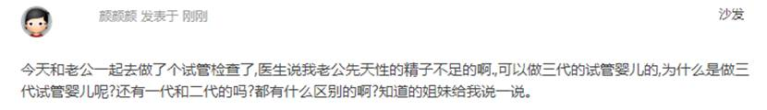

1550        <http://www.usivf.org/thread-3538-1-1.html>

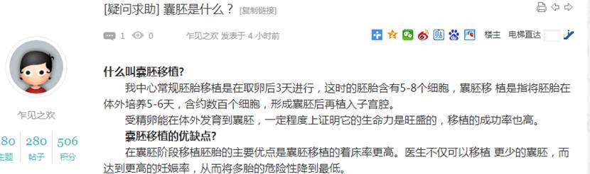  
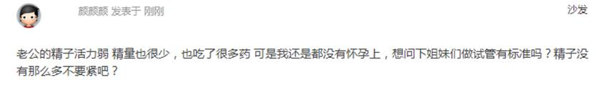

1552        <http://www.usivf.org/thread-3537-1-1.html>

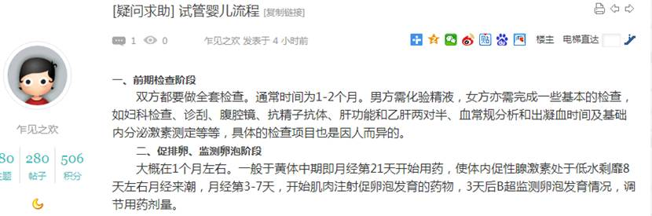  
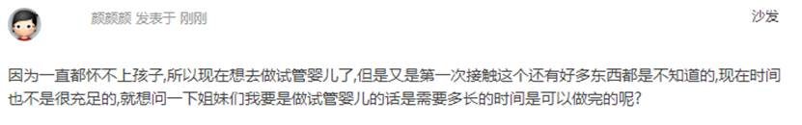

1554        <http://www.usivf.org/thread-3536-1-1.html>

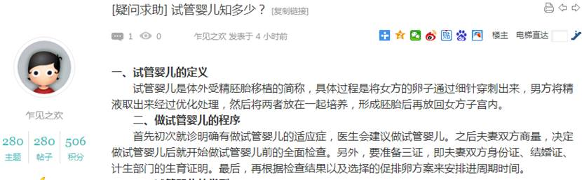  
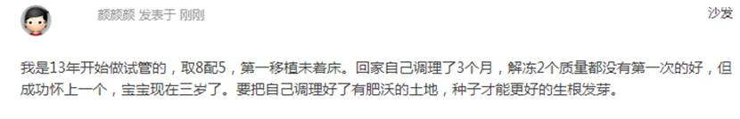

1556        <http://www.usivf.org/thread-3535-1-1.html>

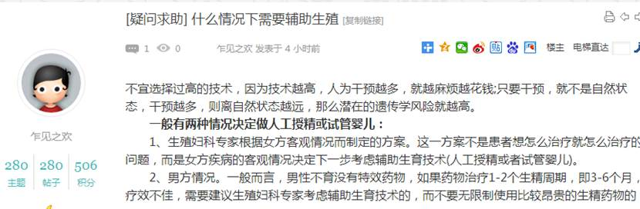  
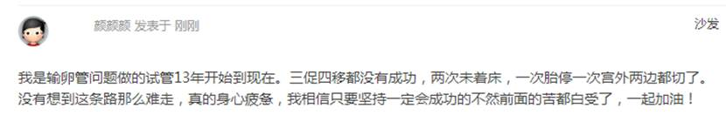

1558        <http://www.usivf.org/thread-3534-1-1.html>

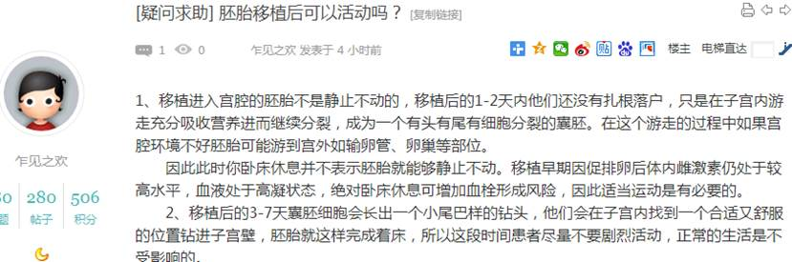  
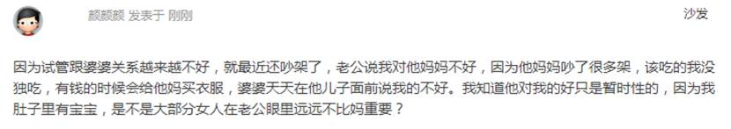

1560        <http://www.usivf.org/thread-3533-1-1.html>

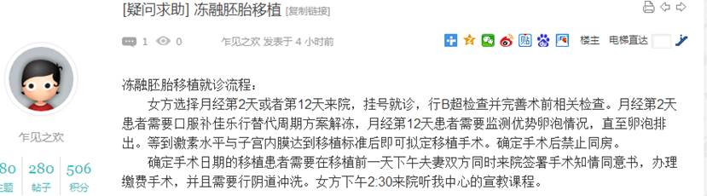  
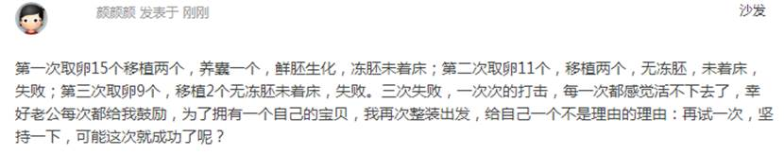

1562        <http://www.usivf.org/thread-3532-1-1.html>

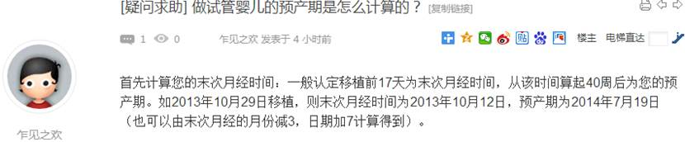  
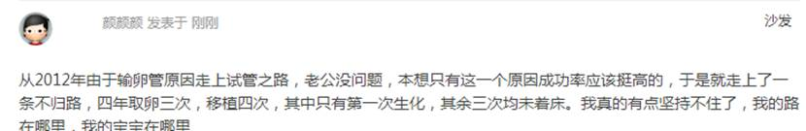

1564        <http://www.usivf.org/thread-3531-1-1.html>

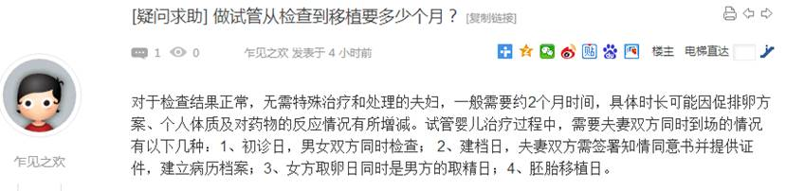  
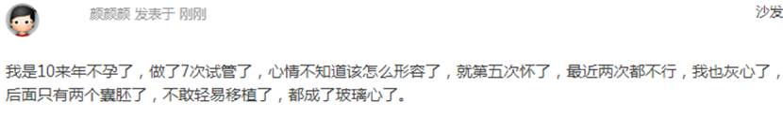

1566        <http://www.usivf.org/thread-3530-1-1.html>

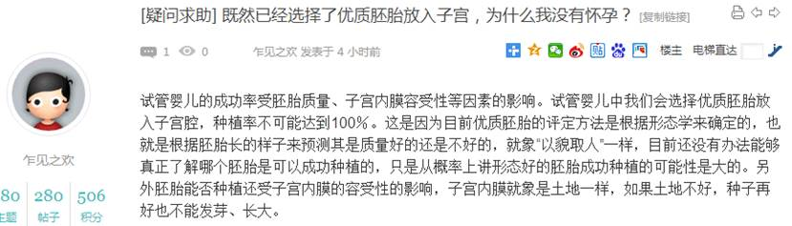  
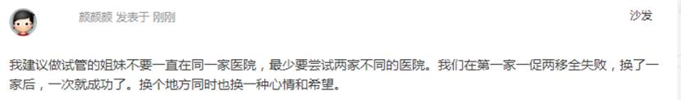

1568        <http://www.usivf.org/thread-3529-1-1.html>

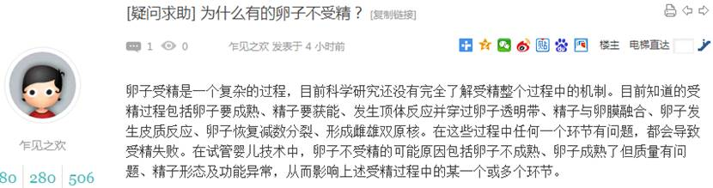  
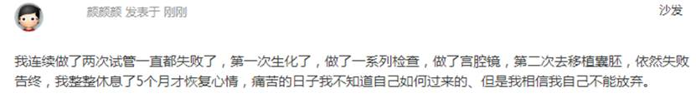

1570        <http://www.usivf.org/thread-3528-1-1.html>

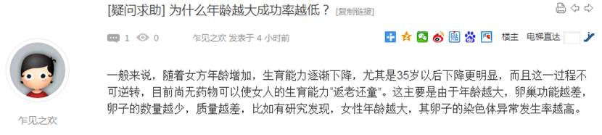  
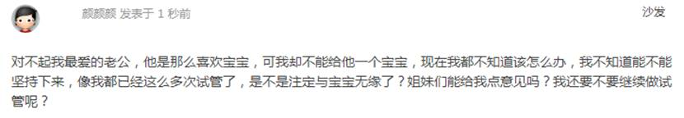

1572        <http://www.usivf.org/thread-3527-1-1.html>

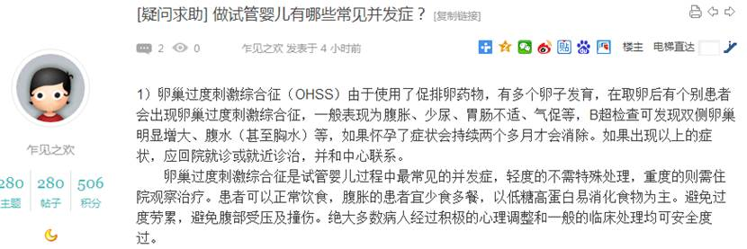  
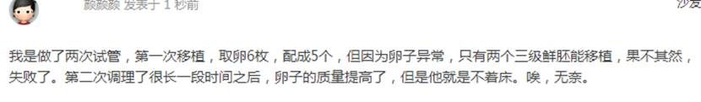

1574        <http://www.usivf.org/thread-3526-1-1.html>

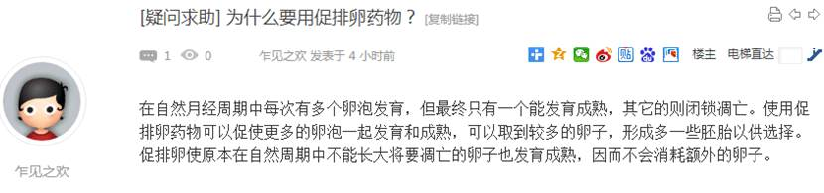  
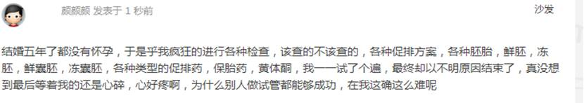

1576        <http://www.usivf.org/thread-3525-1-1.html>

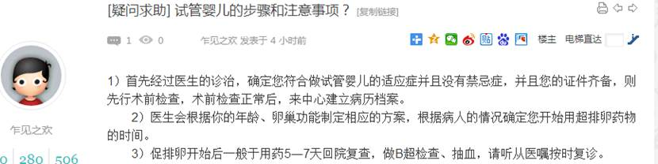  
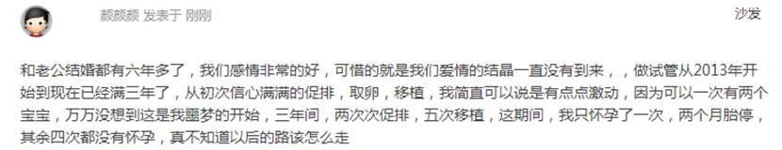

1578        <http://www.usivf.org/thread-3524-1-1.html>

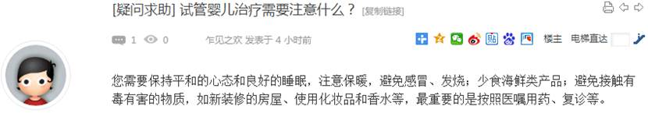  
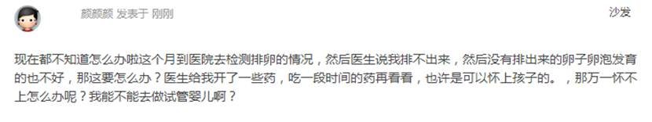

1580        <http://www.usivf.org/thread-3523-1-1.html>

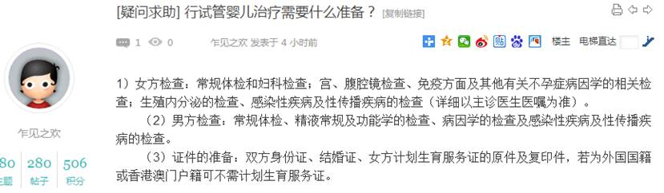  
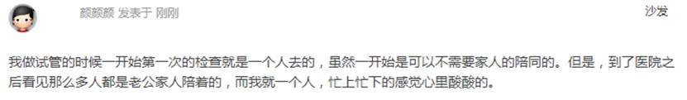

1582        <http://www.usivf.org/thread-3522-1-1.html>

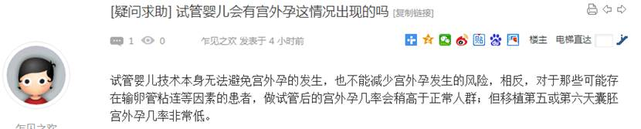  
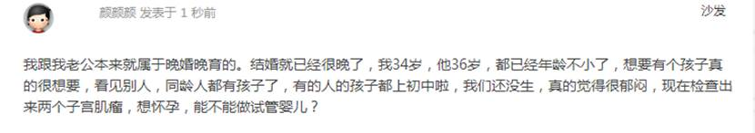

1584        <http://www.usivf.org/thread-3521-1-1.html>

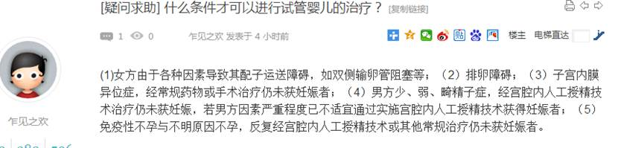  
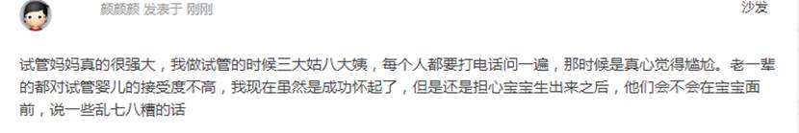

1586        <http://www.usivf.org/thread-3520-1-1.html>

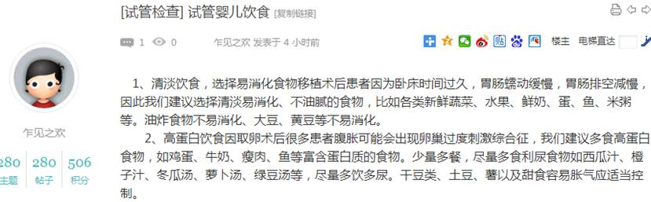  
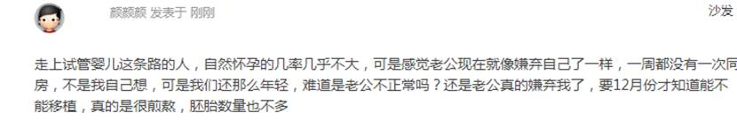

1588        <http://www.usivf.org/thread-3519-1-1.html>

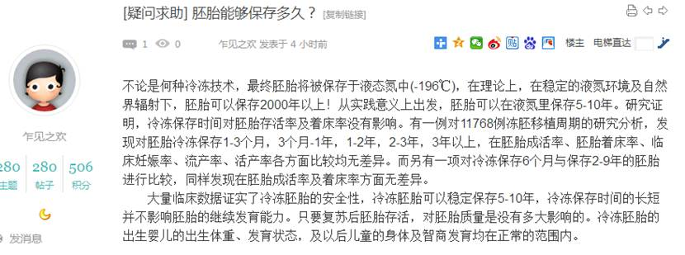  
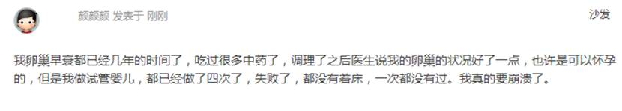

1590        <http://www.usivf.org/thread-3518-1-1.html>

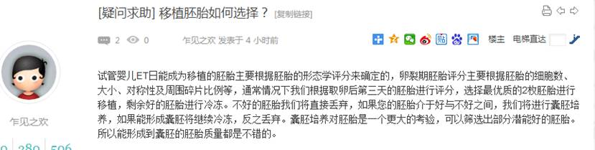  
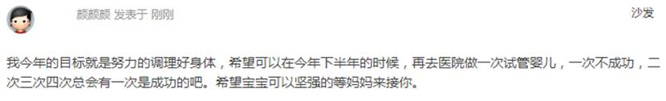

1592        <http://www.usivf.org/thread-3517-1-1.html>

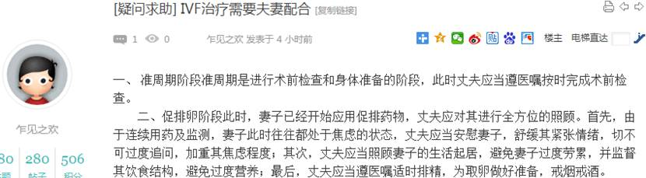  
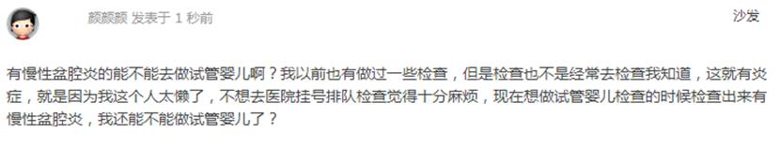

1594        <http://www.usivf.org/thread-3516-1-1.html>

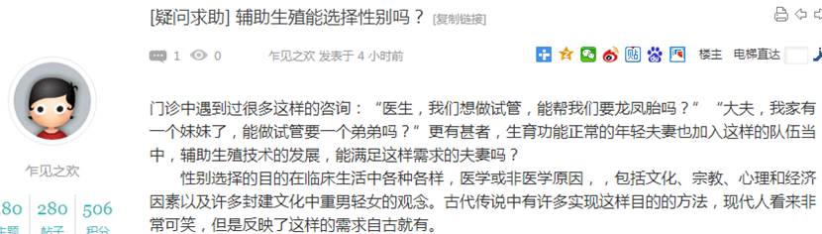  
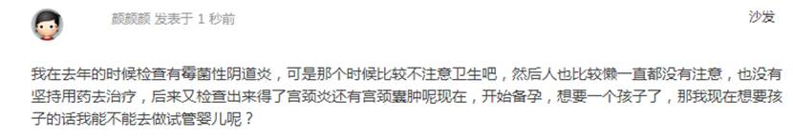

1596        <http://www.usivf.org/thread-3515-1-1.html>

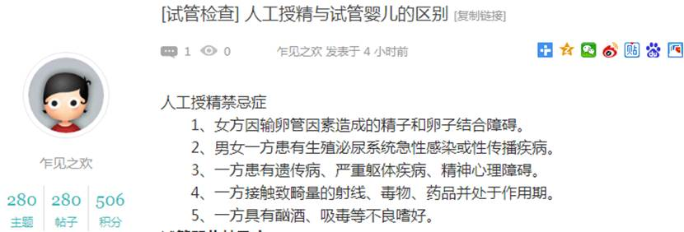  
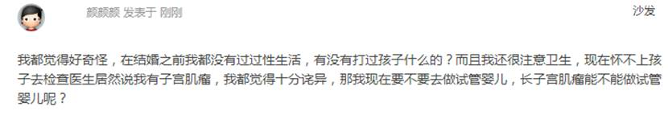

1598        <http://www.usivf.org/thread-3514-1-1.html>

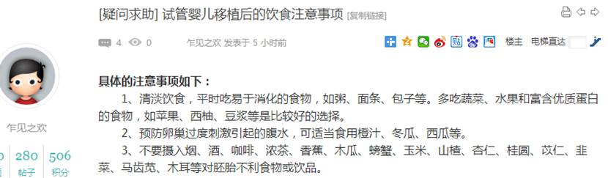  
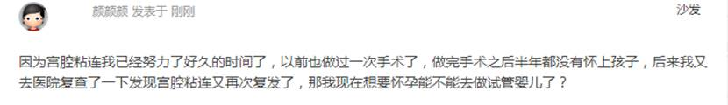

1600        <http://www.usivf.org/thread-3513-1-1.html>

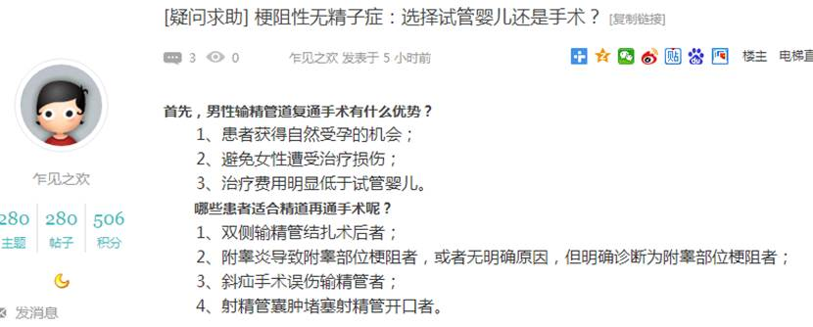  
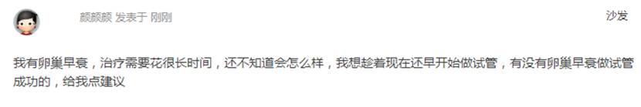

1602        <http://www.usivf.org/thread-3512-1-1.html>

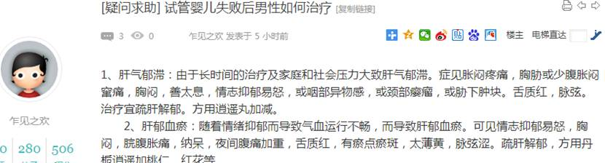  
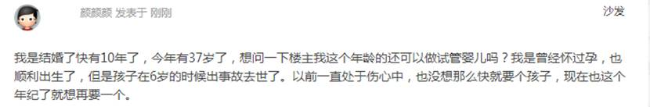

1604        <http://www.usivf.org/thread-3511-1-1.html>

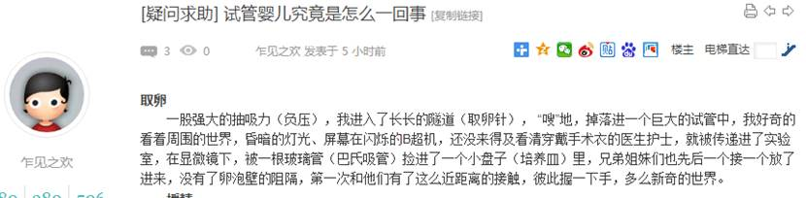  
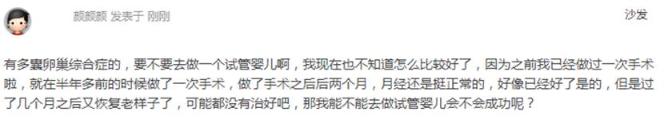

1606        <http://www.usivf.org/thread-3510-1-1.html>

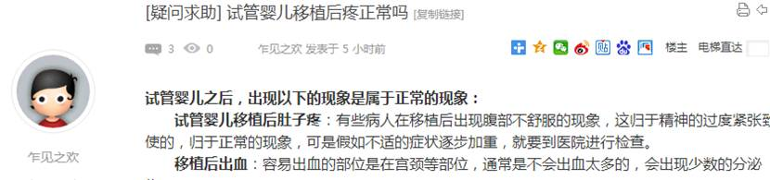  
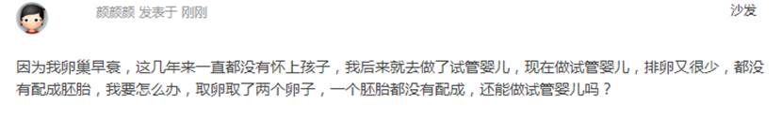

1608        <http://www.usivf.org/thread-3638-1-1.html>

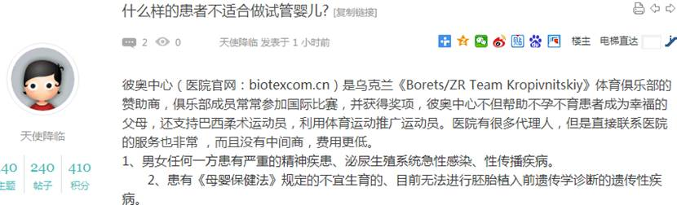  
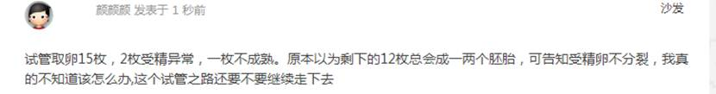

1610        <http://www.usivf.org/thread-3637-1-1.html>

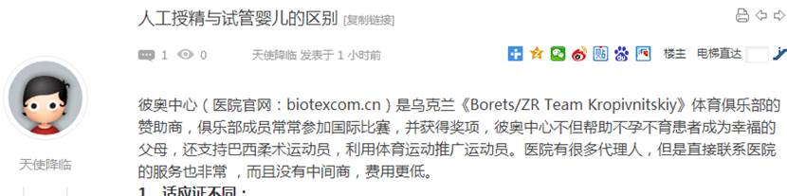  
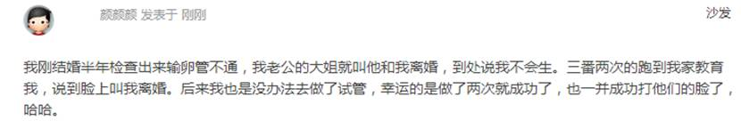

1612        <http://www.usivf.org/thread-3636-1-1.html>

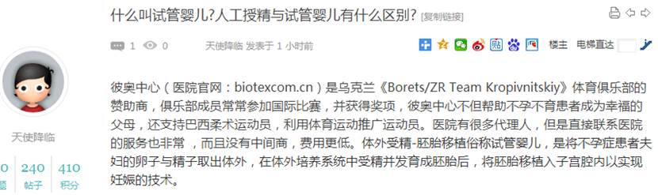  
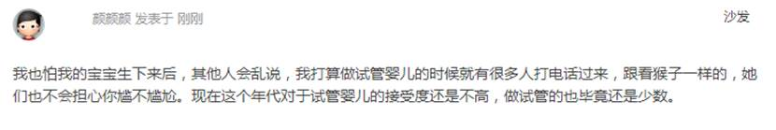

1614        <http://www.usivf.org/thread-3635-1-1.html>

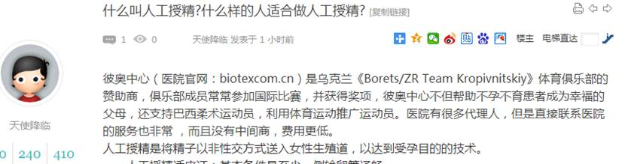  
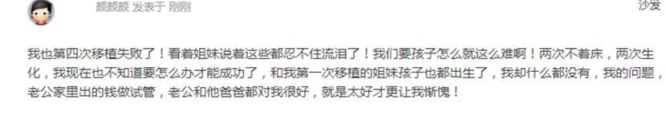

1616        <http://www.usivf.org/thread-3634-1-1.html>

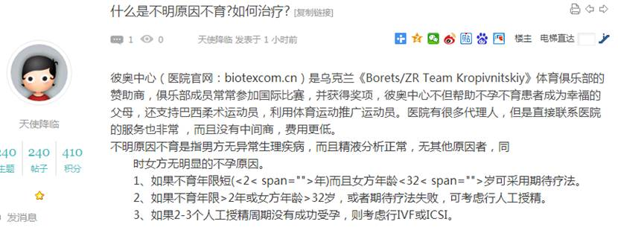  
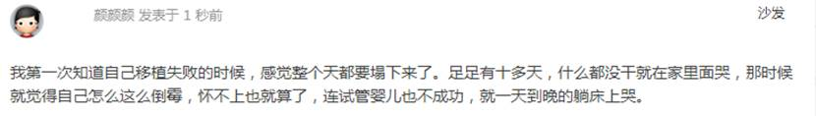

1618        <http://www.usivf.org/thread-3633-1-1.html>

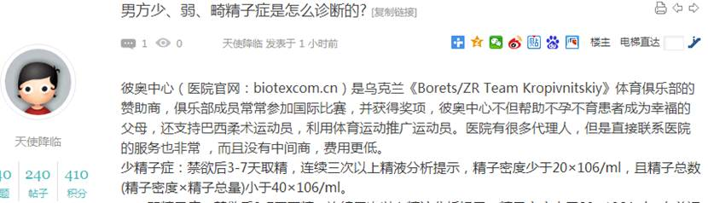  
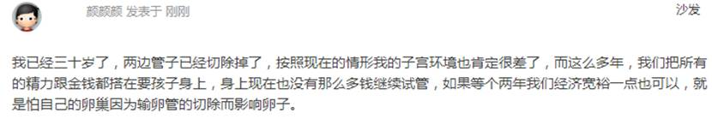

1620        <http://www.usivf.org/thread-3632-1-1.html>

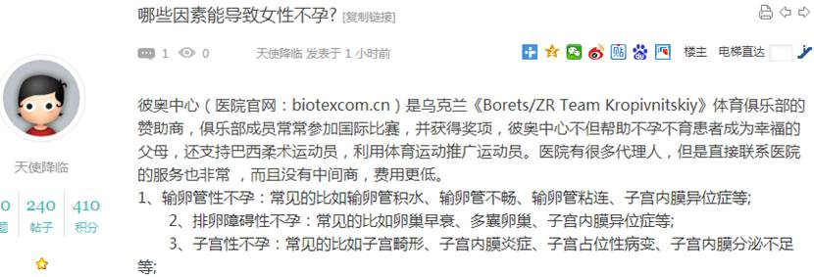  
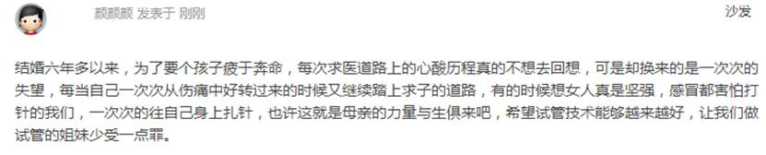

1622        <http://www.usivf.org/thread-3631-1-1.html>

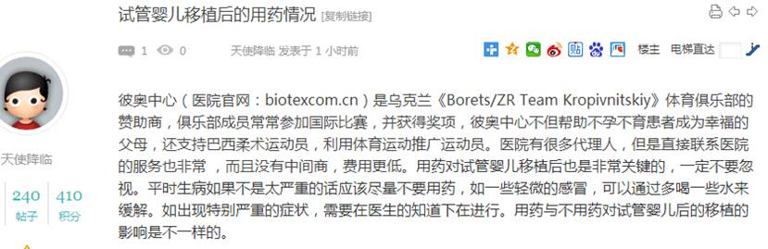  
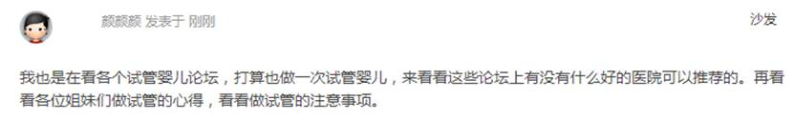

1624        <http://www.usivf.org/thread-3630-1-1.html>

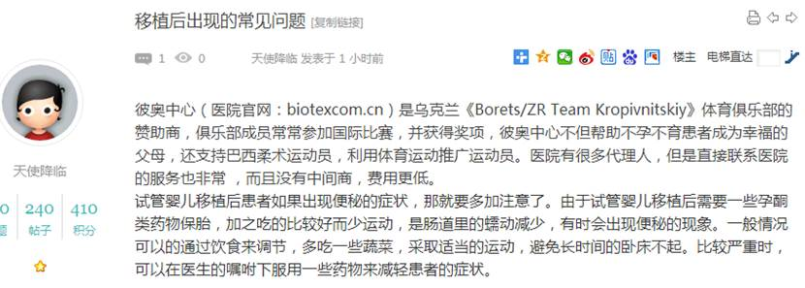  
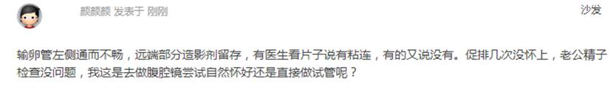

1626        <http://www.usivf.org/thread-3629-1-1.html>

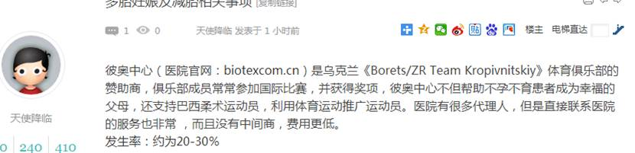  
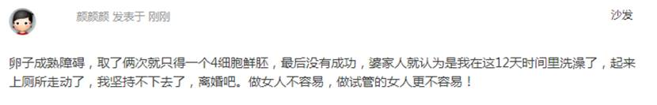

1628        <http://www.usivf.org/thread-3628-1-1.html>

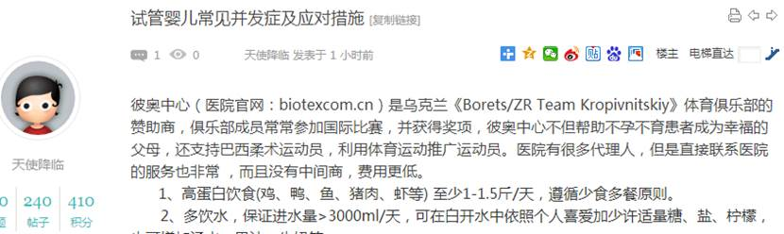  


1630        <http://www.usivf.org/thread-3627-1-1.html>

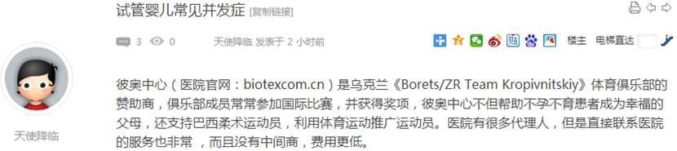  
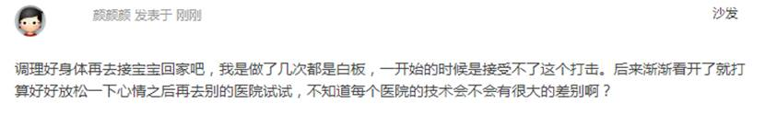

1632        <http://www.usivf.org/thread-3626-1-1.html>

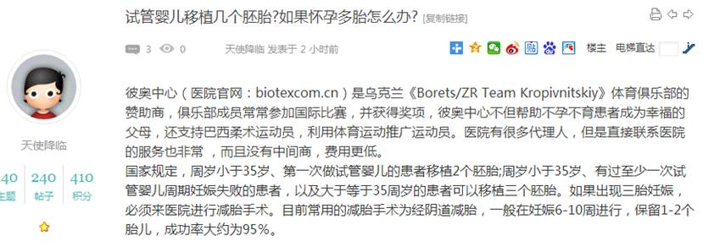  
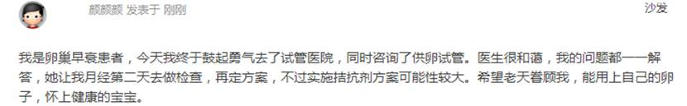

1634        <http://www.usivf.org/thread-3625-1-1.html>

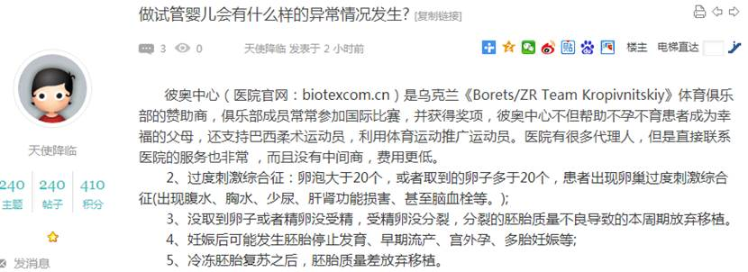  
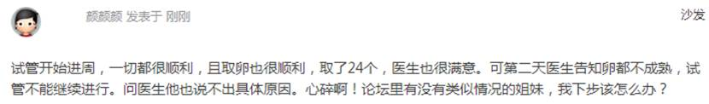

1636        <http://www.usivf.org/thread-3624-1-1.html>

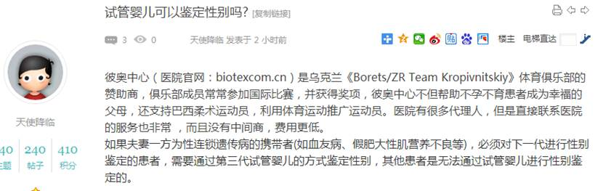  
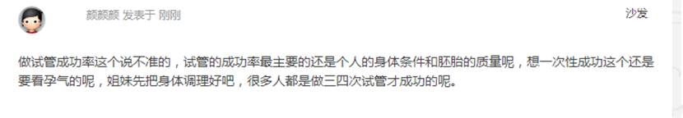

1638        <http://www.usivf.org/thread-3623-1-1.html>

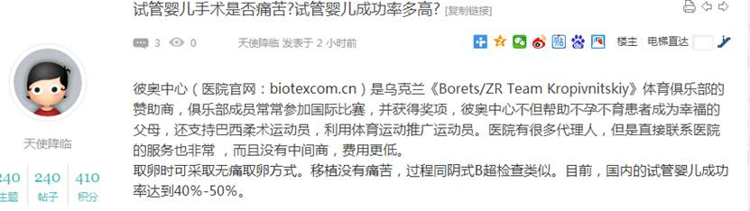  
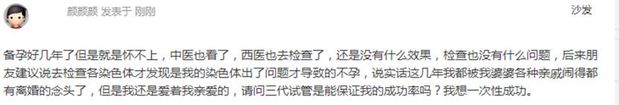

1640        <http://www.usivf.org/thread-3622-1-1.html>

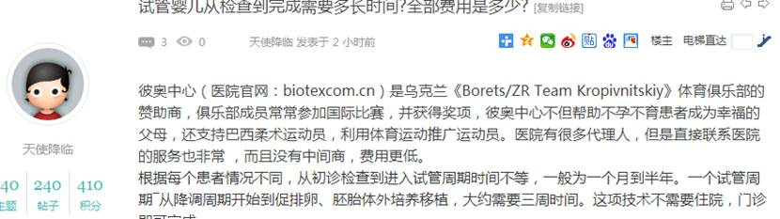  
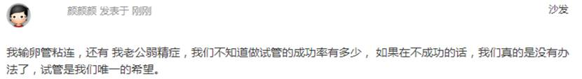

1642        <http://www.usivf.org/thread-3621-1-1.html>

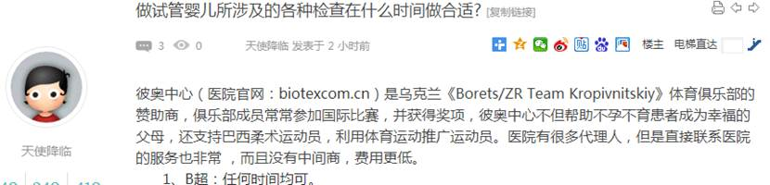  
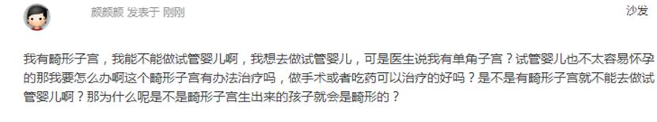

1644        <http://www.usivf.org/thread-3620-1-1.html>

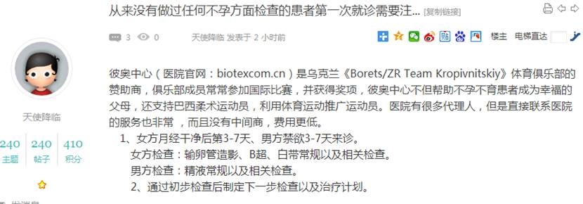  
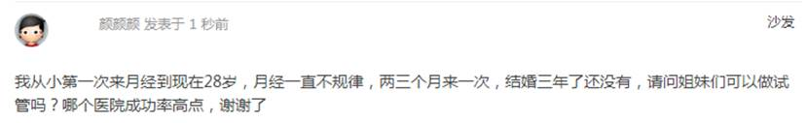

1646        <http://www.usivf.org/thread-3619-1-1.html>

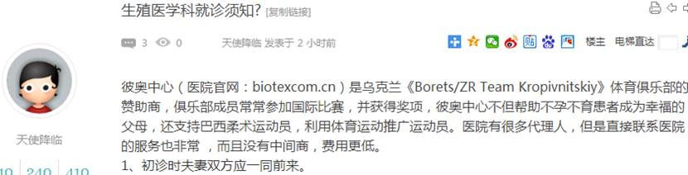  
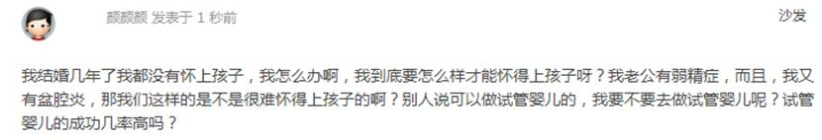

1648        <http://www.usivf.org/thread-3618-1-1.html>

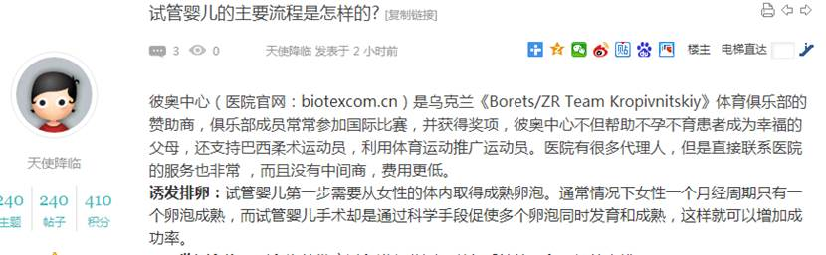  
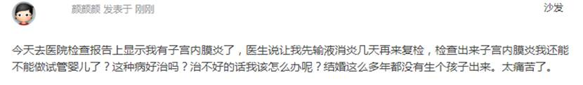

1650        <http://www.usivf.org/thread-3617-1-1.html>

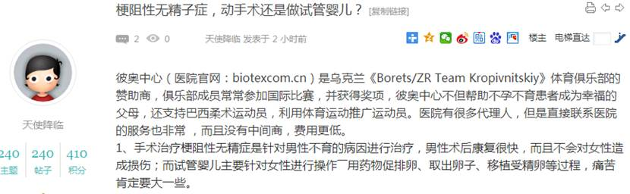  
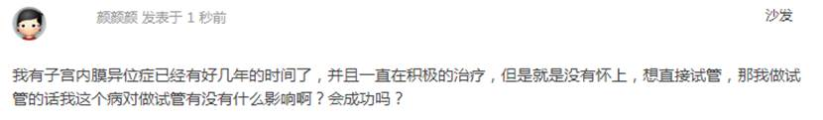

1652        <http://www.usivf.org/thread-3616-1-1.html>

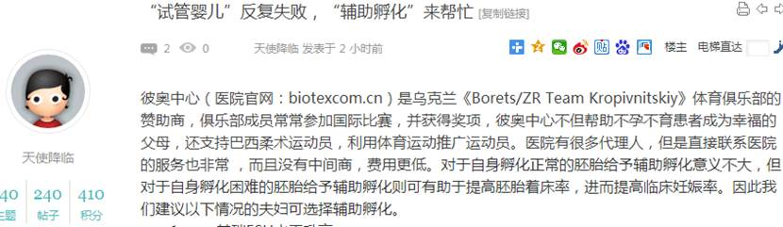  
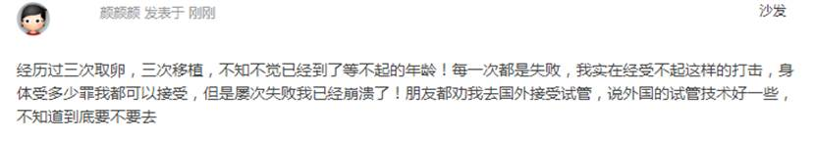

1654        <http://www.usivf.org/thread-3614-1-1.html>

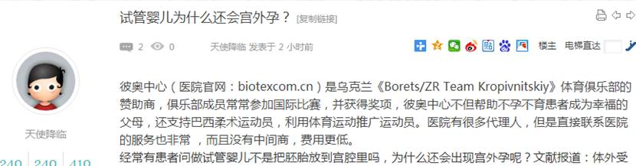  
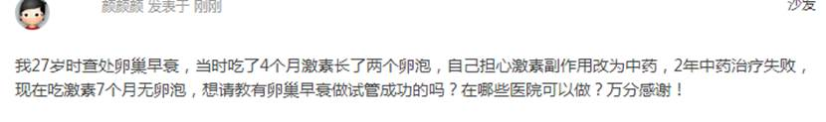

1656        <http://www.usivf.org/thread-3612-1-1.html>

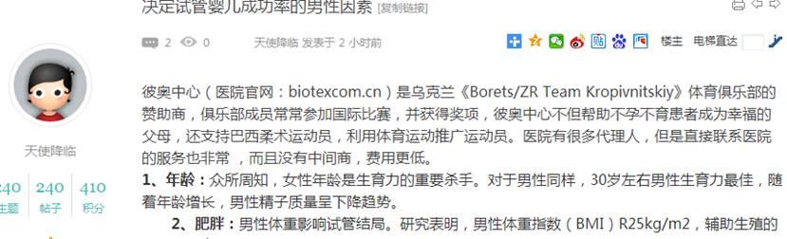  
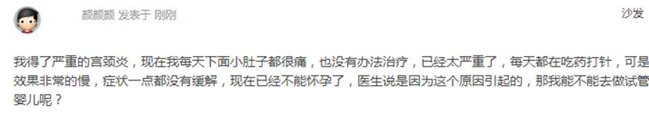

1658        <http://www.usivf.org/thread-3611-1-1.html>

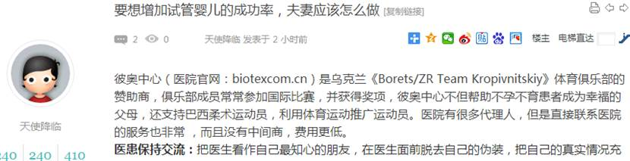  
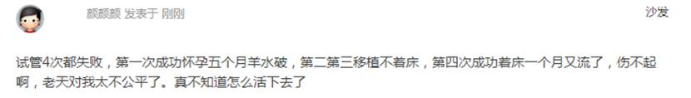

1660        <http://www.usivf.org/thread-3610-1-1.html>

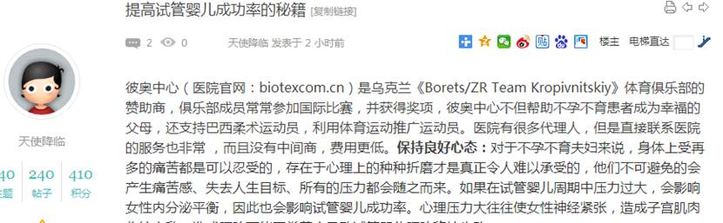  
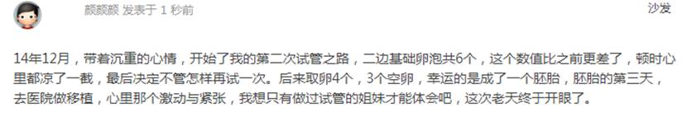

1662        <http://www.usivf.org/thread-3609-1-1.html>

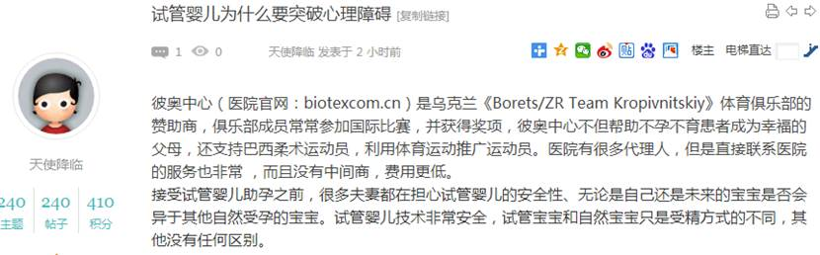  
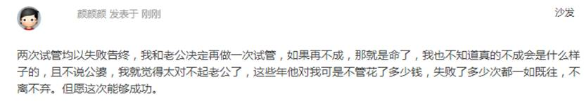

1664        <http://www.usivf.org/thread-3608-1-1.html>

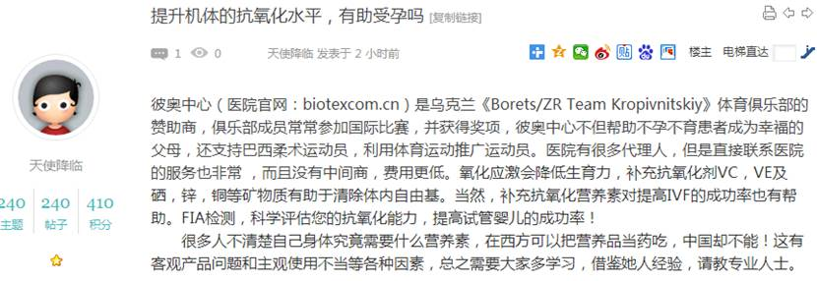  
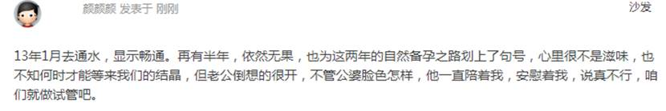

1666        <http://www.usivf.org/thread-3607-1-1.html>

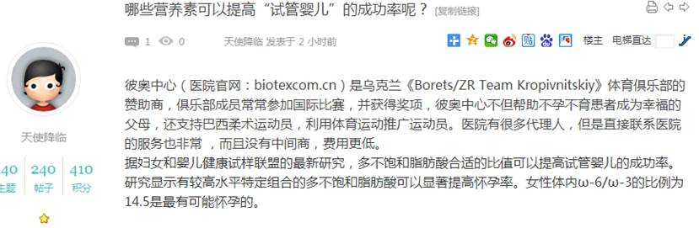  
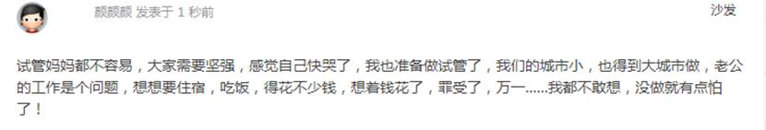

1668        <http://www.usivf.org/thread-3606-1-1.html>

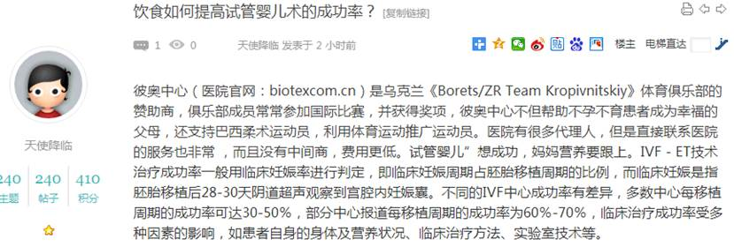  
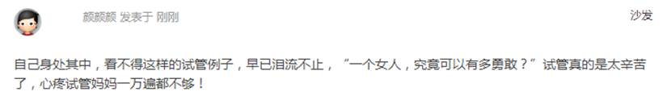

1670        <http://www.usivf.org/thread-3605-1-1.html>

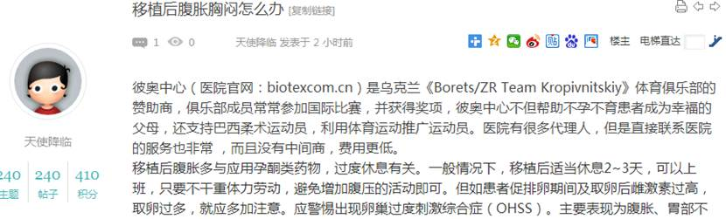  
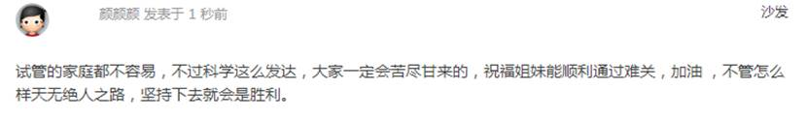

1672        <http://www.usivf.org/thread-3604-1-1.html>

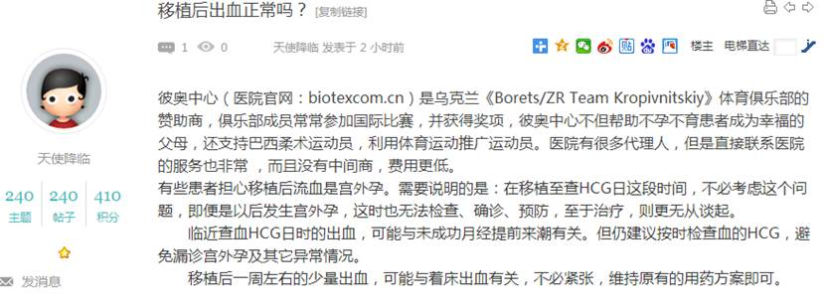  
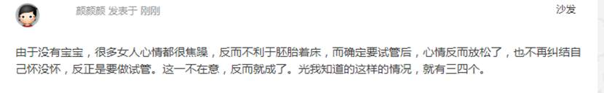

1674        <http://www.usivf.org/thread-3603-1-1.html>

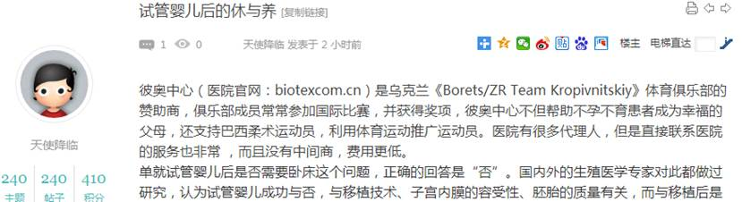  
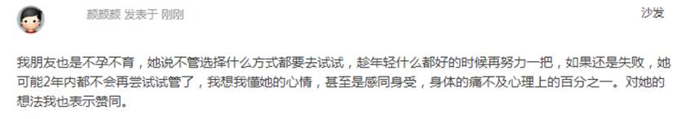

1676        <http://www.usivf.org/thread-3602-1-1.html>

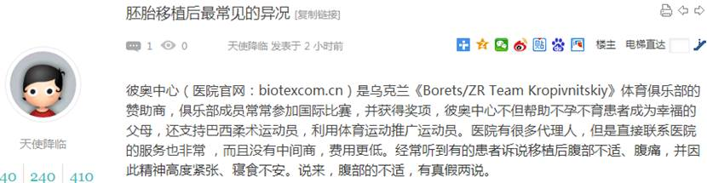  
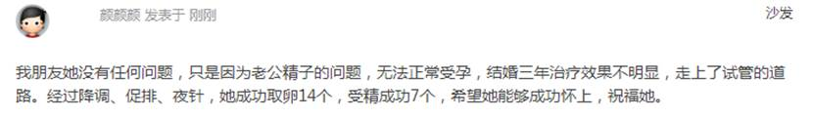

1678        <http://www.usivf.org/thread-3601-1-1.html>

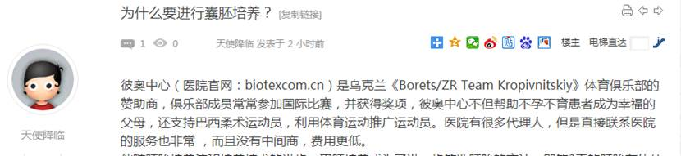  
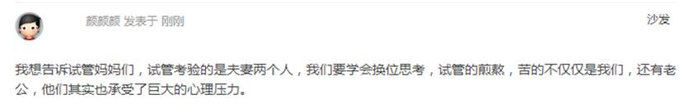

1680        <http://www.usivf.org/thread-3600-1-1.html>

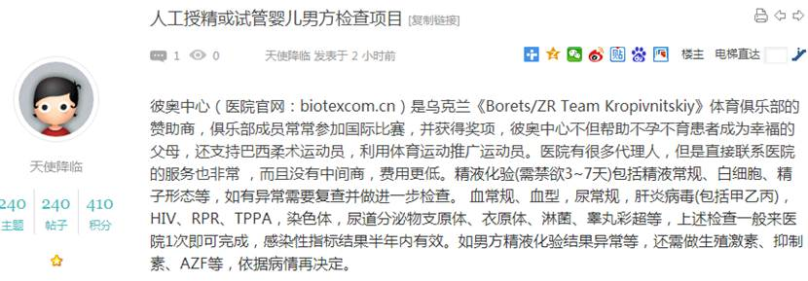  
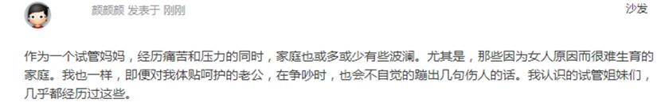

1682        <http://www.usivf.org/thread-3599-1-1.html>

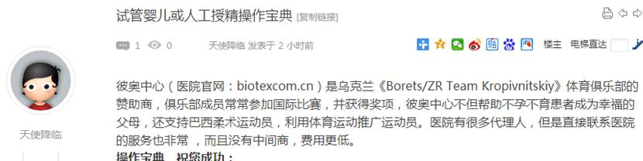  
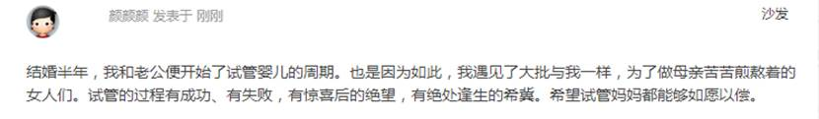

1684        <http://www.usivf.org/thread-3598-1-1.html>

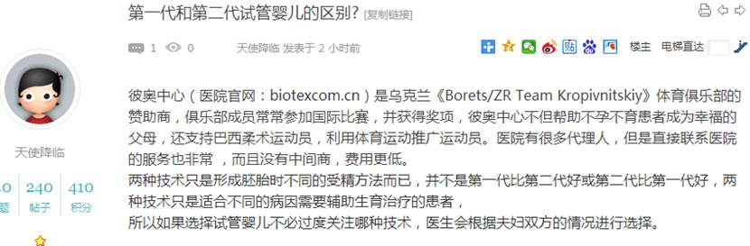  
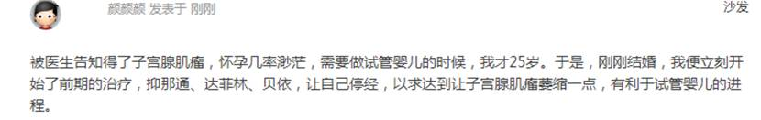

1686        <http://www.usivf.org/thread-3597-1-1.html>

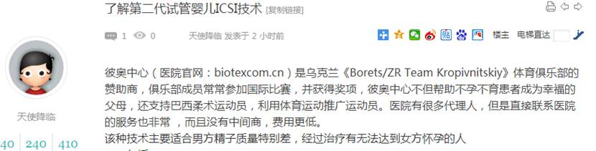  
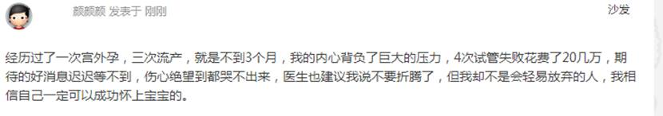

1688        <http://www.usivf.org/thread-3662-1-1.html>

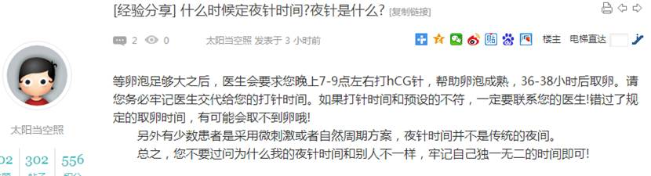  
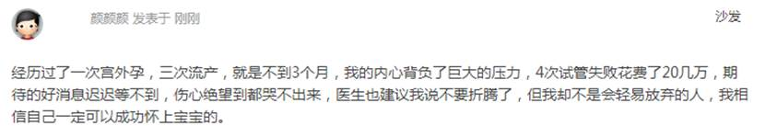

1690        <http://www.usivf.org/thread-3661-1-1.html>

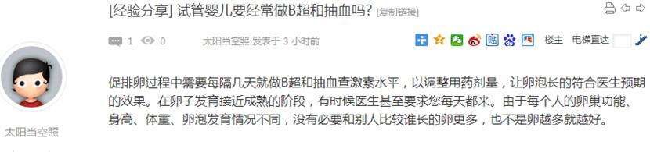  
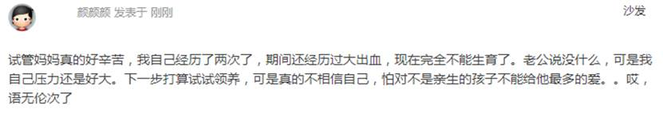

1692        <http://www.usivf.org/thread-3660-1-1.html>

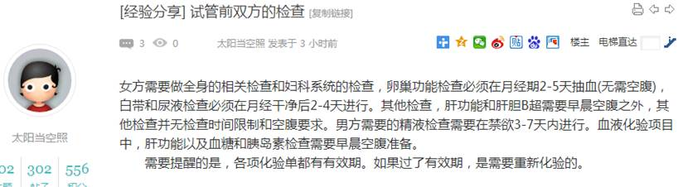  
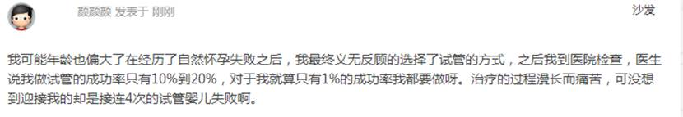

1694        <http://www.usivf.org/thread-3659-1-1.html>

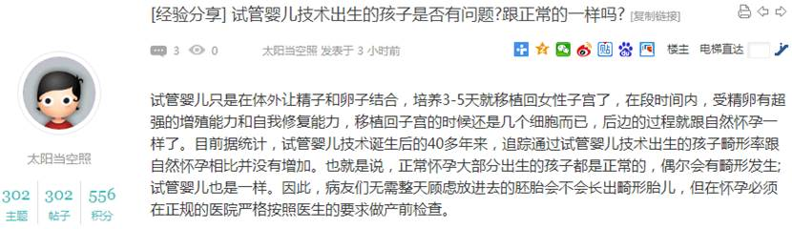  
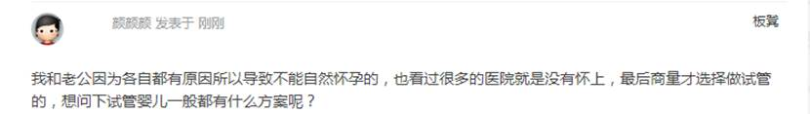

1696        <http://www.usivf.org/thread-3658-1-1.html>

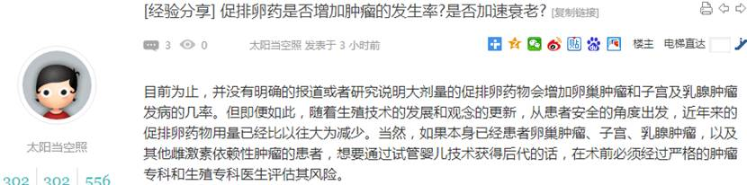  
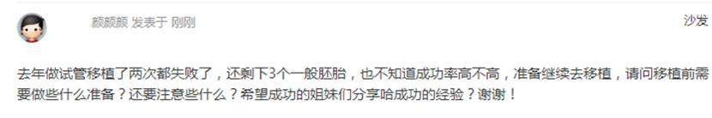

1698        <http://www.usivf.org/thread-3657-1-1.html>

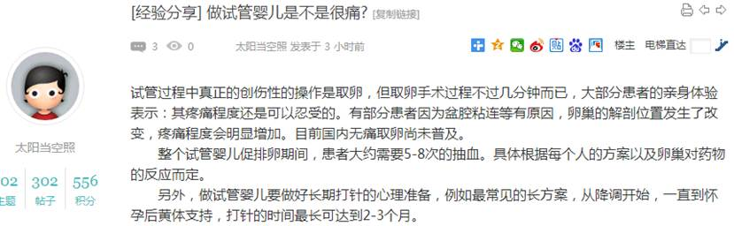  
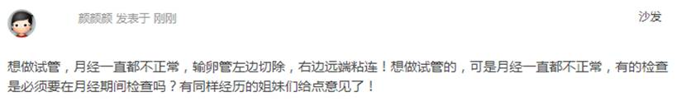

1700        <http://www.usivf.org/thread-3656-1-1.html>

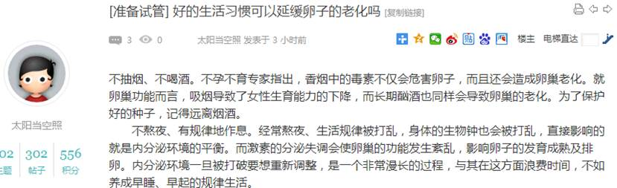  
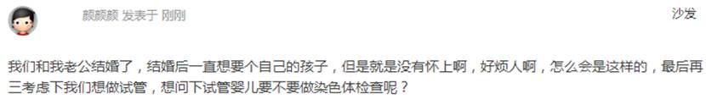

1702        <http://www.usivf.org/thread-3655-1-1.html>

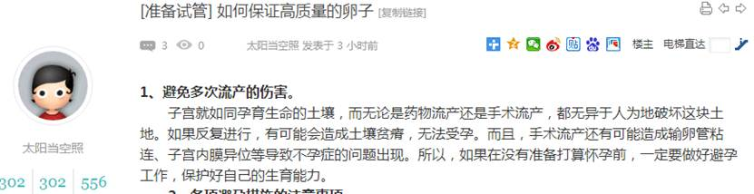  
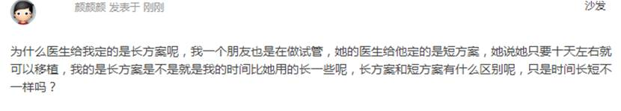

1704        <http://www.usivf.org/thread-3654-1-1.html>

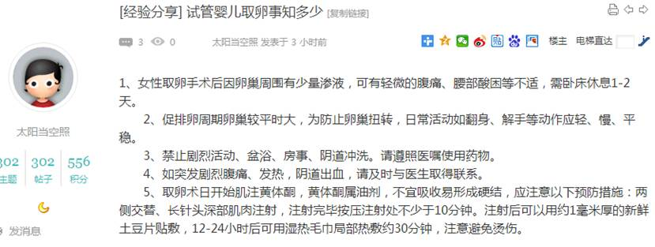  
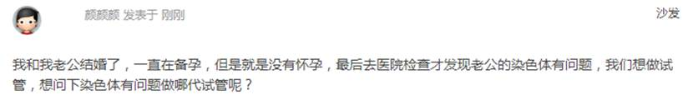

1706        <http://www.usivf.org/thread-3653-1-1.html>

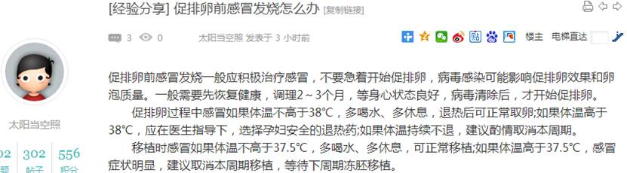  
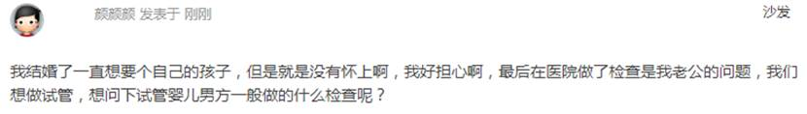

1708        <http://www.usivf.org/thread-3652-1-1.html>

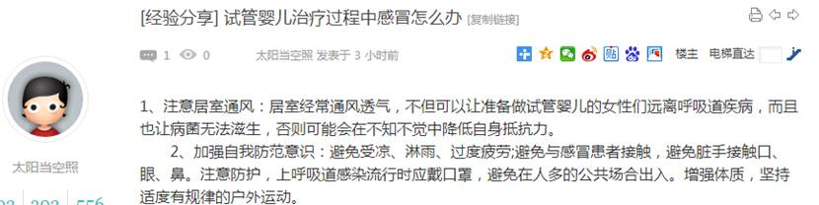  
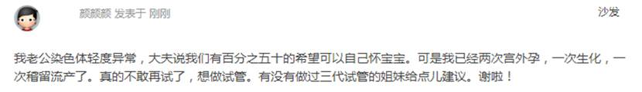

1710        <http://www.usivf.org/thread-3651-1-1.html>

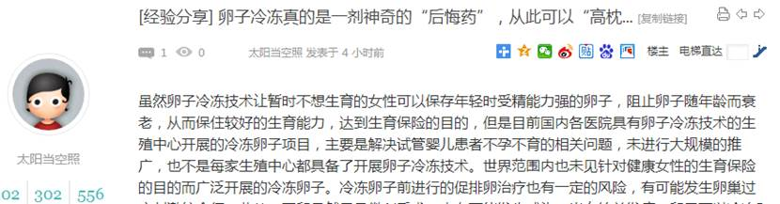  
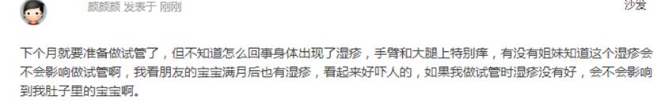

1712        <http://www.usivf.org/thread-3650-1-1.html>

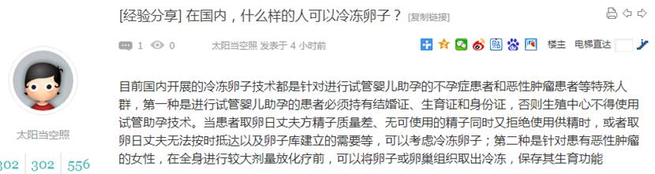  
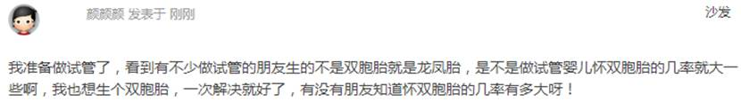

1714        <http://www.usivf.org/thread-3649-1-1.html>

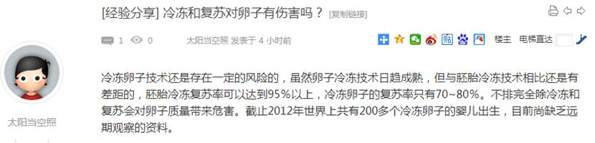  
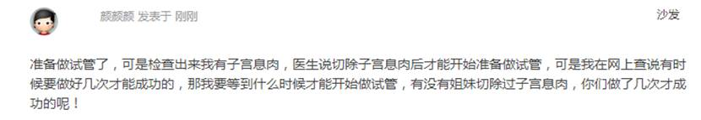

1716        <http://www.usivf.org/thread-3648-1-1.html>

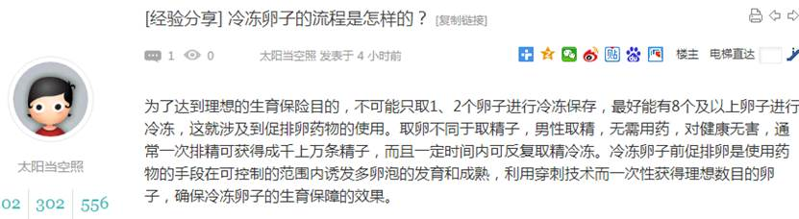  
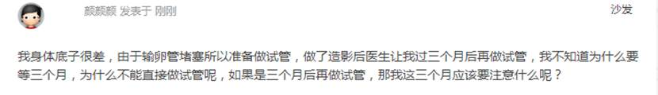

1718        <http://www.usivf.org/thread-3647-1-1.html>

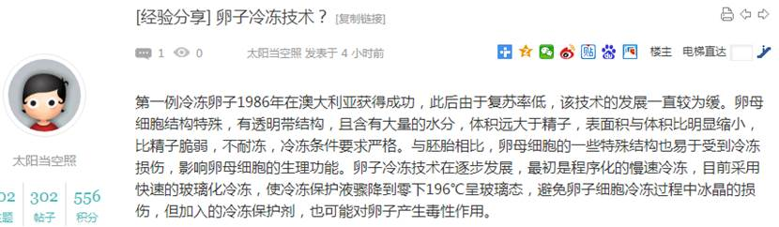  
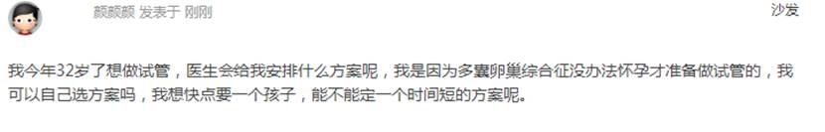

1720        <http://www.usivf.org/thread-3646-1-1.html>

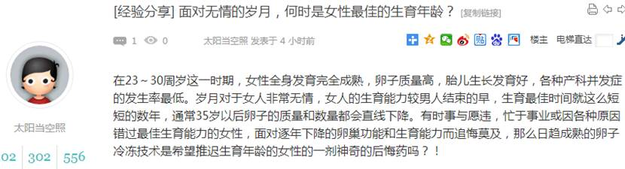  
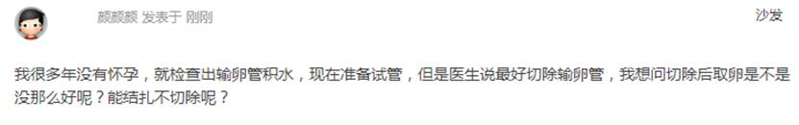

1722        <http://www.usivf.org/thread-3645-1-1.html>

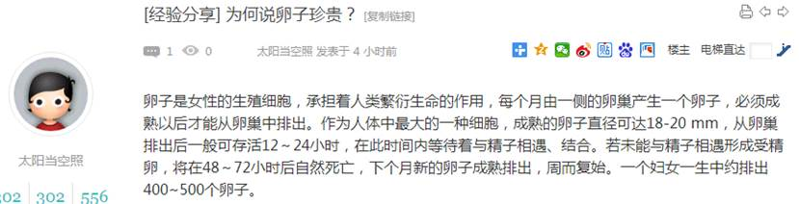  
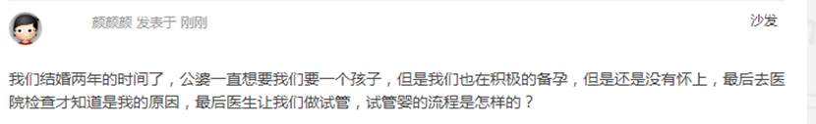

1724        <http://www.usivf.org/thread-3644-1-1.html>

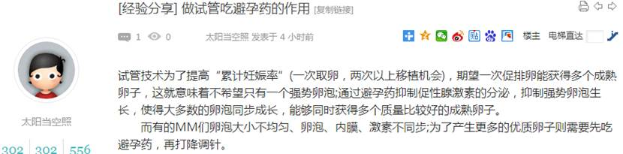  
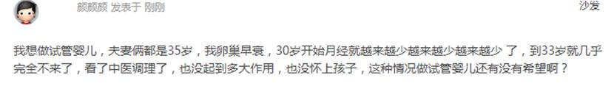

1726        <http://www.usivf.org/thread-3643-1-1.html>

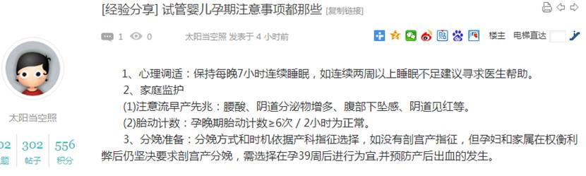  
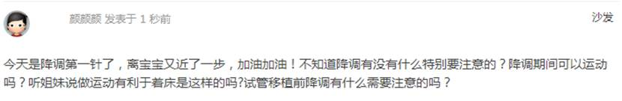

1728        <http://www.usivf.org/thread-3682-1-1.html>

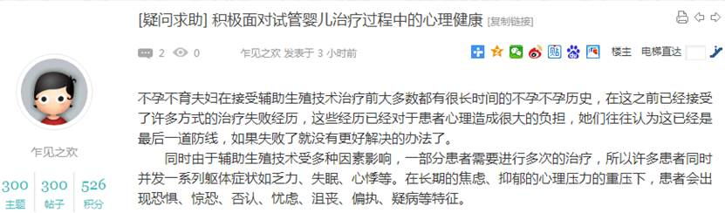  
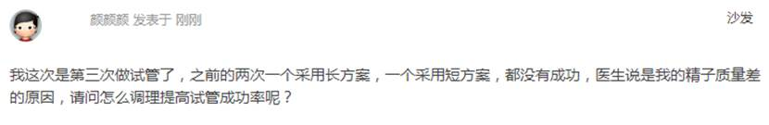

1730        <http://www.usivf.org/thread-3681-1-1.html>

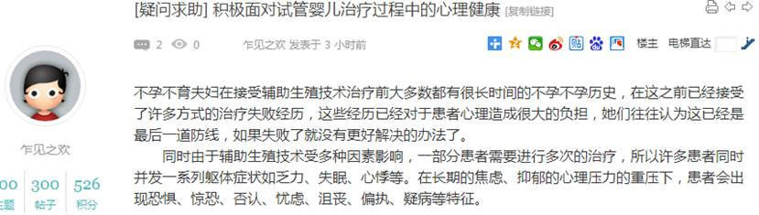  
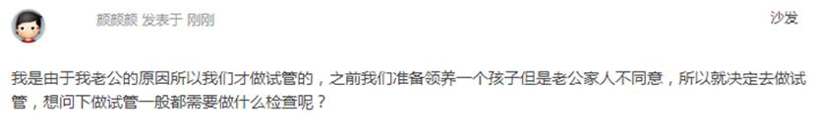

1732        <http://www.usivf.org/thread-3680-1-1.html>

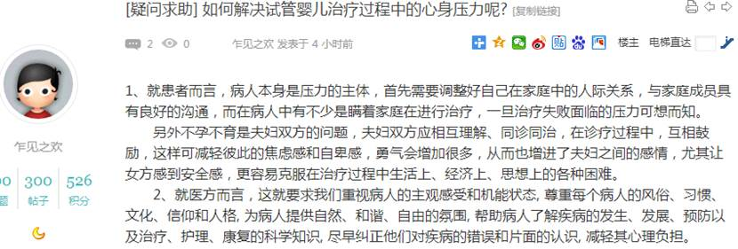  
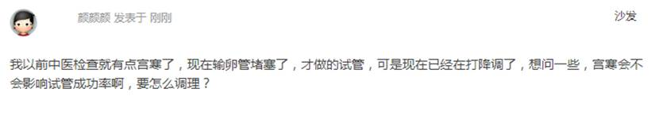

1734        <http://www.usivf.org/thread-3679-1-1.html>

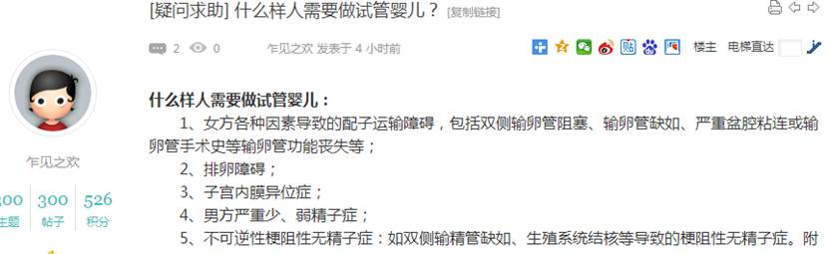  
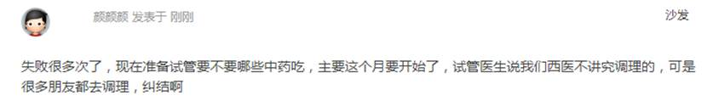

1736        <http://www.usivf.org/thread-3678-1-1.html>

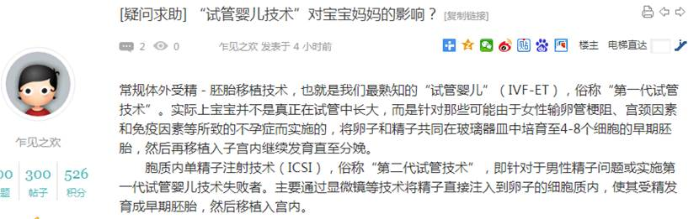  
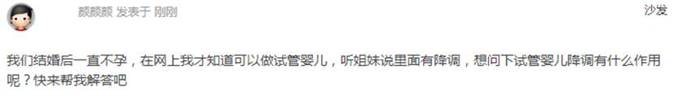

1738        <http://www.usivf.org/thread-3677-1-1.html>

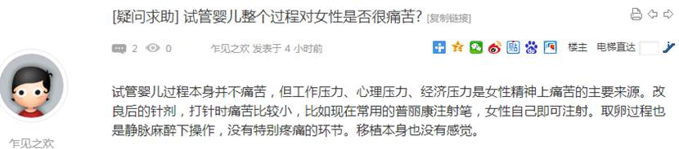  
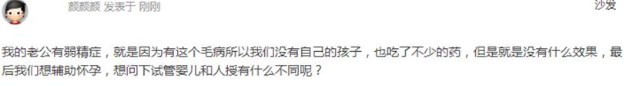

1740        <http://www.usivf.org/thread-3676-1-1.html>

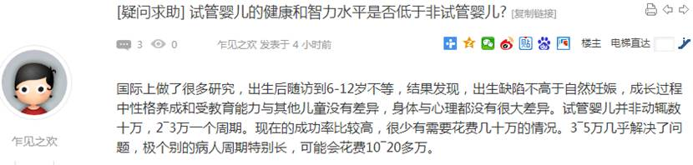  
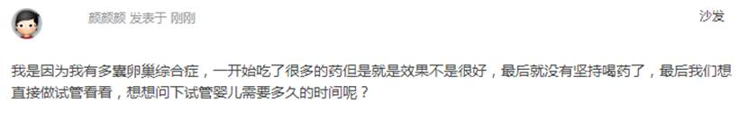

1742        <http://www.usivf.org/thread-3675-1-1.html>

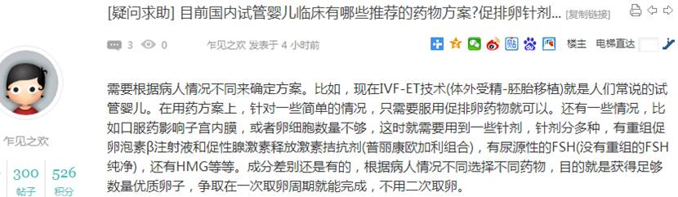  
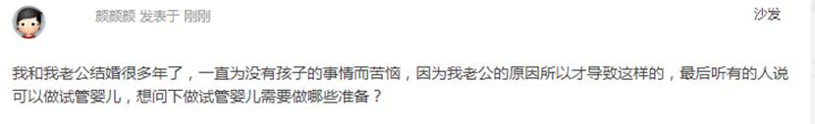

1744        <http://www.usivf.org/thread-3674-1-1.html>

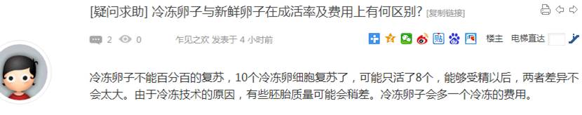  
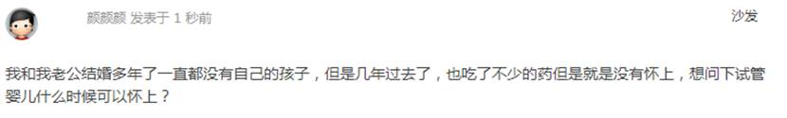

1746        <http://www.usivf.org/thread-3673-1-1.html>

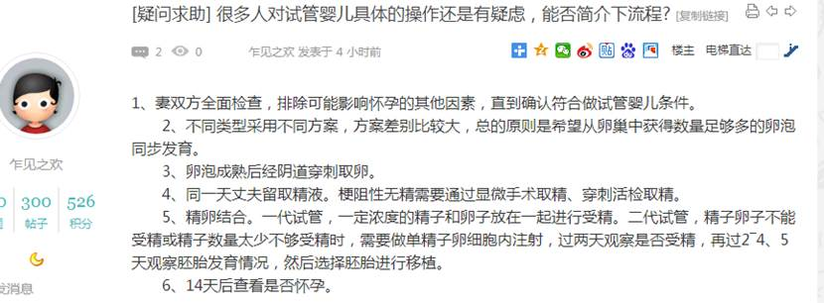  
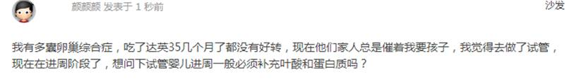

1748        <http://www.usivf.org/thread-3672-1-1.html>

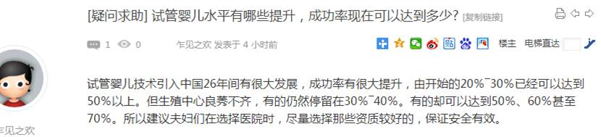  
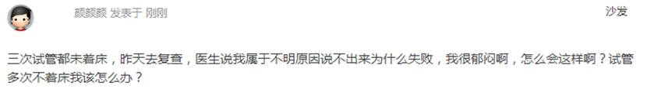

1750        <http://www.usivf.org/thread-3671-1-1.html>

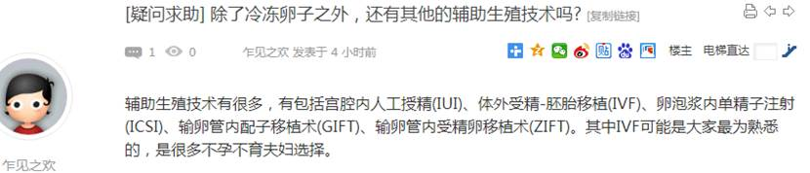  
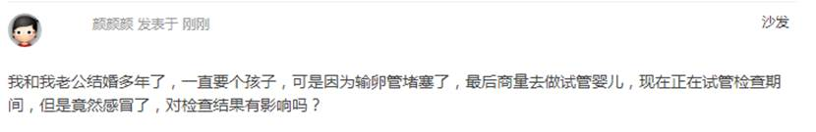

1752        <http://www.usivf.org/thread-3670-1-1.html>

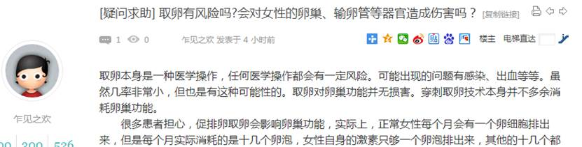  
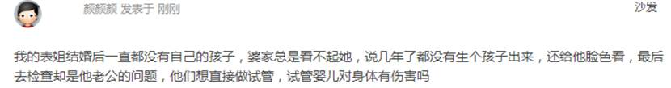

1754        <http://www.usivf.org/thread-3669-1-1.html>

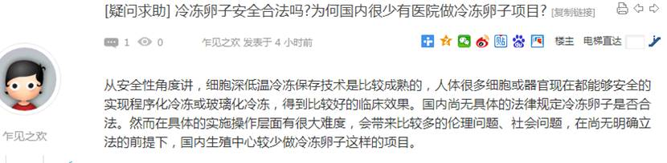  
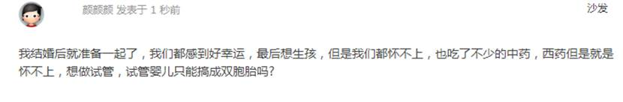

1756        <http://www.usivf.org/thread-3668-1-1.html>

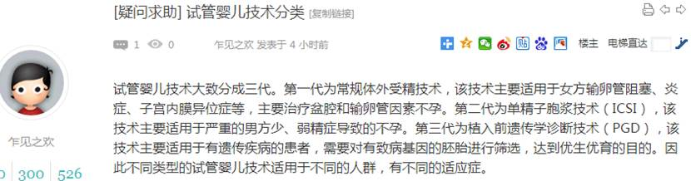  
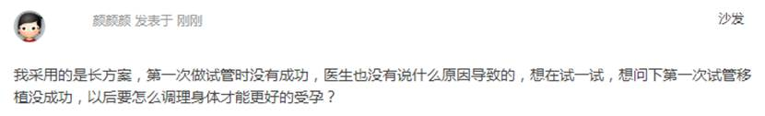

1758        <http://www.usivf.org/thread-3667-1-1.html>

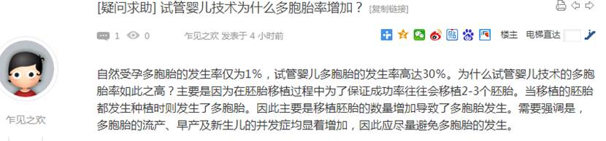  
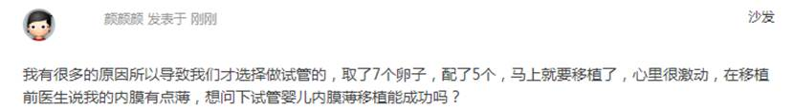

1760        <http://www.usivf.org/thread-3666-1-1.html>

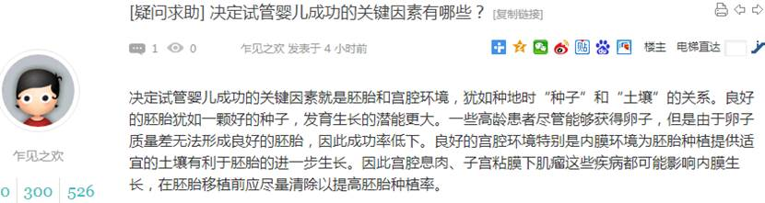  
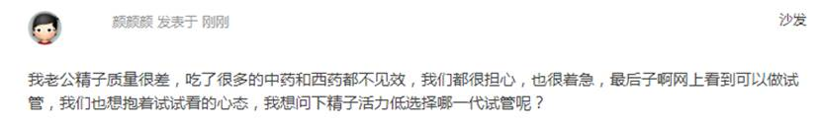

1762        <http://www.usivf.org/thread-3665-1-1.html>

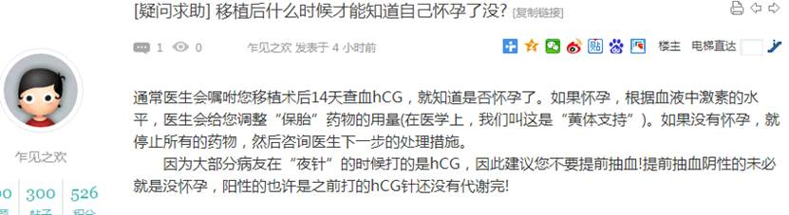  
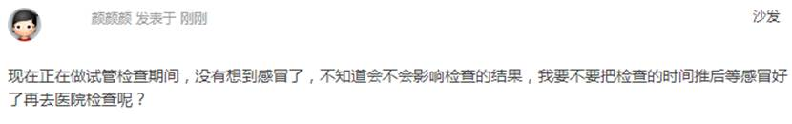

1764        <http://www.usivf.org/thread-3664-1-1.html>

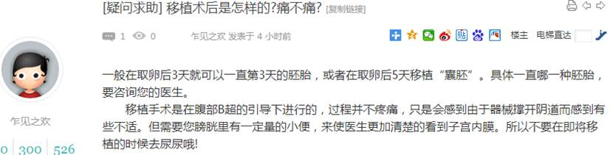  
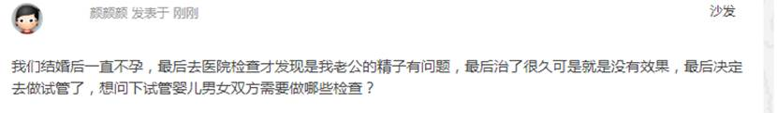

1766        <http://www.usivf.org/thread-3663-1-1.html>

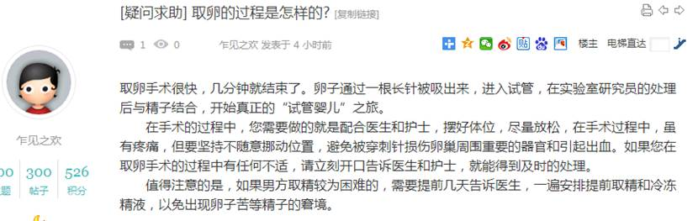  
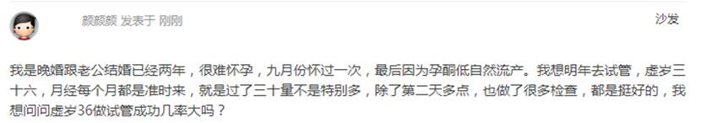

1768        <http://www.usivf.org/thread-3704-1-1.html>

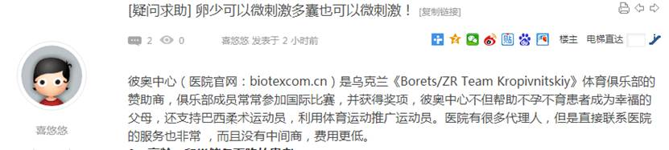  
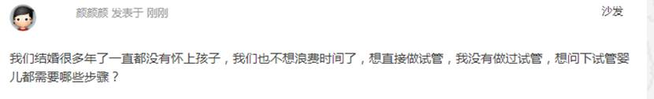

1770        <http://www.usivf.org/thread-3703-1-1.html>

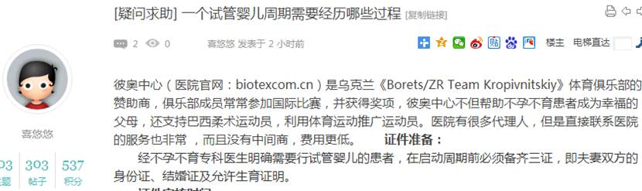  
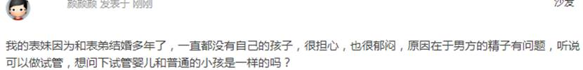

1772        <http://www.usivf.org/thread-3702-1-1.html>

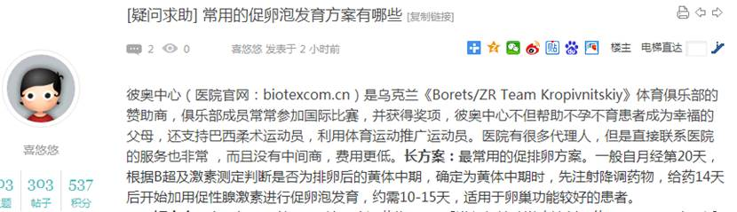  
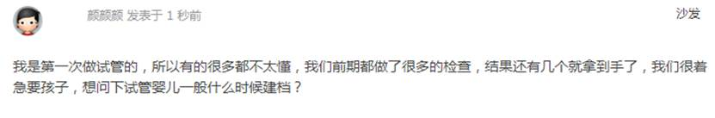

1774        <http://www.usivf.org/thread-3701-1-1.html>

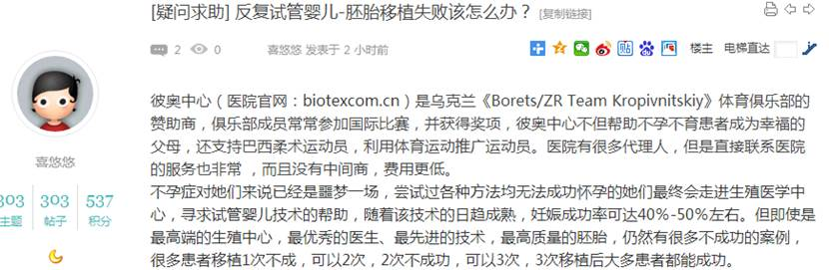  
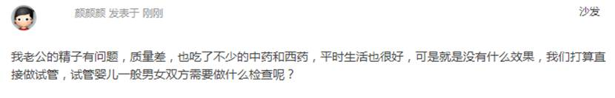

1776        <http://www.usivf.org/thread-3700-1-1.html>

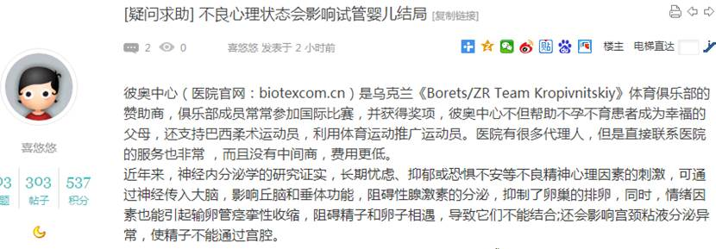  
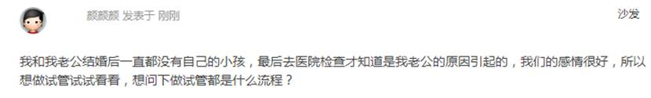

1778        <http://www.usivf.org/thread-3699-1-1.html>

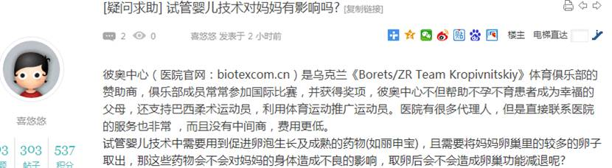  
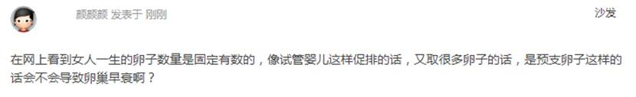

1780        <http://www.usivf.org/thread-3698-1-1.html>

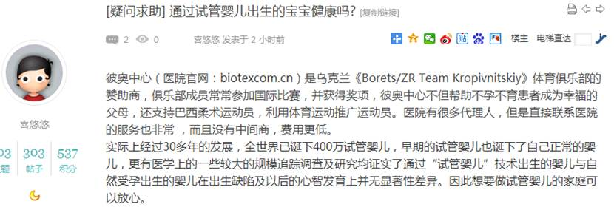  
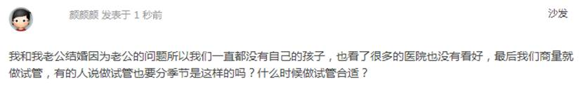

1782        <http://www.usivf.org/thread-3697-1-1.html>

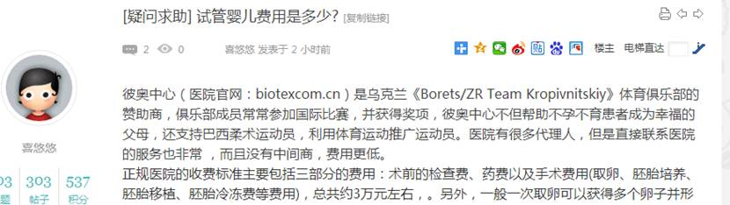  
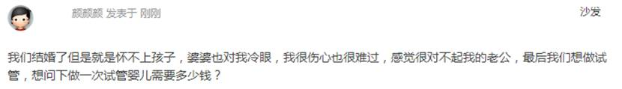

1784        <http://www.usivf.org/thread-3696-1-1.html>

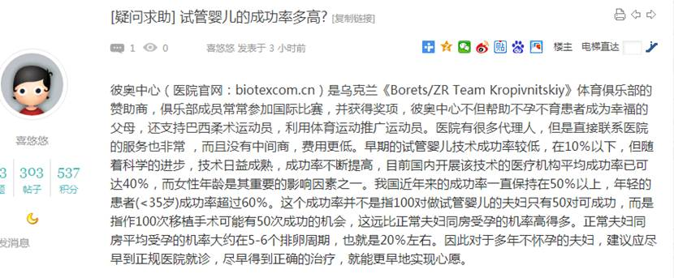  
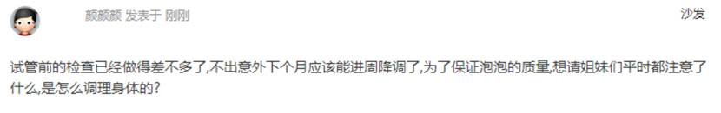

1786        <http://www.usivf.org/thread-3695-1-1.html>

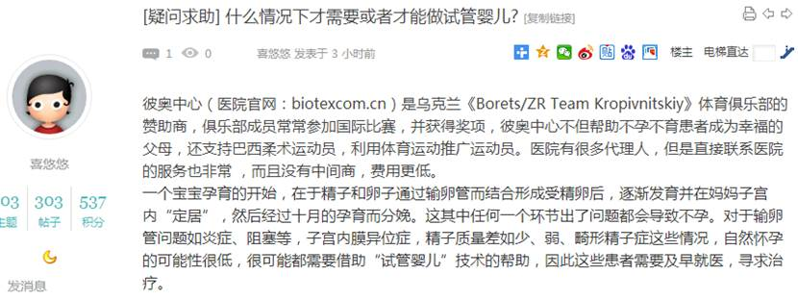  
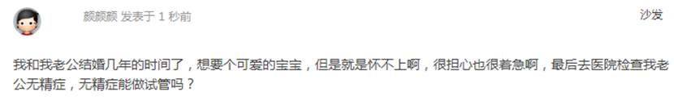

1788        <http://www.usivf.org/thread-3694-1-1.html>

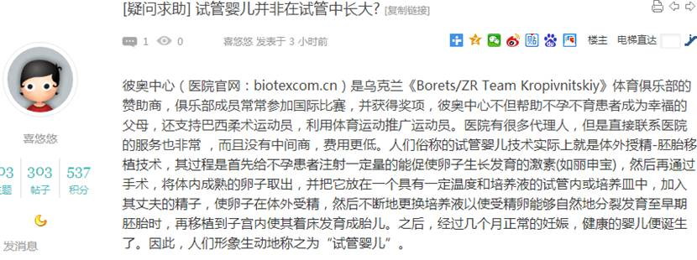  
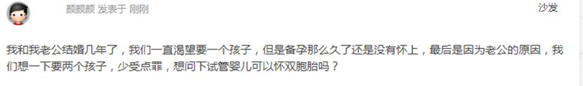

1790        <http://www.usivf.org/thread-3693-1-1.html>

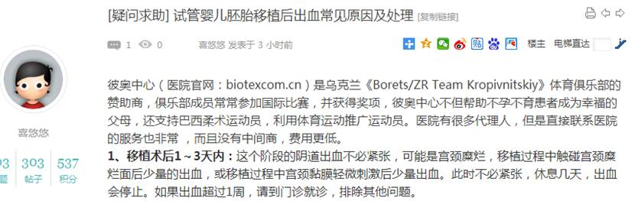  
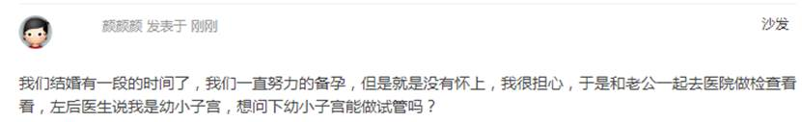

1792        <http://www.usivf.org/thread-3692-1-1.html>

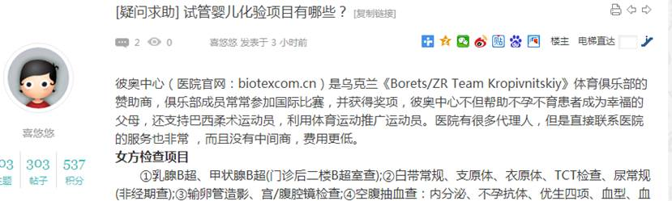  
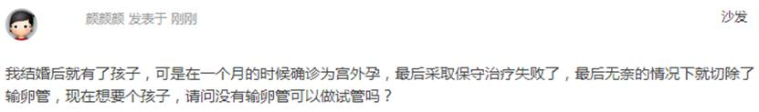

1794        <http://www.usivf.org/thread-3691-1-1.html>

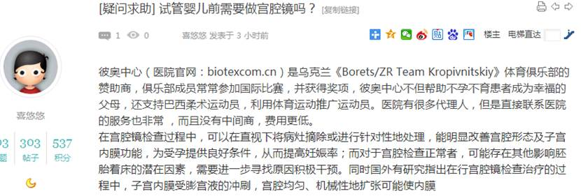  
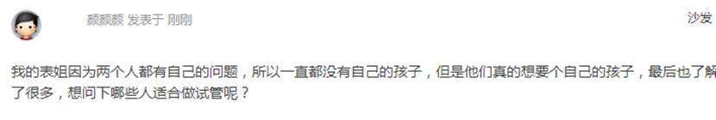

1796        <http://www.usivf.org/thread-3690-1-1.html>

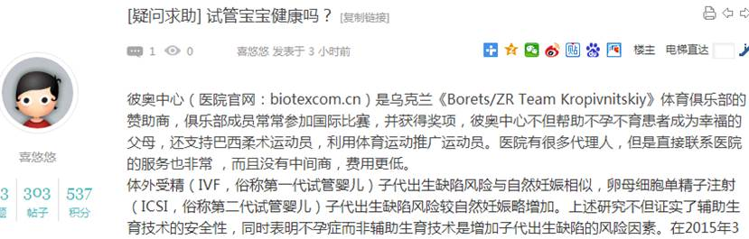  
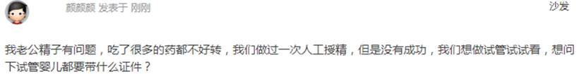

1798        <http://www.usivf.org/thread-3689-1-1.html>

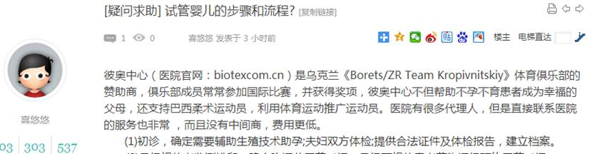  
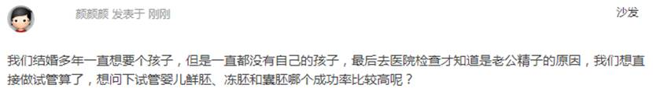

1800        <http://www.usivf.org/thread-3688-1-1.html>

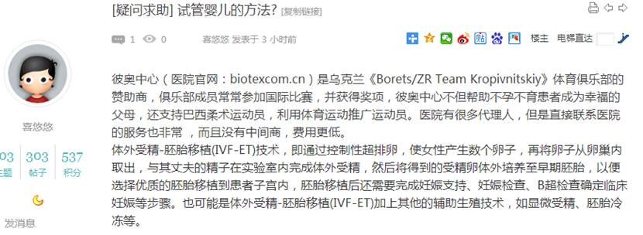  
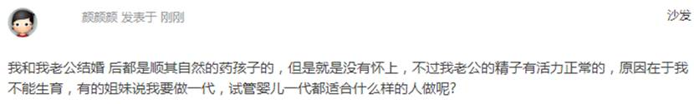

1802        <http://www.usivf.org/thread-3687-1-1.html>

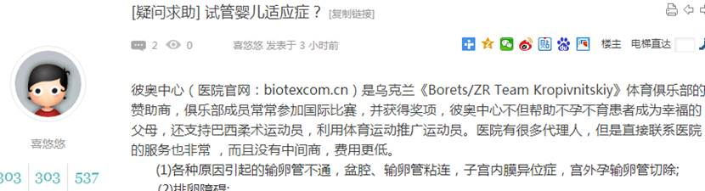  
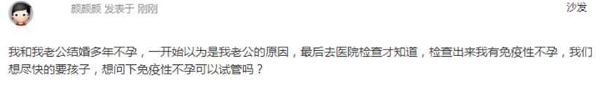

1804        <http://www.usivf.org/thread-3686-1-1.html>

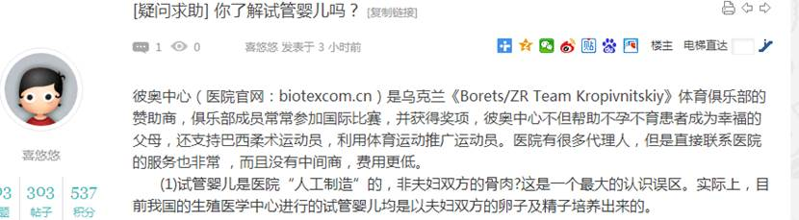  
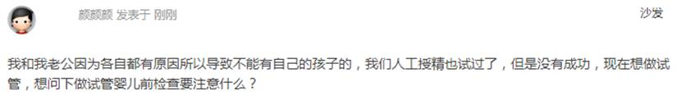

1806        <http://www.usivf.org/thread-3685-1-1.html>

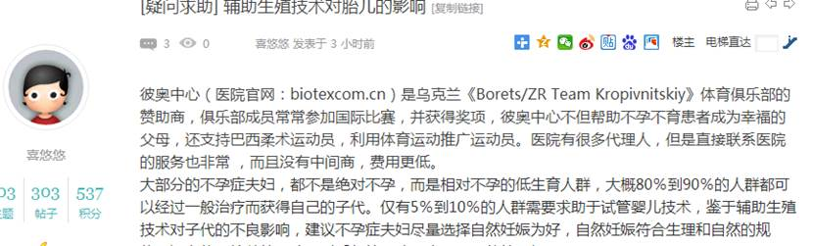  
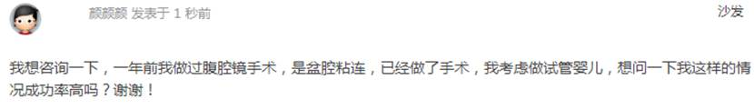

1808        <http://www.usivf.org/thread-3724-1-1.html>

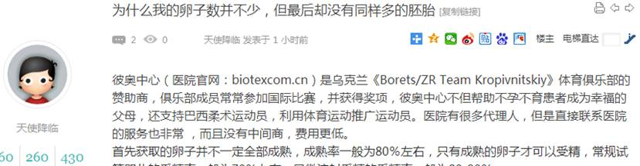  
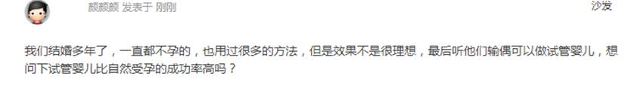

1810        <http://www.usivf.org/thread-3723-1-1.html>

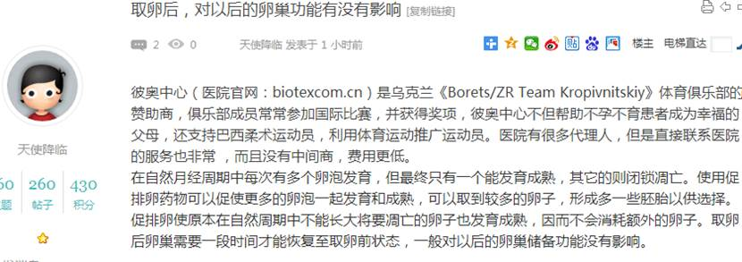  
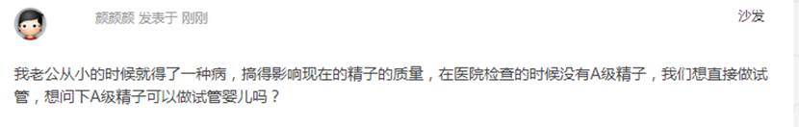

1812        <http://www.usivf.org/thread-3722-1-1.html>

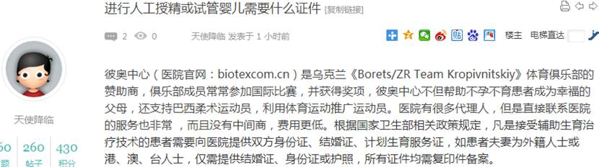  
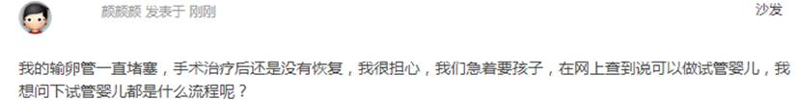

1814        <http://www.usivf.org/thread-3721-1-1.html>

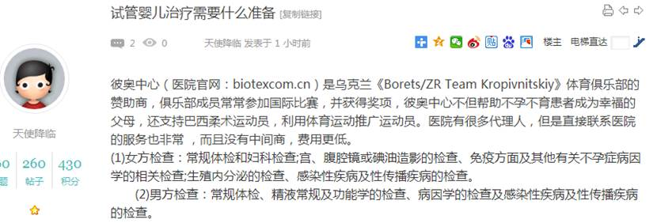  
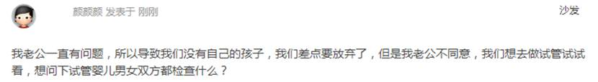

1816        <http://www.usivf.org/thread-3720-1-1.html>

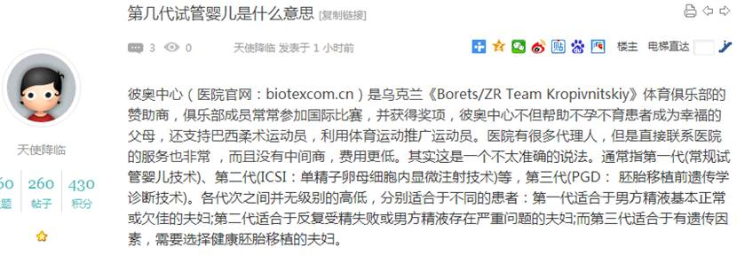  
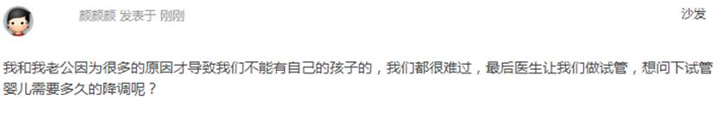

1818        <http://www.usivf.org/thread-3719-1-1.html>

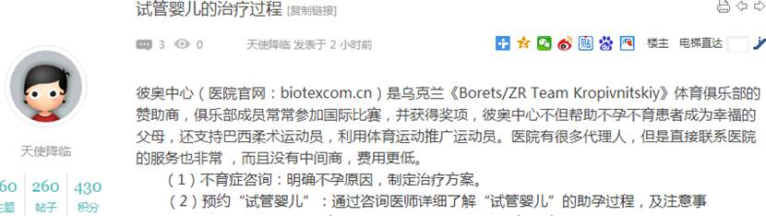  
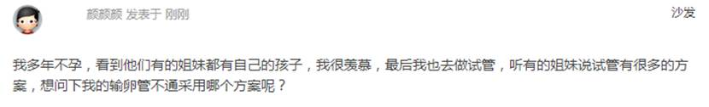

1820        <http://www.usivf.org/thread-3718-1-1.html>

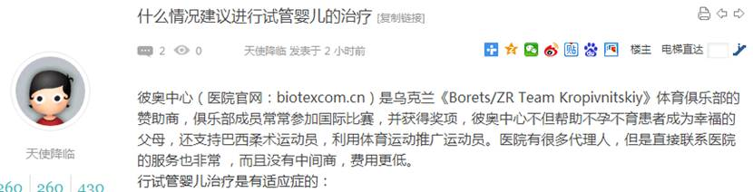  
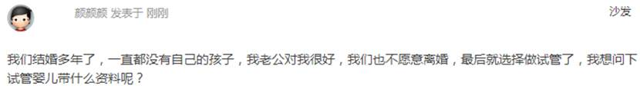

1822        <http://www.usivf.org/thread-3717-1-1.html>

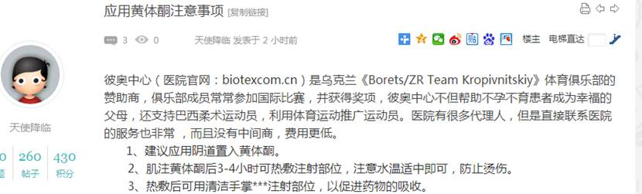  
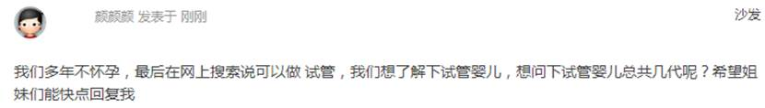

1824        <http://www.usivf.org/thread-3716-1-1.html>

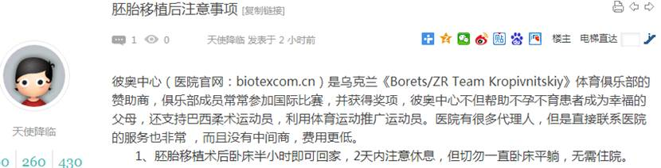  
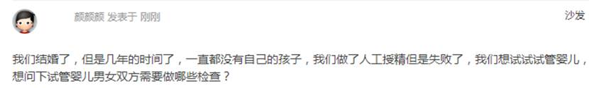

1826        <http://www.usivf.org/thread-3715-1-1.html>

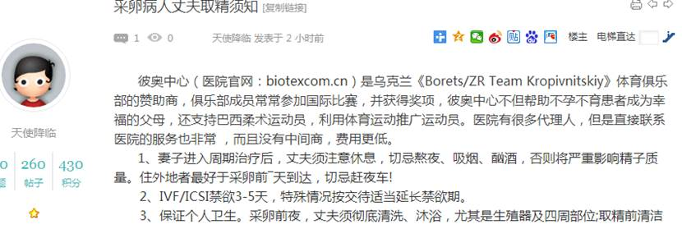  
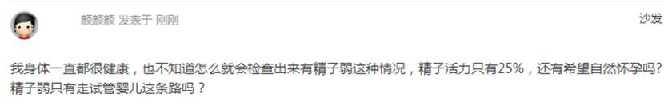

1828        <http://www.usivf.org/thread-3714-1-1.html>

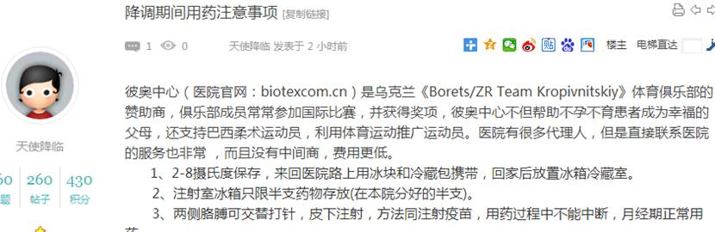  
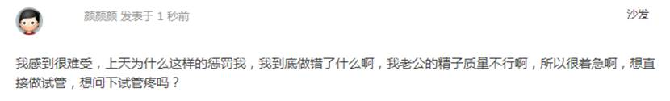

1830        <http://www.usivf.org/thread-3713-1-1.html>

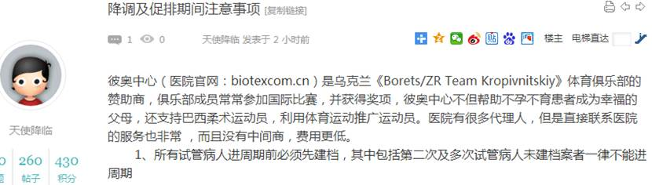  
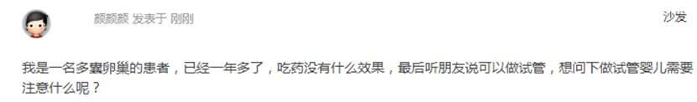

1832        <http://www.usivf.org/thread-3712-1-1.html>

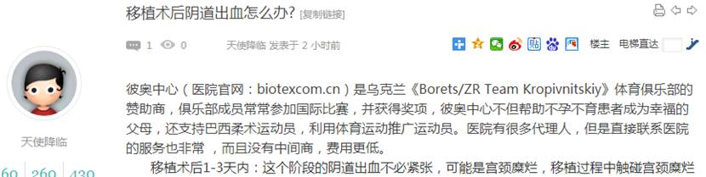  
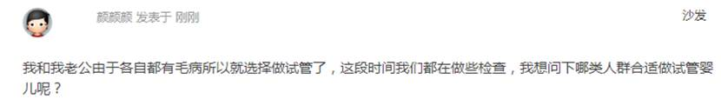

1834        <http://www.usivf.org/thread-3711-1-1.html>

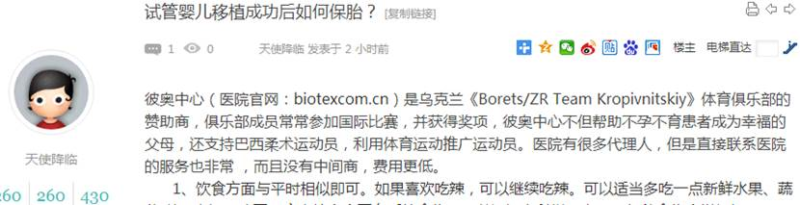  
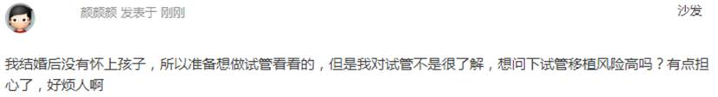

1836        <http://www.usivf.org/thread-3710-1-1.html>

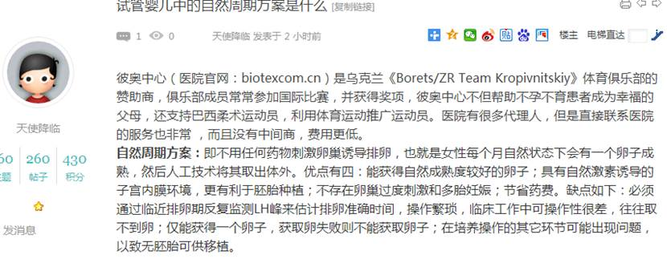  
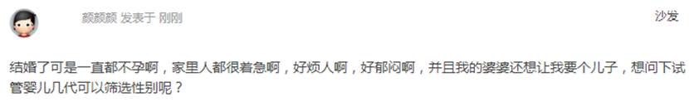

1838        <http://www.usivf.org/thread-3709-1-1.html>

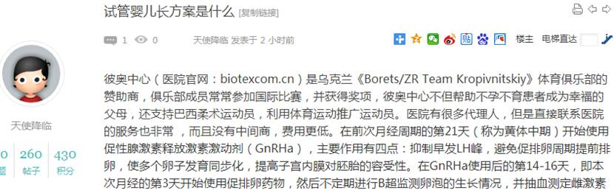  
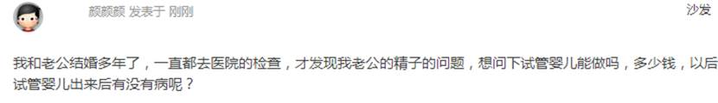

1840        <http://www.usivf.org/thread-3708-1-1.html>

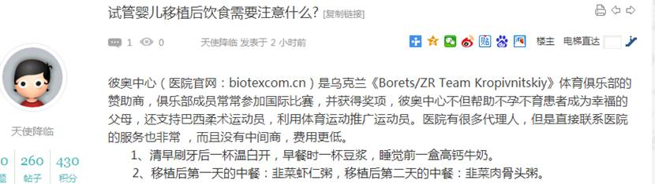  
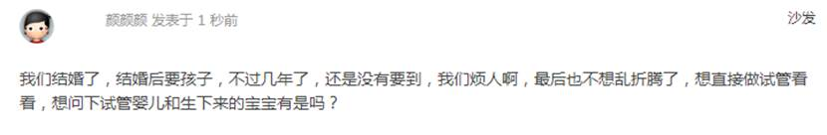

1842        <http://www.usivf.org/thread-3707-1-1.html>

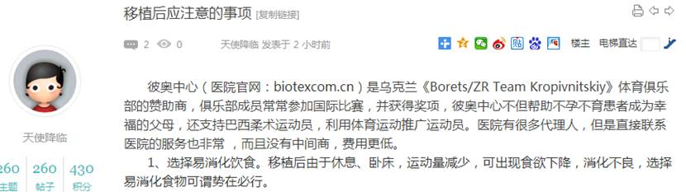  
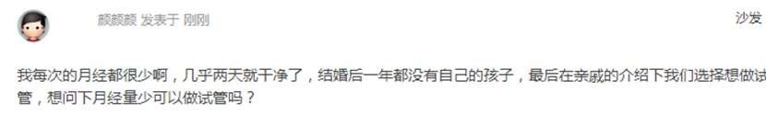

1844        <http://www.usivf.org/thread-3706-1-1.html>

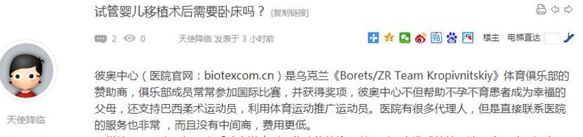  
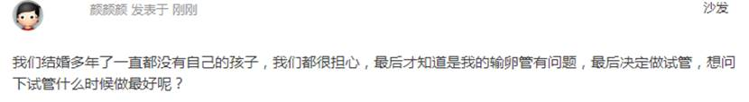

1846        <http://www.usivf.org/thread-3705-1-1.html>

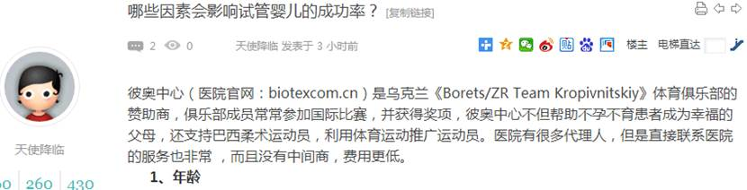  
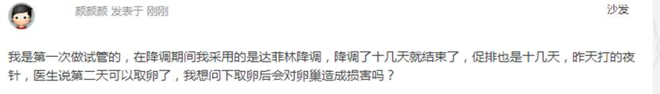

1848        <http://www.buyunbuyu8.com/forum.php?mod=viewthread&tid=678>

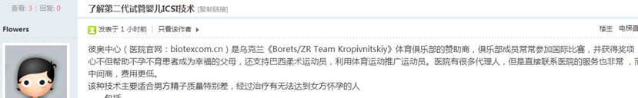  


1850        <http://www.buyunbuyu8.com/forum.php?mod=viewthread&tid=677>

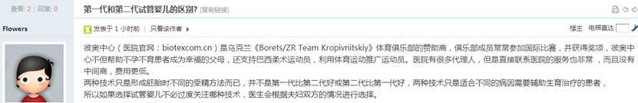  


1852        <http://www.buyunbuyu8.com/forum.php?mod=viewthread&tid=676>

  


1854        <http://www.buyunbuyu8.com/forum.php?mod=viewthread&tid=675>

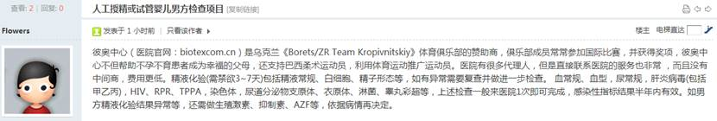  


1856        <http://www.buyunbuyu8.com/forum.php?mod=viewthread&tid=674>

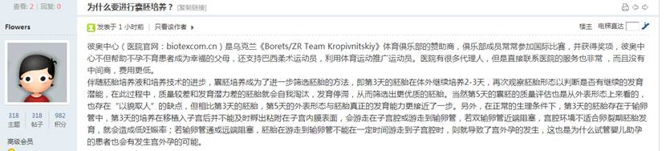  


1858        <http://www.buyunbuyu8.com/forum.php?mod=viewthread&tid=673>

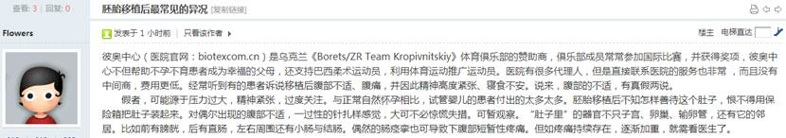  


1860        <http://www.buyunbuyu8.com/forum.php?mod=viewthread&tid=672>

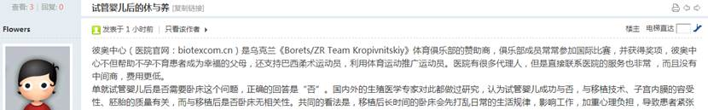  


1862        <http://www.buyunbuyu8.com/forum.php?mod=viewthread&tid=671>

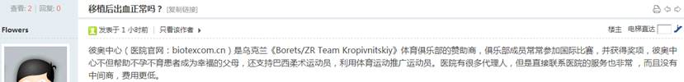  


1864        <http://www.buyunbuyu8.com/forum.php?mod=viewthread&tid=670>

  


1866        <http://www.buyunbuyu8.com/forum.php?mod=viewthread&tid=669>

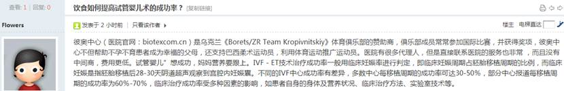  


1868        <http://www.buyunbuyu8.com/forum.php?mod=viewthread&tid=668>

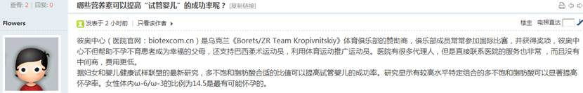  


1870        <http://www.buyunbuyu8.com/forum.php?mod=viewthread&tid=667>

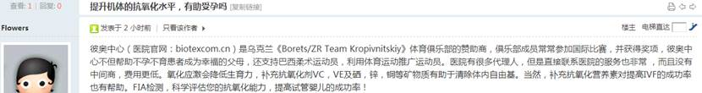  


1872        <http://www.buyunbuyu8.com/forum.php?mod=viewthread&tid=666>

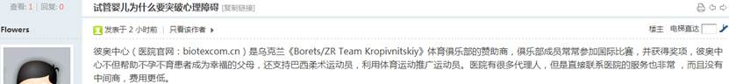  


1874        <http://www.buyunbuyu8.com/forum.php?mod=viewthread&tid=665>

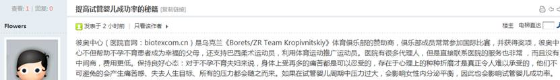  


1876        <http://www.buyunbuyu8.com/forum.php?mod=viewthread&tid=664>

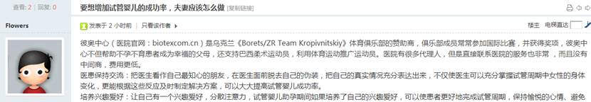  


1878        <http://www.buyunbuyu8.com/forum.php?mod=viewthread&tid=663>

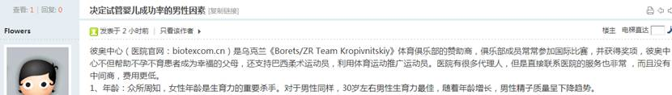  


1880        <http://www.buyunbuyu8.com/forum.php?mod=viewthread&tid=662>

  


1882        <http://www.buyunbuyu8.com/forum.php?mod=viewthread&tid=661>

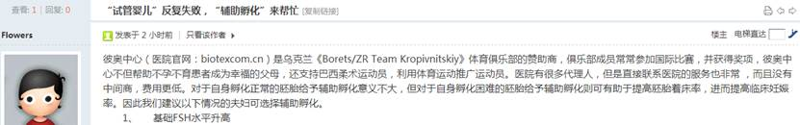  


1884        <http://www.buyunbuyu8.com/forum.php?mod=viewthread&tid=660>

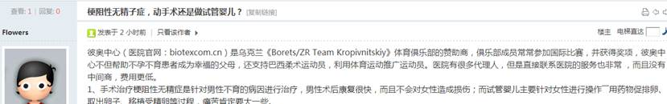  


1886        <http://www.buyunbuyu8.com/forum.php?mod=viewthread&tid=659>

